|  |  |  |  |  |
| --- | --- | --- | --- | --- |
|  | | | | |
| |  | | --- | | **Dimensions** | | **1.** **Ways of thinking ( X  )** | | **2. Ways of living in the world  ( X )** | | **3. Ways of relating with others  ( X )** | | **4. Tools for integrating with the world  ( )** | | | | | |
| **Scenario:** | | | | |
| **Enduring Understanding** | Litter harms our school, community, Costa Rica and the world. The actions we take now to help with litter will help our neighbors today and in the future. | | | |
| **Essential  Question** | Why should we be concerned about litter? | | | |
| **Assessment and Goals** | | | | |
| **Week 1** | **Week 2** | **Week 3** | **Week 4** | **Week 5 & 6** |
| **Theme**   1. What Is Litter? | **Theme**  3. Why is Litter Bad? | **Theme**  3. Where Does Litter Go? | **Theme**  4. What Can I do About Litter? |  |
| **Assessment:**  **L.1.** Recognizes the dialogue of a movie, cartoon or documentary.  **R.PA. 4.** Reads words and sentences to demonstrate knowledge of phonemic awareness.  **W.1.** Writes straightforward text on topics familiar to them using appropriate transitional words such as ‘and’, ‘but’ and’ because’  **Goals:**  **L.1.** understand the dialogue of a movie or cartoon when the visuals provide contextual support.  **R.PA. 4.** demonstrate knowledge of phonemic awareness.  **W.1.** write straightforward text on topics familiar to them using appropriate transitional words such as ‘and’, ‘but’ and’ because’. Can use important connecting words to indicate chronological order (e.g., ‘then’, ’after’, ‘later’). | **Assessment:**  **R.3.** Recognizes short instructions illustrated through step-by-step visuals.  **R.PA. 4.** Reads words and sentences to demonstrate knowledge of phonemic awareness.  **SI.1.** Asks for information as well as offer simple explanations to others.  **W.2.** uses simple grammatical structures to write simple texts.  **Goals:**  **R.3.** understand short instructions illustrated through step-by-step visuals (e.g., simple science experiments, instructions for art projects).  **R.PA. 4.** demonstrate knowledge of phonemic awareness.  **SI.1.** ask for information (e.g., where trash cans are located, if students use trash cans) as well as offer simple explanations to others.  **W.2.** use simple grammatical structures to write simple texts. | **Assessment:**  **R.PA. 4.** Reads words and sentences to demonstrate knowledge of phonemic awareness.  **SP.1.** Describes using simple words, their opinion of a situation or event.  **R.1.** Uses knowledge of first language to aid in understanding the second language.  **Goals:**  **R.PA. 4.** demonstrate knowledge of phonemic awareness.  **SP.1.** describe, using simple words, their opinion of a situation or event (e.g. too much trash, ugly litter, dumping garbage).  **R.1.** use knowledge of first language to aid in understanding the second language. | **Assessment:**  **L.2.** Recognizes simple procedural explanations if given slowly and clearly.  **R.2.** Follows instructions as part of daily activities.  **R.PA. 4.** Reads words and sentences to demonstrate knowledge of phonemic awareness.  **SP.2.** Produces a summary of a short story expressed in a simple sequence of events.  **Goals:**  **L.2.** understand simple procedural explanations if given slowly and clearly, and opportunity is given for clarification (e.g., how to do a project to have a cleaner school, how to live in a cleaner society).  **R.2.** follow instructions for protecting the environment from litter (e.g., reuse, recycle, reduce litter)  **R.PA. 4.** demonstrate knowledge of phonemic awareness.  **SP.2.** produce a summary of a short story expressed in a simple sequence of events. | **Week 5**  Review and Suggested Integrated Mini project  **Week 6**  Suggested Integrated Mini project |
| **Function**   * Describing places and things | **Function**   * Describing how litter affects the environment | **Function**   * Describing cause and effect relationships | **Function**   * Describing actions to clean public places from litter * Retelling events in past simple |
| **Discourse Markers**  Linkers: Sequential - past tense  First, then, after that, finally | **Discourse Markers**  Linkers: Sequential - past tense  First, then, after that, finally | **Discourse Markers**  Linkers: Sequential - past tense  First, then, after that, finally | **Discourse Markers**  Linkers: Sequential - past tense  First, then, after that, finally |
| **Grammar & Sentence Frames**  Using verb tenses (past, present, and future)   * Litter pollutes rivers and sewers. * He planted some plants in the yard last week. * She will collect litter around school tomorrow. | **Grammar &Sentence Frames**    Wh information questions in present tense   * Who leaves litter on the ground? * What can you do about litter? * Which kind of litter takes longer to decompose? | **Grammar & Sentence Frames**  Explaining cause and effect using because and since   * Recycle bins are important because they help us separate garbage. * Litter is dangerous because it pollutes rivers. * The park is dirty since people throw garbage on the ground. | **Grammar & Sentence Frames**  Sequencing adverbs   * First, we have to make a plan. * Then, we will present the plan to our teacher. * Finally, we will make a school campaign. |
| **Phonemic Awareness**  -Practicing minimal pair sounds**: ʃ / tʃ**  **shoes / choose**  **sheep / cheap**  **wash / watch**  **mash / match**  **cash / catch**  **ship/ chip**  **share/chair**  **shop/ chop**  **cash/ catch**  **shin/ chin**  **shock/chock**  **sherry/cherry** | **Phonemic Awareness**   * Cognates and false cognates   **Cognates:** problem, toxic, gases, ocean, ideas, different, cause, effect, recycle, materials.  **False Cognates:** idiom, bomber, large, library, grocery, cartoon, policy, exit, introduce. | **Phonemic Awareness**   * Creation of new words when a specific grapheme is changed, added, or removed in the initial, medial, or final position (e.g., face to place to space) | **Phonemic Awareness**   * Applying knowledge of affixes to base words in context: tree --> trees protect--> protects --> protected --> protecting |
| **Vocabulary**  **1. What is litter?**  **Objects**  **Nouns**   * (Old) food * Paper and plastic used for wrapping things * (Empty) containers * Garbage * Trash * Waste * Ground   **Verb forms (simple present)**   * Litter * Be * Throw * Affect | **Vocabulary**  **2. Why is litter bad?**  **Nouns**   * Water * Health * Recreation * Environment * Ecology   **Verb forms (simple present)**   * Pollute * Affect * Trap * Look * Cause * Throw   **Adjectives**   * Ugly * Dirty | **Vocabulary**  **3. Where does litter go?**  **Nouns**   * Rivers * Containers * Sewers * Streets * Lot * Ocean   **Verb forms** **(present and future tense)**   * Damage * Destroy * Travel * Go * Throw   **Adjectives**   * Dangerous * Harmful   **Opinion:**   * I think… * I believe… * In my opinion… | **Vocabulary**  **4. What can I do about litter?**  **Nouns**   * Garbage * Goods/products   **Verb forms (present and future tense)**   * Reuse * Recycle * Reduce * Dispose * Clean * Dispose * Use/buy   **Adjectives**   * Reusable * Recyclable * Right * Responsible |
| **Psycho-social**   * Expressing positive attitudes such as pride in their culture and community   **Sociocultural**  Avoiding impoliteness when expressing contempt or dislike related littering  **Idioms/phrases**  Expressions   * Go Green | **Psycho-social**   * Expressing positive attitudes such as pride in their culture and community   **Sociocultural**   * Applying conventions for turn-taking as in discussions or debates   **Idioms/phrases**  Expressions   * Give a Hoot, Don’t Pollute | **Psycho-social**   * Showing intrinsic/extrinsic motivations for social responsibility focused on the community   **Sociocultural**   * Avoiding impoliteness when expressing contempt or dislike related littering   **Idioms/phrases**  Expressions   * Go Green * Give a Hoot, Don’t Pollute | **Psycho-social**   * Describing values related to ethical and moral service   **Sociocultural**   * Expressing social responsibility in actions related to the environment   **Idioms/phrases**  Expressions   * Go Green * Give a Hoot, Don’t Pollute * Reduce, reuse, recycle |  |

|  |  |  |  |  |  |  |  |  |  |
| --- | --- | --- | --- | --- | --- | --- | --- | --- | --- |
| **Term:** | | **Level: Sixth Grade** | | | **Unit: 3 Environmentally Speaking** | | | **Week:1** | |
| **Domain: Socio-interpersonal** | | | | **Scenario: Environmentally Speaking** | | **Theme 1:** What Is Litter? | | | |
| **Enduring Understanding**: Litter harms our school, community, Costa Rica and the world. The actions we take now to help with litter will help our neighbors today and in the future. | | | | | | | | | |
| **Essential Question: Why should we be concerned about litter?** | | | | | | | | | |
| |  | | --- | | **Dimensions** | | **1.** **Ways of thinking ( X  )** | | **2. Ways of living in the world  ( X )** | | **3. Ways of relating with others  ( X )** | | **4. Tools for integrating with the world  ( )** | | | | | | | | | | |
| **Learn to Know** | | | | **Learn to Do** | | **Learn to Be and Live in Community** | | | |
| **Grammar & Sentence Frames**  **Using verb tenses (past, present, and future)**   * Litter pollutes rivers and sewers. * He planted some plants in the yard last week. * She will collect litter around school tomorrow.   **Phonemic Awareness**  -Practicing minimal pair sounds**: ʃ / tʃ**  **shoes / choose**  **sheep / cheap**  **wash / watch**  **mash / match**  **cash / catch**  **ship/ chip**  **share/chair**  **shop/ chop**  **cash/ catch**  **shin/ chin**  **shock/chock**  **sherry/cherry**  **Vocabulary**  **1. What is litter?**  **Objects**   * (Old) food * Paper and plastic used for wrapping things * (Empty) containers * Garbage * Trash * Waste * Ground   **Verb forms (simple present)**   * Litter –protect-damage-plant-pollute-do-reduce-recycle- reuse-save- waste- be- affect-refuse-commit- * throw (away)- clean (up)-cut (down)- turn (off)- pick(up) | | | | **Function**   * Describing places and things   **Discourse Markers**  Linkers: Sequential - past tense:  First, then, after that, finally | | **Psycho-social**   * Expressing positive attitudes such as pride in their culture and community   **Sociocultural**  Avoiding impoliteness when expressing contempt or dislike related littering  **Idioms/phrases**  Expressions   * Go Green | | | |
| **Assessment Strategies & Indicators of learning**  (Diagnostic, formative, summative) | **Goals** | | | **Pedagogical Mediation/ Didactic Sequence** | | | | | **Time** |
| Learner… | Learner can… | | | **Pre-Teaching**  **Routine:** Greet, checking attendance. Teacher tapes on the wall the Essential Question and Enduring Understanding (annex 1) and talks with the students about them both, then she/he shares the class agenda, etc.  **Warm up**  Students watch a video that shows some helpful tips on how to maintain an environmentally friendly lifestyle. In the following link, teacher will find the video.  [**https://www.youtube.com/watch?v=8DJ45Yc3urg**](https://www.youtube.com/watch?v=8DJ45Yc3urg) Students are asked to take notes about the different ways to go green they find in the video.  **Activation of Prior Knowledge**  After watching the video, teacher tells students that there are plenty of small ways to make a big impact on the environment. Teacher tapes or projects on the board a picture (annex 2) with the idiom "Go Green" and asks the following two questions:  Niños con un título que dice GO  What is the meaning of GO GREEN?  What are some examples of litter?  Teacher elicits students´ responses and takes notes on the board, then she/he explains that *Going Green* is defined as making more environmentally friendly decisions such as to "reduce, reuse and recycle." Using the notes from the Warm-up activity, students mention some actions they can do to go green at their school and at home. Teacher takes notes on the board (annex 3) using the following chart.  Es una ilustración para que la persona docente tome nota de la lluvia de idea de sus estudiantes. El cuadro en su primera columna dice AT SCHOOL, en la segunda columna AT HOME, y finalmente  en la columna del centro dice EXAMPLES OF LITTER.  Teacher shares the goal(s) for the week.  **Modeling**  Using the previous chart, unknown phrases and vocabulary are checked (meaning and pronunciation) Teacher tells students that our Mother Earth is currently facing a lot of environmental concerns. The environmental problems like global warming, acid rain, air pollution, water pollution, climate change and many more affect every human, animal, and nation on this planet. She/he states that it’s not necessary to turn your life upside down to make a difference. If we all commit to just one or two lifestyle choices that are more sustainable, over time this will have a cumulative and positive impact on the Earth. To start talking about different ways to help the environment, teacher presents some important verbs using a video. In the following link, teacher will find the video. <https://www.youtube.com/watch?v=hXE_D5r4g54> She/he plays the video and stops it at ‘4:46. Students pronounce each verb (at least three times) every time it appears in the video. Once, students know the meaning and the pronunciation of the verbs, they are asked to watch another video to review the three verb tenses. In the following link, teacher will find the video.  <https://www.youtube.com/watch?v=4Rm9l6y3-WY> Then, she/he presents the sentence frames for the week and encourages students to help her/him to make sentences using the different verb tenses (annex 4). For example:   |  | | --- | | PLANT | | I plant trees in my community. | | I planted some trees in my community last week. | | Next month, I will plant some trees in my community. |   **Clarifying**  When they finish making sentences along with the teacher, she/he plays the VERB VIDEO again <https://www.youtube.com/watch?v=hXE_D5r4g54> to practice and check understanding. Teacher plays the video from ‘4:46 to ‘5:54. They all can make the worksheet together if it is projected on the board or teacher can give students a copy with the practice (annex 6). Students have to complete sentences using the verbs from the box.Es una ilustración que contiene una práctica de la etapa de la  clarificación donde el estudiante debe completar oraciones con diferentes verbos relacionados con el tema de ambiente.  Teacher allows some time to finish the practice and checks it using the video (From ‘6:00 to ‘7:06). Teacher provides feedback if necessary. The video will be played one more time to make a practice in which students have to read carefully some sentences and circle the letter of the correct answer.  Teacher gives students a worksheet (annex 7) and allows some minutes to finish it, then she/he checks answers playing the video again from ‘7:14 to ‘8:20. Teacher provides feedback if necessary.  La ilustración contiene una práctica donde los estudiantes deben leer oraciones que no están completas y seleccionar la opción que la complete correctamente | | | | | ‘7  ‘3  ‘10  ‘15  ‘15 |
| **L.1.** recognizes the dialogue of a movie; (cartoon or documentary).  **Indicators of learning:**  **L.1.1.** gets the gist of a dialogue of a movie; (cartoon or documentary).  **L.1.2.** recognizes the type of dialogue that is heard in a cartoon or documentary. | **L.1.** understand the dialogue of a movie when the visuals provide contextual support. | | | **Pre-Task**  Teacher shares L.1 indicators.  Using a PowerPoint Presentation (annex 5), teacher shows students a picture (slide#2) and they are asked to infer what the dog is about to do. Teacher listens to the different inferences and tells students that the dog is going to watch a movie.  Es una ilustración que muestra a perrito negro con gafas rojas, palomitas y refresco en sus patas, listo para ver una película.  Using the same PowerPoint presentation, teacher gives the definition of movie and asks for some examples and types. She/he takes notes of names and types and tells students that today they are going to focus on two types of movies (Cartoons and Documentaries). She/he presents the information about documentaries and asks students two questions: Have you seen a documentary? What was it about? Teacher presents the information about cartoons and asks student the following question: What is your favorite cartoon? Teacher elicits students’ responses about the differences they can spot between cartoons and documentaries. She/he takes notes on the board. In the following link, teacher will find the presentation.  <https://recursos.mep.go.cr/sitio_primaria_ingles/sexto.html>  Presentación que se usará en la semana 1 donde se explica qué es una pelicula y los dos tipos de pelicula que se estudiarán.  **Task-Rehearsal**  Students watch a trailer from the documentary “Trashed”. In the following link, teacher will find the video <https://www.youtube.com/watch?v=5z2s_klZkFg>. Students watch the video for the first time and are asked to get the gist of it. Teacher writes or projects on the board the following question (annex 8) and its possible answer:  **What is the general idea of the video?**   1. Damage to the environment through pollution of our air, land and sea by waste. 2. Overpopulation and its effect on Earth. 3. The global average surface temperature is changing, resulting in climate change.   Students watch a trailer of Wall-E movie. In the following link, teacher will find the video <https://www.youtube.com/watch?v=CZ1CATNbXg0>  Students watch the video for the first time and are asked to get the gist of it. Teacher writes or projects on the board the following question and its possible answer:  **What is the general idea of the video?**   1. A robot that cleans the Earth up from trash. 2. Life in a spaceship. 3. A technologically advanced robot sent to the space to clean it up.   **Task-Completion**  Students are asked to listen to two audio snippets. They have to recognize if what they listened is a cartoon or a documentary based on the dialogue and the characteristics of each type of movie. Every time they listen to a snippet, teacher stops the audio and asks them if it is a cartoon or documentary. They answer orally.  (Double click on the icons to listen to the snippets)    **Task-Assessment**  To check understanding, students are asked to describe what they saw and listened in the videos from the Task-Rehearsal stage. Teacher takes notes on the board and gives feedback if necessary.  Students participate in self-assessment of task performance.    **Student Self-assessment Grid**   |  |  |  |  | | --- | --- | --- | --- | | Indicators | Level of achievement | | | | I can ... | Not achieved yet | In progress | Achieved | | get the gist of a dialogue of a movie; (cartoon or documentary) |  |  |  | | recognize the type of dialogue that is heard in a cartoon or documentary |  |  |  |   **Post-Task**  Based on the information from the videos, students are asked to write three commitments to the Environment in order to prevent littering and pollution. Students use the vocabulary and sentences frames from the Pre-Teaching stage. They use a copy given by the teacher (annex 12). In pairs, students share answers. Note: This graphic organizer will be used again in a writing activity this week.  Esta foto muestra la práctica ques se usará en el post-task de escucha. Contiene un organizador gráfico donde se escribirán 3 compromisos que el estudiante adquiere para cuidar el ambiente. | | | | | ‘15  ‘10  ‘5  ‘5  ‘5 |
| **R.PA.4.** reads words and sentences to demonstrate knowledge of phonemic awareness.  **Indicators of learning:**  R.PA.4.1. identifies minimal pair sounds: ʃ / tʃ in words and sentences.  **R.PA.4.2.** articulates minimal pair sounds: ʃ / tʃ in words and sentences.  **R.PA.4.3.** reads minimal pair sounds: ʃ / tʃ in words and sentences to demonstrate knowledge of phonemic awareness. | **R.PA. 4.** demonstrate knowledge of phonemic awareness. | | | **Pre-Task**  Teacher shares R.PA.4. Indicators.  Students watch a video that presents differences between the consonant sounds: ʃ / tʃ that are similar in pronunciation but definitely not the same to a native speaker. In the following link, teacher will find the video. <https://www.youtube.com/watch?v=dz7FHvzaItE> Students along with the teacher practice how to produce the sound. Teacher stops the video at ‘2:15.  **Task-Rehearsal**  The video will be played again from ‘2:15 to ‘3:06. In the video the sounds will be emphasized so students can clearly hear the differences. Teacher explains that /sh/ is voiceless and it sounds like the quiet sound “Shhhhhhhh…..” The /ch/ is voiceless too and it sounds like a sneeze “Ah-choo!”  Teacher tapes or projects the following chart on the wall (annex 9).  En la imagen se muestra un cuadro con la diferencia en pronunciación entre la sh y ch.  Students listen and repeat a list of words. Students pronounce minimal pairs after the teacher using the words from the following list:   * **shoes / choose** * **sheep / cheap** * **wash / watch** * **mash / match** * **cash / catch** * **ship/ chip** * **share/chair** * **shop/ chop** * **cash/ catch** * **shin/ chin** * **shock/chock** * **sherry/cherry**   A video will be played for students to practice again the pronunciation of some minimal pairs. In the following link, teacher will find the video.  <https://www.youtube.com/watch?v=2qUiHxYfMSU> Teacher stops the video at ‘1:55.  **Task-Completion**  Students work in worksheet #1 (annex 10) where they listen to some minimal pairs and circle the word they hear. The words chosen to be pronounced are: shoe, chair, watch, ship, cash, catch, sheep, shop, cherry.  En la imagen se muestra la práctica 1 de conciencia fonológica.  In practice #2 (annex 11), students are asked to listen to the teacher reading some sentences that contain minimal pairs. They have to complete them by writing the missing word.  The sentences are:   * She´s eating my cheese. * This ship is not cheap. * Should Sherry wash her cherry? * We went to the shop to buy two chairs. * Keep your chin up! * Chop the cheese into small cubes. * I don´t want to share my toys. * The sheep is white color.   En la imagense muestra la práctica 2 de conciencia fonológica donde los estudiantes completarán las oraciones escribiendo la correcta minimal pair.  Students try to remember how to move their tongue, lips, teeth and jaw to produce /sh/ and /ch /sounds. In pairs and taking turns, they pronounce words from practice 1. Teacher walks around the class to give feedback if necessary.  Students along with the teacher participate in choral reading with sentences from practice #2.  With their elbow partner and taking turns, students read again the sentences from practice #2, then they volunteer to read them aloud.  **Task-Assessment**  Students are asked to play a game. In this game, students spin the wheel, pronounce the word that is selected and say the sound (sh or ch).Teacher models the activity for them. In the following link, teacher will find the game <https://wordwall.net/resource/13442357/sh-and-ch-sounds>  Students participate in self-assessment of task performance.  **Student Self-assessment Grid**   |  |  |  |  | | --- | --- | --- | --- | | Indicators | Level of achievement | | | | I can ... | Not achieved yet | In progress | Achieved | | identify minimal pair sounds: ʃ / tʃ in words and sentences |  |  |  | | articulate minimal pair sounds: ʃ / tʃ in words and sentences |  |  |  | | read minimal pair sounds: ʃ / tʃ in words and sentences to demonstrate knowledge of phonemic awareness |  |  |  |   **Post-Task**  If there is internet connection at school, students can have extra practice with some fun and interactive games. They choose out of the following options (whack-a-mole, airplane, group sort, balloon pop, gameshow quiz).In the following link, teacher will find the games.  <https://wordwall.net/resource/13442357/sh-and-ch-sounds> | | | | | ‘5  ‘15  ‘15  ‘7  ‘5  ‘3 |
| **W.1.** writes straightforward text on topics familiar to them using appropriate transitional words such as ‘and’, ‘but’ and’ because’  **Indicators of learning:**  **W.1.1.** lists key words, phrases and expressions to write a straightforward text to describe places and things.  **W.1.2.** organizes main ideas using graphic organizers to describe places and things.  **W.1.3.** drafts a text that describe places and things using appropriate transitional words such as ‘and’, ‘but’ and’ because’.  **W.1.4** revises the text to look for mistakes related to capitalization, spelling, and basic punctuation and appropriate transitional words such as ‘and’, ‘but’ and’ because’.  **W.1.5.** edits a text that describe places and things. | **W.1.** write straightforward text on topics familiar to them using appropriate transitional words such as ‘and’, ‘but’ and’ because’. Can use important connecting words to indicate chronological order (e.g., ‘then’, ’after’, ‘later’). | | | **Pre-Task**  Teacher shares W.1 indicators.  Students are asked to use again the graphic organizer with the commitments completed in the last session (annex 12).  En la imagen se muestra la hoja que se usó en el post- task de escucha para que los estduiantes tomen la información que escribieron y la usen para redactar.  Teacher tells students that they will write a paragraph using the commitments they made.  Teacher explains the task:  You belong to an organization that helps the environment. Last month, you worked on a community that was littered and polluted. You decided to do some actions to help the community and the environment. Write a paragraph explaining three actions you did.  To write the paragraph take into consideration the following aspects:   * Use the graphic organizer to write the paragraph. * Choose a topic. * Write an introductory sentence. * Use the order of the commitments to establish a sequence. * Add more details to each commitment. * Use sequencing and linking word. * Write a conclusion.   Before working on the task, teacher introduces students to sequence adverbs (e.g., first, then, next, finally) as a way of clarifying sequencing. Sequencing refers to the identification of the components of a story or event (the beginning, middle, and end) The words ***first, next, then, finally*** are sequencing words. Teacher explains that these words tell us the order in which events happened.  As an example, teacher retells the sequence of her/his morning routine using the sequence words. She/ he says that ‘First’ signals the first thing someone did in a story or the first step in a procedure. ‘Then’, ‘later’, ‘after’ are sequence words that might be found in the middle of a story and “finally” refers to the end of the story.  Teacher also reviews somelinking or connecting words (but, and, because) and explains that they are used to link together different ideas in a text.  **Task-Rehearsal**  Students make a list of verbs and key words found in the commitment copy to start working on the graphic organizer. Students work in pairs. Student A reads his/her commitments to student B and he/she retells them using past tense.  En la imagen se muestra la hoja que se usó en el post- task de escucha para que los estduiantes tomen la información que escribieron y la usen para redactar.  **Task-Completion**  Teacher shows students an example of the expected outcome (annex 13). She/he shows a graphic organizer with all the information provided and gives clear explanations on how to do it. She/he presents and explains each section to finally present an example of the expected paragraph. Then, teacher gives students an empty graphic organizer (annex 14) for students to complete it.  En la imagen se muestra un organizador gráfico lleno como ejemplo para que los estudiantes vean el trabajo que se espera que ellos hagan.Es la imagens e muestra un organizador gráfico vacío para ser llenado por los estudiantes guiándose  con el ejemplo presentado por el docente.  Once they finished the conclusion, they start drafting the text. Teacher reminds students some aspects to be included in the draft.  • Use the information from the graphic organizer to make the draft.  • Make sure the commitments are in order.  • Add more details to each commitment.  • Use sequencing and linking word.  **Task-Assessment**  Using a checklist each student revises their own paragraph and tries to improve it, then using the same instrument each student will check her/his elbow partner´s paragraph. Teacher monitors the process and provides feedback.   |  |  |  |  | | --- | --- | --- | --- | | Checklist | Yes | No | Partially | | I wrote a topic |  |  |  | | I wrote an introduction |  |  |  | | My actions are in order |  |  |  | | My spelling is correct |  |  |  | | I used capitals and periods |  |  |  | | I used sequencing words |  |  |  | | I used linking words |  |  |  | | I wrote a conclusion |  |  |  |   Students participate in self-assessment of task performance.  **Student Self-assessment Grid**   |  |  |  |  | | --- | --- | --- | --- | | Indicators | Level of achievement | | | | I can ... | Not achieved yet | In progress | Achieved | | list key words, phrases and expressions to write a straightforward text to describe places and things |  |  |  | | organize main ideas using graphic organizers to describe places and things |  |  |  | | draft a text that describe places and things using appropriate transitional words such as ‘and’, ‘but’ and’ because’ |  |  |  | | revise the text to look for mistakes related to subject-verb Agreement, capitalization, spelling, and basic punctuation and appropriate transitional words such as ‘and’, ‘but’ and’ because’ |  |  |  | | edit a text that describe places and things (check after Post-Task) |  |  |  |   **Post- Task**  Considering their classmates’ feedback, learners correct and modify their paragraph. Teacher also monitors learners and helps them in the editing process. Once, their work is finished, they tape their final draft on the wall so classmates can read them. | | | | | ‘20  ‘5  ‘20  ‘10  ‘5 |
| **Integrated Mini-Project** | | | | | | | | | **Time** |
| Phase: _______  See options in week # 5. | | | | | | | | |  |
| **Reflective Teaching** | | | | | | | | | |
| What worked well | | | What didn’t work well | | | | How to improve | | |
| **Enduring Understanding Reflection** | | | | | | | | | |
|  | | | | | | | | | |

List of links:

<https://www.youtube.com/watch?v=8DJ45Yc3urg>

<https://www.youtube.com/watch?v=hXE_D5r4g54>

<https://www.youtube.com/watch?v=4Rm9l6y3-WY>

<https://www.youtube.com/watch?v=hXE_D5r4g54>

<https://www.youtube.com/watch?v=5z2s_klZkFg>.

<https://www.youtube.com/watch?v=CZ1CATNbXg0>

<https://www.youtube.com/watch?v=dz7FHvzaItE>

<https://www.youtube.com/watch?v=2qUiHxYfMSU>

<https://wordwall.net/resource/13442357/sh-and-ch-sounds>

<https://wordwall.net/resource/13442357/sh-and-ch-sounds>

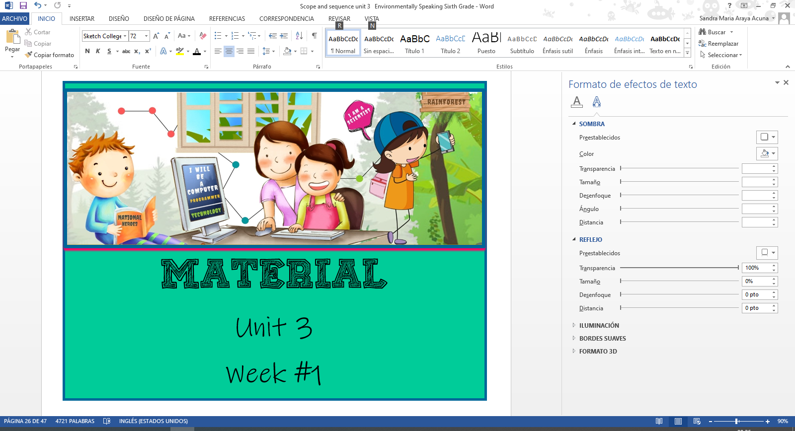

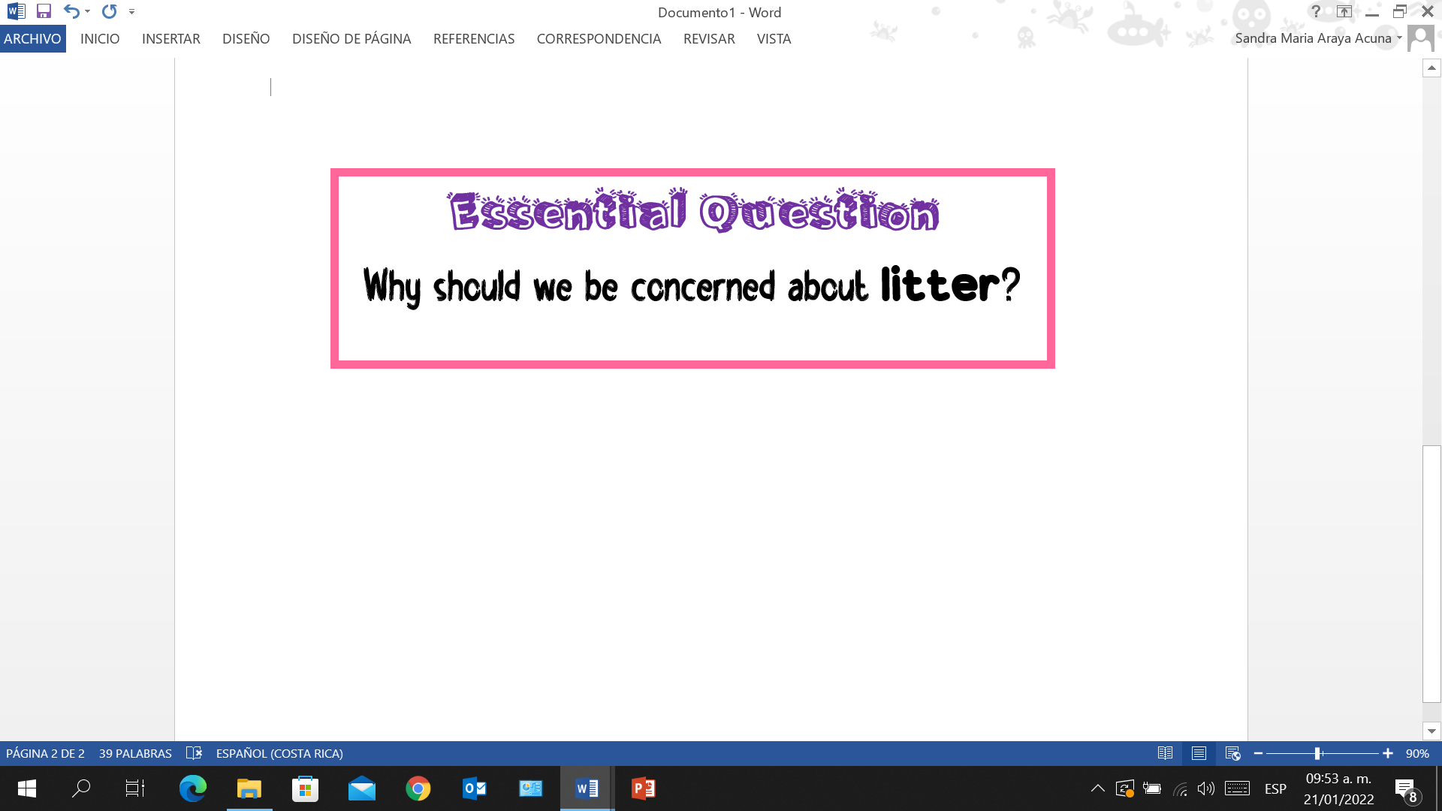

**Annex 1**

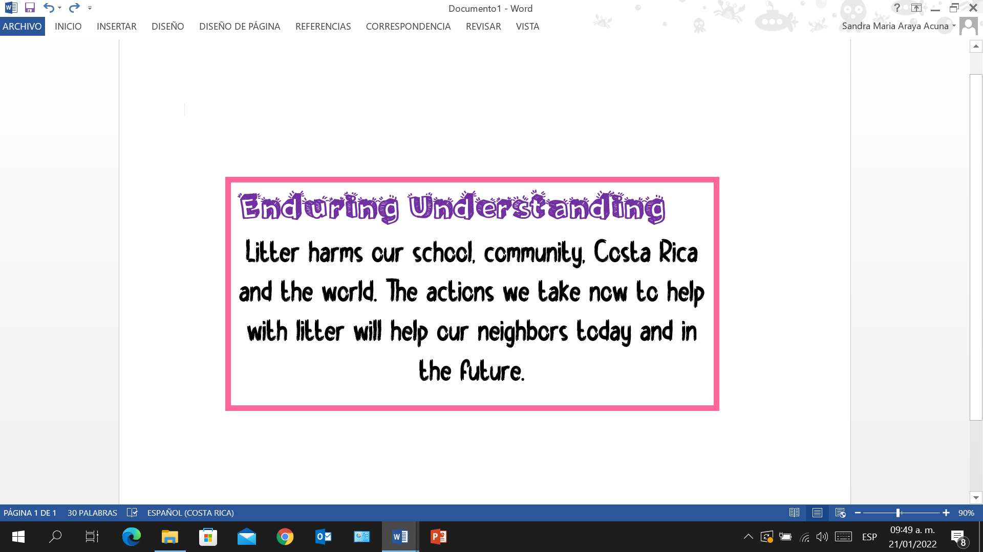

**Annex 1**

**Annex 2**

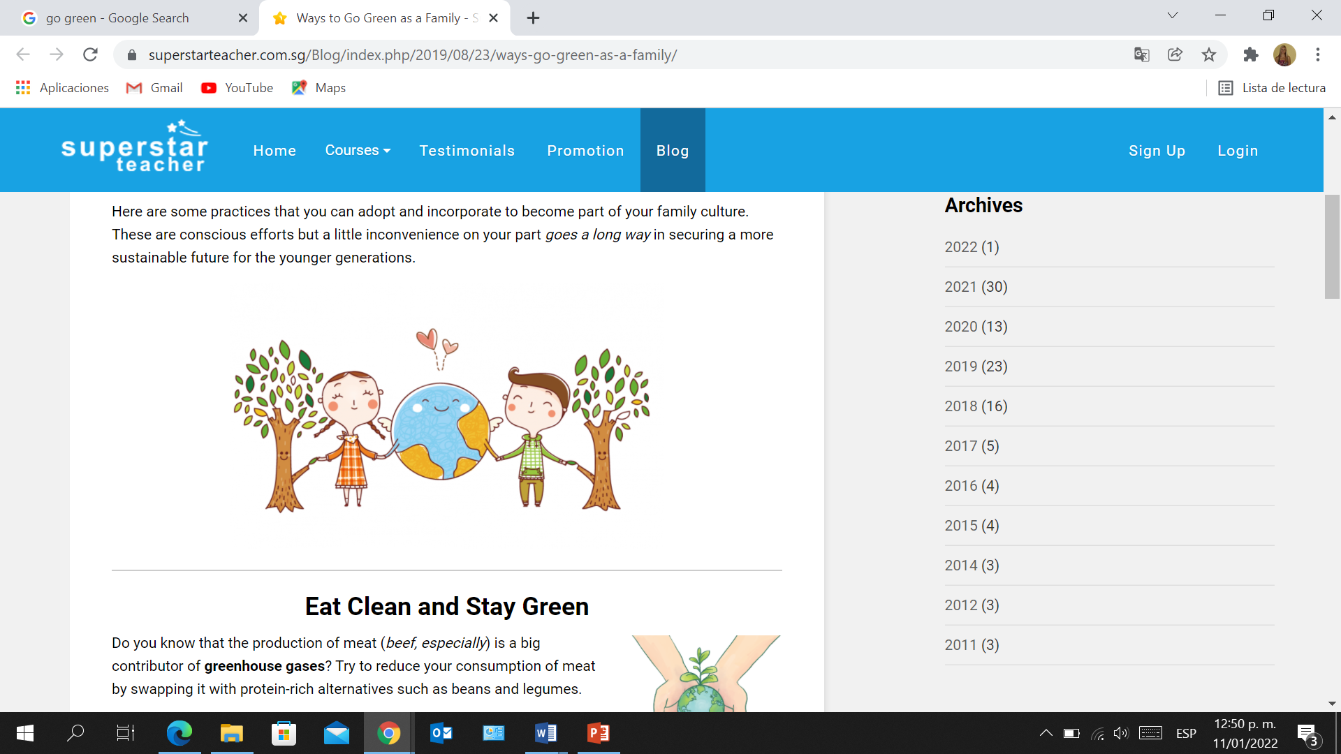

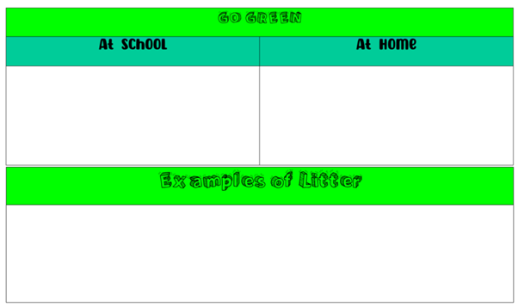

**Annex 3**

**Annex 4**

|  |
| --- |
| PLANT |
| I plant trees in my community. |
| I planted some trees in my community last week. |
| Next month, I will plant some trees in my community. |

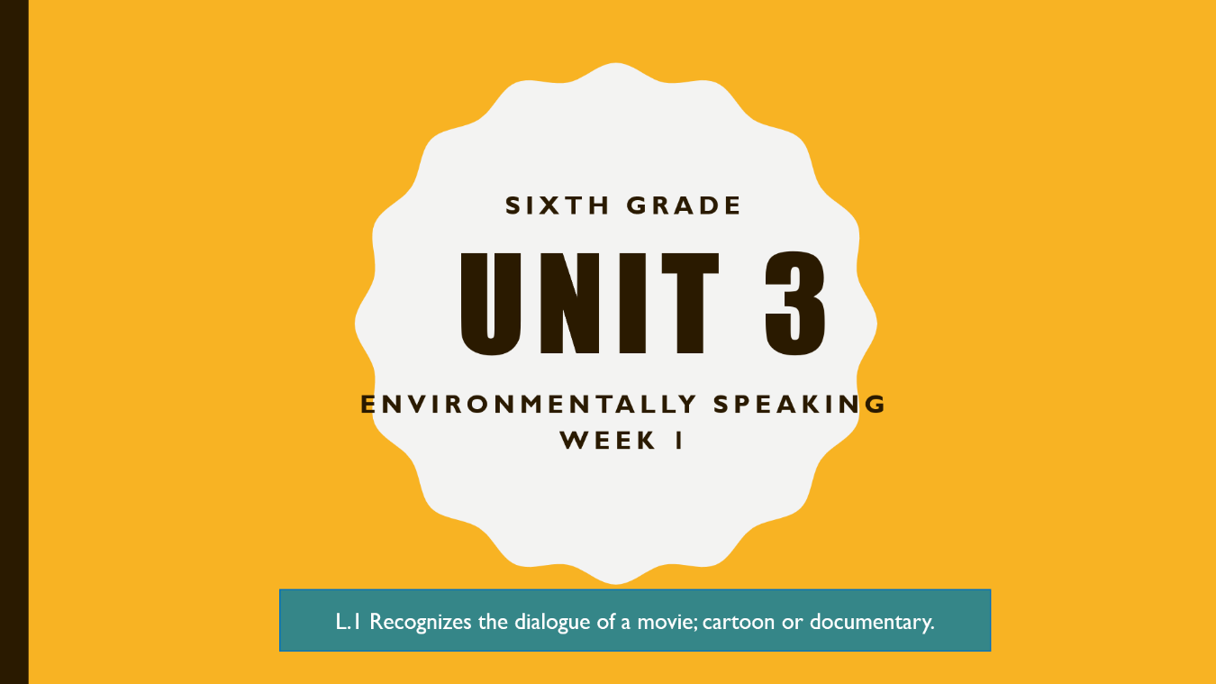

**Annex 5**



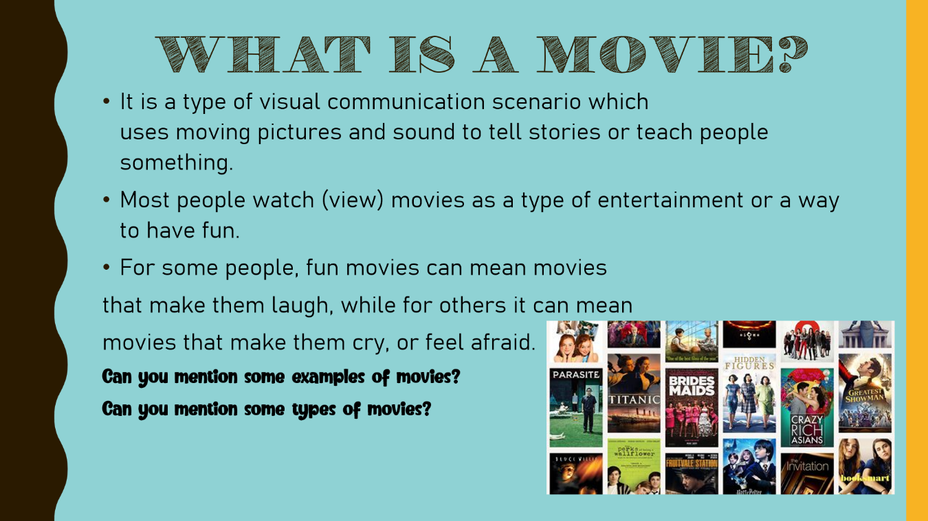

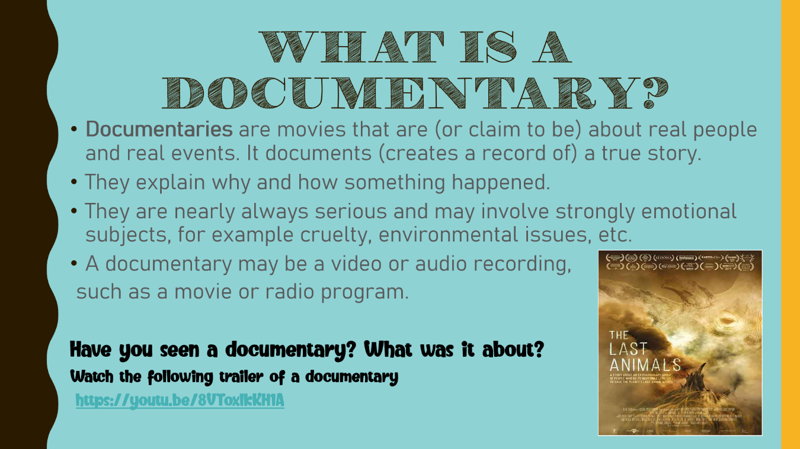

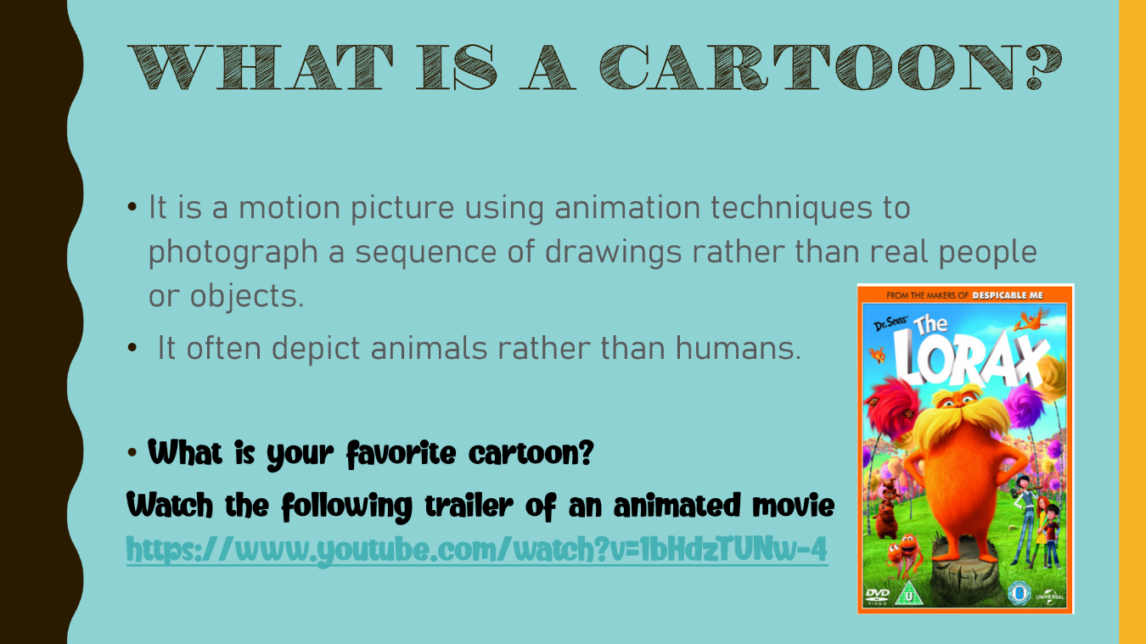

Practice

**Annex 6**

Clean up

Damage

Throw away

Plant

Recycle

Save

Cut down

Pollute

Waste

Protect

Reuse

Turn off

1. Don´t __________ water!
2. Don´t __________ old things __________. __________ them again and again.
3. Don’t __________ trees __________. __________ more of them.
4. __________ our planet. Don´t__________ the environment!
5. __________ your computer __________ and __________ batteries.
6. After the picnic, we need to __________ the park __________.
7. Don´t __________ the ocean. __________ the marine life.

________________________________________________________________________________

Practice

Clean up

Damage

Throw away

Plant

Recycle

Save

Cut down

Pollute

Waste

Protect

Reuse

Turn off

1. Don´t __________ water!
2. Don´t __________ old things __________. __________ them again and again.
3. Don’t __________ trees __________. __________ more of them.
4. __________ our planet. Don´t__________ the environment!
5. __________ your computer __________ and __________ batteries.
6. After the picnic, we need to __________ the park __________.
7. Don´t __________ the ocean. __________ the marine life.

________________________________________________________________________________

Practice

Clean up

Damage

Throw away

Plant

Recycle

Save

Cut down

Pollute

Waste

Protect

Reuse

Turn off

1. Don´t __________ water!
2. Don´t __________ old things __________. __________ them again and again.
3. Don’t __________ trees __________. __________ more of them.
4. __________ our planet. Don´t__________ the environment!
5. __________ your computer __________ and __________ batteries.
6. After the picnic, we need to __________ the park __________.
7. Don´t __________ the ocean. __________ the marine life.

Read carefully and circle the letter of the correct answer.

**Annex 7**

1. People ______ the river and kill the fish.
2. waste b. pollute c. protect
3. Please don´t ______ those things! They’re expensive.
4. damage b. protect c. save
5. You can ______ old things and make new things from them.
6. clean up b. waste c. recycle
7. We never ______ water in my house.
8. damage b. waste c. protect

_________________________________________________________________________

Read carefully and circle the letter of the correct answer.

1. People ______ the river and kill the fish.
2. waste b. pollute c. protect
3. Please don´t ______ those things! They’re expensive.
4. damage b. protect c. save
5. You can ______ old things and make new things from them.
6. clean up b. waste c. recycle
7. We never ______ water in my house.
8. damage b. waste c. protect

_________________________________________________________________________

Read carefully and circle the letter of the correct answer.

1. People ______ the river and kill the fish.
2. waste b. pollute c. protect
3. Please don´t ______ those things! They’re expensive.
4. damage b. protect c. save
5. You can ______ old things and make new things from them.
6. clean up b. waste c. recycle
7. We never ______ water in my house.
8. damage b. waste c. protect

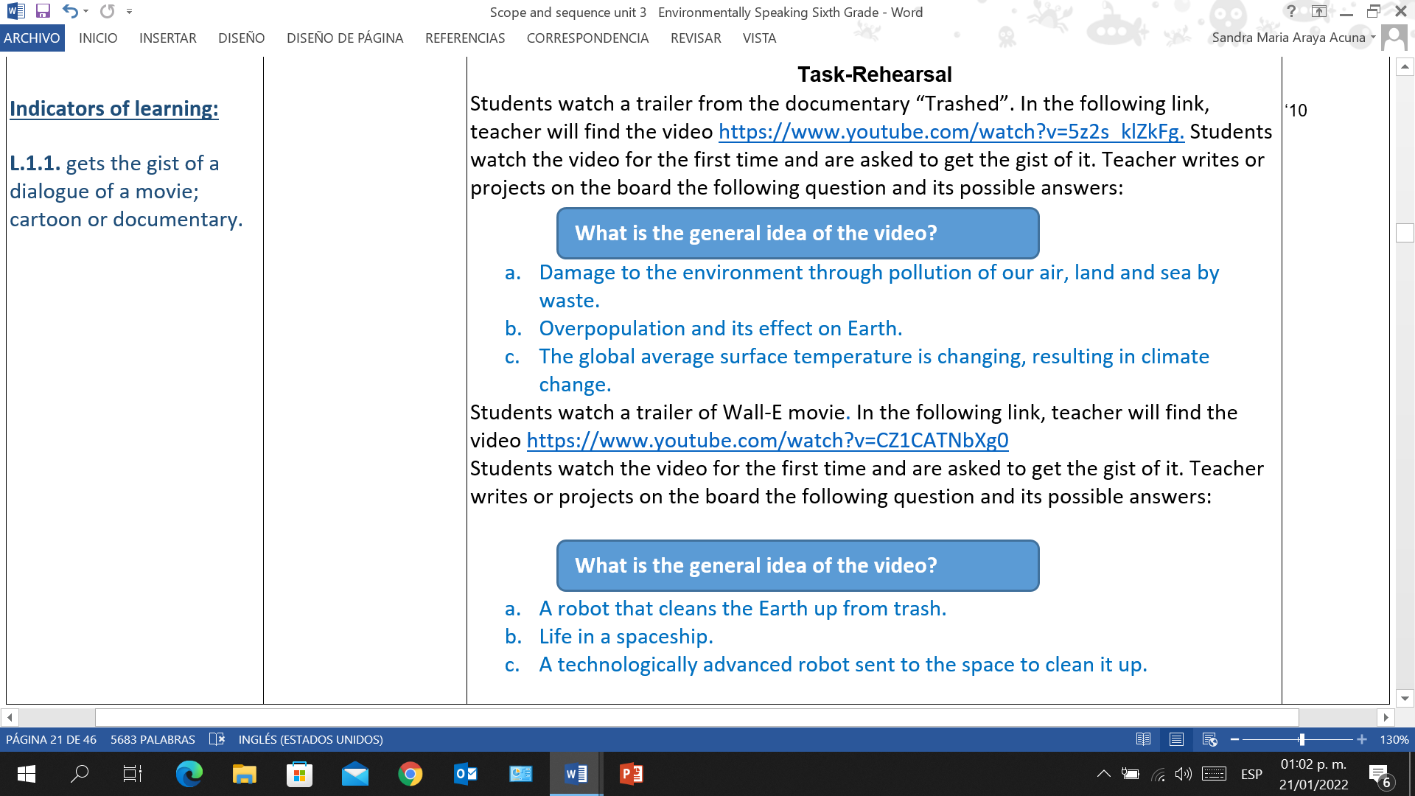

**Annex 8**



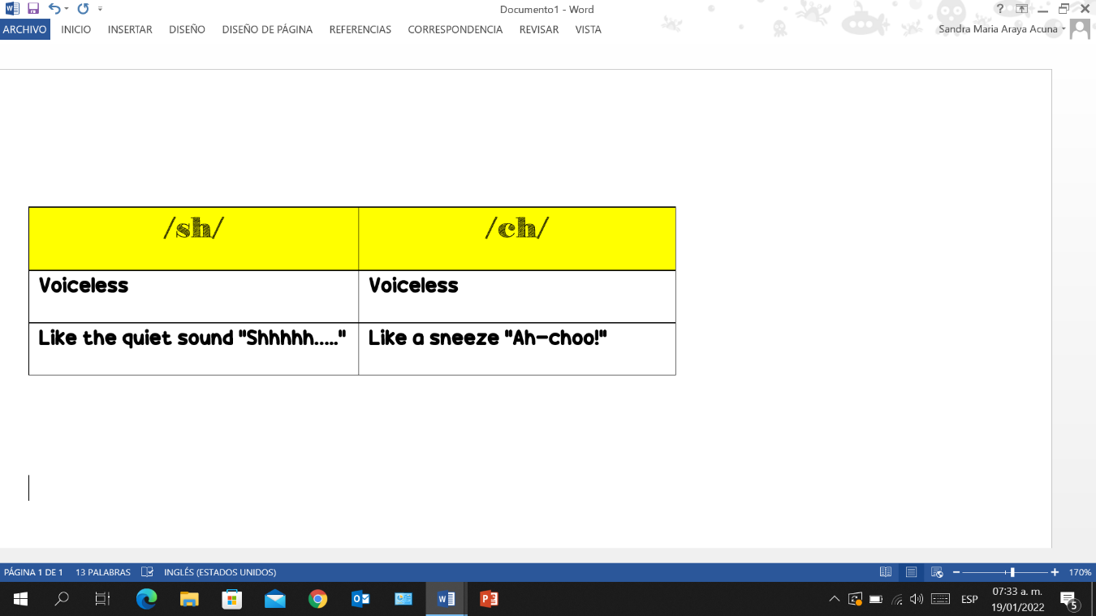

**Annex 9**

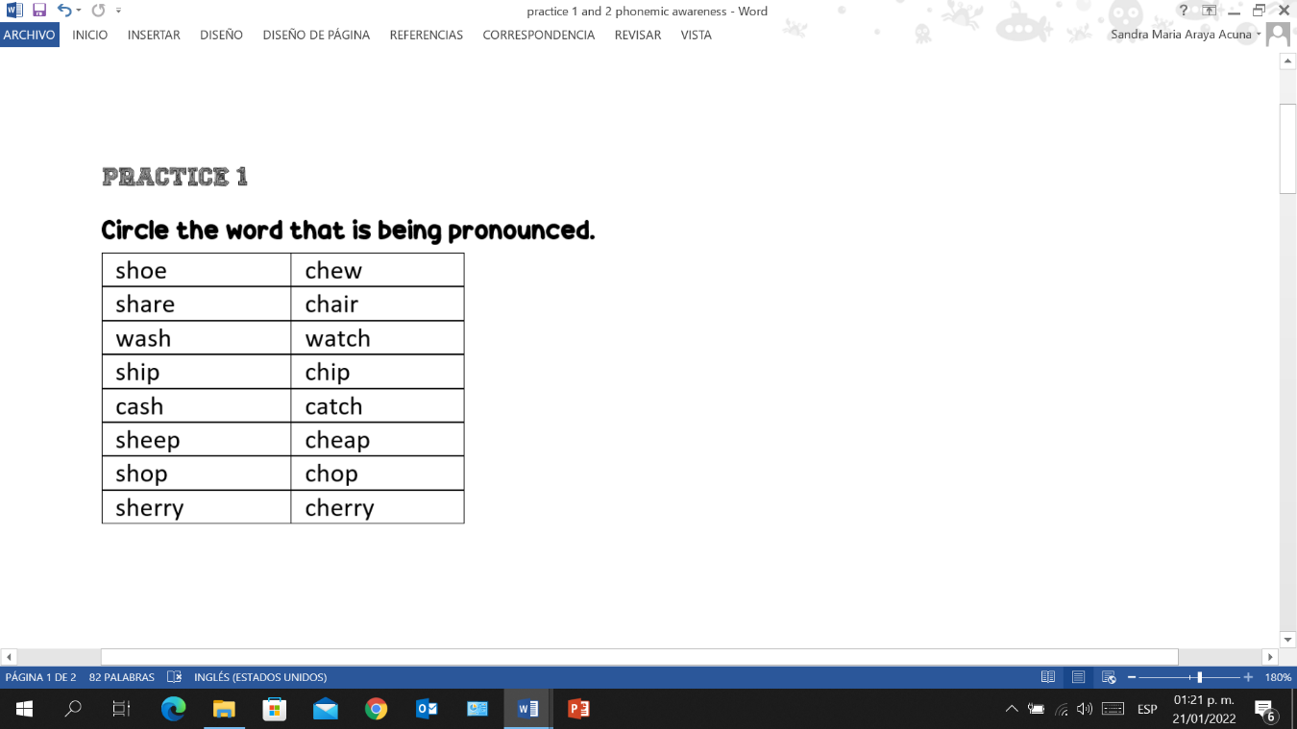

**Annex 10**



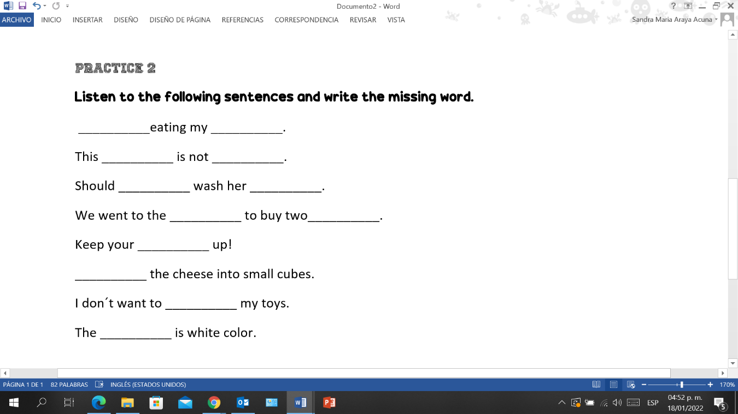

**Annex 11**



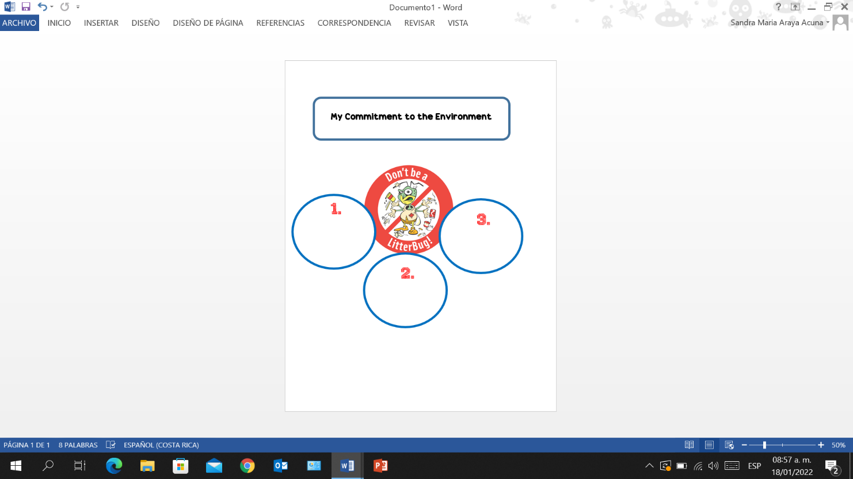

**Annex 12**

|  |  |  |  |
| --- | --- | --- | --- |
| Topic: | My commitment to my community | | |
| Introduction: | In my community there are many places that have a lot of trash. I do not want my community to look this way, so I decided to do some actions to clean it up. | | |
| Name: Noah | First  Pick up trash in the park | Then  Clean the local creek up | Finally  Recycle paper, glass, plastic and metal. |
| Conclusion: | I feel happy because I was a super hero that helped my community to be better and look more beautiful. | | |
| Paragraph:  **My commitment to my community**  In my community there are many places that have a lot of trash. I do not want my community to look this way, so I decided to do some actions to clean it up.  First, I picked up trash in the park. I found many plastic objects and cans. Then, I cleaned the local creek up because it was full of trash. I found many things that could be recycled like tires, plastic bottles and bags. Finally, I recycled paper, glass, plastic and metal.  I feel happy because I was a super hero that helped my community to be better and look more beautiful. | | | |

**Annex 13**

**Annex 14**

|  |  |  |  |
| --- | --- | --- | --- |
| Topic: |  | | |
| Introduction: |  | | |
| Name: | First  _______________  _______________  _______________ | Then  _______________  _______________  _______________ | Finally  _______________  _______________  _______________ |
| Conclusion: |  | | |
| Paragraph:  __________________________________________________________________________________________________________________________________________________________________________________________________________________________________________________________________________________________________________________________________________________________________________________________________________________________________________________________________________________________________________________________________________________________________________________________________________________________________________________________________________________________________________________________________________________________________________________________________________________________________________________________________________________________________________________________________________________________________________________________________________________________________________________________________________________________________________________________________________________________________________________________________________________ | | | |

|  |  |  |  |  |  |  |  |
| --- | --- | --- | --- | --- | --- | --- | --- |
| **Term:** | | **Level: Sixth Grade** | | **Unit: 3** | | **Week: 2** | |
| **Domain: Socio-interpersonal** | | | **Scenario:** Environmentally Speaking | | **Theme:** Why is Litter Bad? | | |
| **Enduring Understanding**: Litter harms our school, community, Costa Rica and the world. The actions we take now to help with litter will help our neighbors today and in the future. | | | | | | | |
| **Essential Question:** Why should we be concerned about litter? | | | | | | | |
| **New Citizenship:**   |  | | --- | | **Dimensions** | | **1.** **Ways of thinking ( X  )** | | **2. Ways of living in the world  ( X )** | | **3. Ways of relating with others  ( X )** | | **4. Tools for integrating with the world  ( )** | | | | | | | | |
| **Learn to Know** | | | **Learn to Do** | | **Learn to Be and Live in Community** | | |
| **Grammar & Sentence Frames**  **Wh- Information questions in present tense**  -Who leaves litter on the ground?  -What can you do about litter?  -Which kind of litter takes longer to decompose?  **Vocabulary**  Why is litter bad?  **Nouns**   * Water, Health, Recreation, Environment, Ecology   Because it affects….  **Verb forms** (simple present)   * Pollute * Affect * Burn * Bury * Dump * Trap * Look * Cause * Throw   **Adjectives**   * Ugly * Littered   **Phonology**  **Cognates and false cognates**  **Cognates:** problem, toxic, gases, ocean, ideas, different, cause, effect, recycle, materials.  **False Cognates:** idiom, bomber, large, library, grocery, cartoon, policy, exit, introduce. | | | **Function**  Describing how litter affects the environment  **Discourse Markers**  **Linkers:** Sequence adverbs-past tense  -First, then, after that, finally | | **Psycho-social**   * -Expressing positive attitudes such as pride in their culture and community   **Sociocultural**   * -Applying conventions for turn-taking as in discussions or debates   **Idioms/phrases**  **Expressions**  Litterbug  Go Green  I´m all ears.   * Give a Hoot, Don’t Pollute! | | |
| **Assessment Strategies & Evidences of learning**  (Diagnostic, formative, summative) | **Goals** | | **Pedagogical Mediation/ Didactic Sequence** | | | | **Time** |
| Learner… | Learner can… | | **Pre-Teaching**  **Routine:** Welcome students, checking attendance, share the class agenda, etc.  **Warm up**  Students get five words written on the board **Water, Health, Recreation, Environment, Ecology.** Students listen to the teacher and repeat the vocabulary. Then, teacher tapes five pictures (annex 1): (printed in advance) on the board and 5 volunteers match them with their corresponding word by tracing a line.  Ilustración a color que representa aspectos de la  ecología como el agua, luz, reciclaje, planeta, etcIlustración  que muestra aguaIlustración a color de un corazón  que reprsenta la saludIlustración a color de un niño disfrutando del agua, recreaciónIlustración a color que muestra animales en el mundo, medioambiente  **Activation of Prior Knowledge**  Students watch a two-minute documentary trailer. In the following link, teacher will find the documentary regarding litter and its environmental impact.  <https://www.youtube.com/watch?v=gd9ZFVgoQ68&t=128s> While watching the video, students are asked to take notes on vocabulary or expressions they recognize from last week. When the video is over, orally, the students answer the following questions:   * Was the video about a forest or an ocean? * Was the ocean clean or littered? * Can you mention some examples of litter? * Is litter ugly or beautiful? * Is litter bad or good?   **Modeling**  Using a PPT (annex 2), teacher reviews verbs, adjectives and sequence adverbs. She/he also presents idioms, grammar/ sentence frames and unknown vocabulary for the week. Teacher writes on the board the question: **Why is litter bad?** She/he also writes **“Because it affects…”** Every time teacher points to a picture, students are asked to add information for a response using the 5 words from the warm-up activity (Water, Health, Recreation, Environment, Ecology) to complete the expression. The activity is repeated as many times as necessary to use all the words in context. Students along with the teacher emphasize words to reinforce pronunciation and meaning. Once it is done, teacher shares weekly goals. In the following link, teacher can find the PPT  <https://recursos.mep.go.cr/sitio_primaria_ingles/sexto.html>  Es una imagen que muestra la presentación de powerpoint que se usará en la etapa modeling.  **Clarifying**  Students check understanding of vocabulary and expressions by answering to some TRUE and FALSE claims. Sentences are written on the board for them to take as a point of reference. They listen to the instructor reading each sentence. As a whole, they say aloud if each sentence is TRUE or FALSE. Teacher provides feedback if necessary.  ***Sentences:***  Plastic pollutes oceans.  Litter affects the environment.  A net traps only fish in the water.  The park looks dirty.  Pollution causes health problems. | | | | 5´  5´  5´  15´  10´ |

|  |  |  |  |  |  |  |  |  |  |  |  |  |  |  |  |  |  |  |  |  |  |  |  |  |  |  |  |  |  |  |  |  |  |  |  |  |  |  |  |  |  |  |  |
| --- | --- | --- | --- | --- | --- | --- | --- | --- | --- | --- | --- | --- | --- | --- | --- | --- | --- | --- | --- | --- | --- | --- | --- | --- | --- | --- | --- | --- | --- | --- | --- | --- | --- | --- | --- | --- | --- | --- | --- | --- | --- | --- | --- |
| **R.3.** recognizes short instructions illustrated through step-by-step visuals.  **Indicators of learning:**  **R.3.1.** gets the gist of short instructions illustrated through step-by-step visuals.  **R.3.2.** labels short instructions illustrated through step-by-step visuals.  **R.3.2** recognizes important information in short instructions illustrated through step-by-step visuals. | **R.3.** understand short instructions illustrated through step-by-step visuals (e.g., simple science experiments, instructions for art projects). | | **Pre-Task**  Teacher shares R.3 indicators and tells students they are going to read a conversation in which two friends are talking about how to deal with trash. Before reading the conversation, students are exposed to a matching exercise with key vocabulary for them to understand better the conversation. The matching exercise can be written on the board or teacher can make copies of it (annex 3).  Teacher explains that *Column A* contains definitions of key words in a conversation and *Column B* contains the corresponding words. Students read words in Column B and find their definition in Column A.  Es una práctica de una correspodencia con palabras en la columna B y sus respectivas definicIones en la columna A.  Randomly, students give answers. Students draw pictures in their notebooks of words from the matching to clarify meaning.  **Task-Rehearsal**  Teacher asks WHAT IS A GENERAL IDEA? Students brainstorm some ideas that will be written on the board. Using a picture (annex 4), teacher presents the definition of general/main idea. This picture can be printed or projected.  Es una imagen que contiene la definición de main idea.  Teacher tells students that today they will be looking for the general idea of a conversation and writes on the board some steps for them to follow:   1. Look at the tittle…What is it about? 2. Look at the illustration… What can you see? 3. Look for clue words that are used repeatedly. 4. Look for the first and last sentence.   As an example to model what students should do, a picture with a text (annex 5) is presented. Students along with the teacher follow the previous steps to get the gist of the text.  Se muestra un texto de reduce, reuse, recycle para modelar la actividad de obtener la idea general.  Once students know what to do, teacher presents the conversation (annex 6), and they are asked to read it and follow again the steps to get the gist of it. Teacher monitors students and provides feedback if necessary.  ES UNA IMAGEN CON LA CONVERSACIÓN TALKING ABOUT TRASH DE LA ETAPA DEL TASK-REHEARSAL.  **Task-Completion**  Some statements are presented in a chart (annex 7). Those statements contain information taken from the conversation. Students are asked to read each statement and find an appropriate label for each description.  Es una imagen con la práctica de labeling.  The labels to be used are:   * Air pollution * Land pollution * Litterbug * Recycle * Reuse * Reduce * Water pollution   In pairs, students check answers. Then, volunteers give answers aloud.  Students read the conversation again and a graphic organizer (annex 8) is provided for them to complete. They have to look for information in the conversation such as: topic, participants, positive and negative advice given in the conversation in order to get rid of trash.  es una imagen con un graphic organizer para la etapa de task-completion  Randomly, students give answers. Teacher provides feedback if necessary.  **Task-Assessment**  Based on the information provided in the conversation, students are asked to read the following statements (annex 9) and decide whether they are true or false.   |  |  |  | | --- | --- | --- | | **Statements** | **True** | **False** | | Today trash is a big problem. |  |  | | Dumping trash in the ocean or rivers cause toxic gases. |  |  | | Each one of us throws away almost one kilogram of trash per year. |  |  | | One solution is to reduce the amount of materials we consume. |  |  | | Burning trash is a great solution to deal with littering. |  |  |   Teacher monitors students and provides feedback if necessary.  Students participate in self-assessment of task performance.    **Student Self-assessment Grid**   |  |  |  |  | | --- | --- | --- | --- | | Indicators | Level of achievement | | | | I can ... | Not achieved yet | In progress | Achieved | | get the gist of short instructions illustrated through step-by-step visuals |  |  |  | | label short instructions illustrated through step-by-step visuals |  |  |  | | recognize important information in short instructions illustrated through step-by-step visuals |  |  |  |   **Post-Task**  Students make a list of items that can be reduced, recycled or reused. Teacher can use the following chart (annex 10).  imagen para hacer un listado de cosas que se pueden reciclar, reusar y reducir.  Teacher supports students with translation of words if required. Teacher encourages the use of the expression…. How do you say _______ in English? Feedback is provided if necessary. | | 15´  10´  12´  7´  7´  5´  5´ |
| **R.PA.4.** reads words and sentences to demonstrate knowledge of phonemic awareness.    **Indicators of learning:**  **R.PA.4.1.** identifies cognates and false cognates in words and sentences.  **R.PA.4.2.** gets meaning of cognates and false cognates in sentences.  **R.PA.4.3.** reads cognates and false cognates in words and sentences to demonstrate knowledge of phonemic awareness. | **R.PA. 4.** demonstrate knowledge of phonemic awareness. | | **Pre-Task**  Teacher shares R.PA.4 indicators and writes on the board the word **FAMILY.** She/he asks for its meaning and waits for students´ responses. Then she/he asks them how they know the meaning and waits again for their answers. After that, she/he says that it was easy to know the meaning because the word is similar to the word **FAMILIA** in Spanish. It is a Cognate. Once again, she/he writes on the board another word (**LIBRARY**) and repeats the previous activity. Teacher tells them that it is a False cognate. Then, she/he displays a PPT to present examples of cognates and false cognates.  In the following link, teacher can find the PPT (annex 11).  <https://recursos.mep.go.cr/sitio_primaria_ingles/sexto.html>  ES UNA IMAGEN QUE PRESENTA LAS DIAPOSITIVAS DE COGNATE Y FALSE COGNATES.  **Task-Rehearsal**  Students are asked to use again the reading **TALKING ABOUT TRASH** (annex 6). They have to circle all cognates and underline all false cognates they found in the conversation.  La imagen muestra una conversación enttre dos personas donde se dan indicaciones para deshacerse de los desechos sólidos.  **Task-Completion**  Students are given a matching activity (annex 12). They have to match underlined cognates and false cognates in column B with their corresponding definitions in column A.  Es una imagen de la práctica de asocie de cognates and false cognates.  Teacher monitors students and provides feedback if necessary.  **Task-Assessment**  In pairs, students read sentences from Column B and say if the underlined word is a cognate or false cognate. They also practice pronunciation of words.  1. Littering is a serious **problem.**  2. A **large** amount of trash affects the environment.  3. “Go green” is an **idiom** that means to take care of the environment.  4. I feel **embarrassed** because I don´t recycle.  5. **Different** kinds of materials can be recycled.  Students participate in self-assessment of task performance.  **Student Self-assessment Grid**   |  |  |  |  | | --- | --- | --- | --- | | Indicators | Level of achievement | | | | I can ... | Not achieved yet | In progress | Achieved | | identify cognates and false cognates in words and sentences |  |  |  | | get meaning of cognates and false cognates in sentences |  |  |  | | read cognates and false cognates in words and sentences to demonstrate knowledge of phonemic awareness |  |  |  |   **Post-Task**  Students are asked to play the game **RUN AND TOUCH** (annex 13). Teacher tapes some pictures on the board. Ten volunteers are split into two teams. Each team gets in line (two lines). Every time the teacher reads a sentence that contains a cognate or false cognate, one participant from each team runs and touches the picture that represents it.  The sentences are:   * Gases cause air pollution. * I like to read books in the library. * I feel embarrassed that I was a litterbug. * Large animals are affected by littering. * Littering is a serious problem.   ES UNA IMAGEN A COLOR DE UNA NIÑA EN UNA BIBLIOTECA ES UNA IMAGEN DE UNA BALLENA COMIENDO BASURA IMAGEN A COLOR DE UNA MUJER AVERGONZADAIMAGEN DE GASES CAUSE AIR POLLUTIONIMAGEN QUE MUESTRA LITTERING IS A SERIOUS PROBLEM | | 10´  5´  5´  5´  5´ |
| **SI.1.** asks for information as well as offer simple explanations to others.  **Indicators of learning:**  **SI.1.** brainstorms vocabulary, phrases and questions to ask for information as well as offer simple explanations to others.  **SI.1.2.** makes a list of single words, phrases, and expressions to ask for information and offer explanations.  **SI.1.3.** asks questions to others.  **SI.1.4.** offers simple explanations to others. | **SI.1.** ask for information (e.g., where trash cans are located, if students use trash cans) as well as offer simple explanations to others. | | **Pre-task**  Teacher shares SI.1 indicators and presents students the following task:  **You are an interviewer in a talk show. You will interview a famous environmental activist in order to give people advice on how we can reduce or avoid litter.**  Before students start planning their talk show, teacher asks them to brainstorm some vocabulary, phrases and questions they can use as a prompt in the given task.  Students will be divided into pairs: interviewer and guest.  Teacher writes on the board some questions for students to use as a guide. They will answer each question based on information given in the class. Both students will answer the questions because they will switch roles.  Teacher sets up chairs, one in front of the other.  **Possible Questions:**   * What is litter? * What can you do about litter? * Why is litter bad? * Which kind of litter takes longer to decompose?   Some time is given for students to make a list of single words, phrases, and expressions to prepare the answers choosing the appropriate vocabulary, grammar structure and sentence frames. Also, each student will think about the way to introduce his/her guest. Teacher models the activity with a volunteer for students to know what they have to do and to see the expected outcome.  **Task-Rehearsal**  Once students have answered the questions, they are asked to practice the introduction, questions and answers individually. They work on pronunciation, intonation and tone of voice. Teacher walks around the class and monitors students´ work. They ask for help if necessary.  **Task- Completion**  Students get in pairs and start the interviews. They switch roles in order to ask and answer the questions offering simple explanations. Teacher monitors students and provides feedback if necessary.  **Task-Assessment**  Teacher asks for some volunteers to come to the front of the class (the audience) and hold their interviews. Teacher opens the floor to questions from the audience.  Students participate in self-assessment of task performance.    **Student Self-assessment Grid**   |  |  |  |  | | --- | --- | --- | --- | | Indicators | Level of achievement | | | | I can ... | Not achieved yet | In progress | Achieved | | brainstorm vocabulary, phrases and questions to ask for information as well as offer simple explanations to others |  |  |  | | make a list of single words, phrases, and expressions to ask for information and offer explanations |  |  |  | | ask questions to others |  |  |  | | offer simple explanations to others |  |  |  |   **Post-Task**  Teacher reviews vocabulary, grammar structures and sentence frames from week 1 and 2. | | 7´  5´  5´  5´  5´ |
| **W.2.** uses simple grammatical structures to write simple texts.  **Indicators of learning:**  **W.2.1.** brainstorms key words, phrases and expressions to describe how litter affects the environment.  **W.2.2.** makes an outline to organize the main ideas about how litter affects the environment.  **W.2.3.** drafts a text/paragraph using simple grammatical structures to describe how litter affects the environment.  **W.2.4.** revises the text/paragraph to look for mistakes related to subject-verb Agreement, capitalization, spelling, and basic punctuation and content.  **W.2.5.**edits a text that describes how litter affects the environment. | **W.2.** use simple grammatical structures to write simple texts. | | **Pre-Task**  Teacher shares W.2. indicators and writes on the board the following idiom:  Give a hoot, don´t pollute!  She/he explains that to 'give a hoot' is like 'to care'. A common expression people use is 'I don't give a hoot!’ which means I don't care, or I couldn't care less. So, **“*Give a hoot, don´t pollute”*** means***'Show you care, don't pollute'****.*  Teacher tells students that they should give a hoot about the environment and that they should be concerned about the way people is littering the world and the way it affects life on Earth. Students are asked to watch a video that contains an example of how litter affects the environment. In the following link, teacher will find the video.  <https://www.youtube.com/watch?v=dEIY-fn_xag>  After watching the video students are asked to brainstorm key words, phrases or expressions that describe how litter affects the environment. Teacher takes notes on the board.  Students are presented with the following task:  You are sad and concerned because your best friend acts as a litterbug and he does not give a hoot about the environment. Write a WhatsApp message to your best friend to convince him to care about the environment. Use the following ideas as a guide to tell your best friend:   1. how his behavior makes you feel 2. how litter affects the environment 3. what he can do to help the environment   Use sequence adverbs and the idioms; Give a hoot, don’t pollute! and Litterbug.  **Task-Rehearsal**  Before writing the WhatsApp message, students make an outline with all the ideas generated from the brainstorm activity. Students are provided with an outline (annex 14) for them to organize their ideas.  Es una imagen con el outline a usar en la etapa TASK-REHEARSAL. Además contiene el LAYOUT del Whatsapp donde deben escribir el mensaje.  **Task -Completion**  Students take information from the outline and write the preliminary message. Students use the WhatsApp layout provided in the previous activity. Teacher monitors students and provides feedback if necessary.      **Task-Assessment**  Using a checklist each student revises their own message and tries to improve it, then using the same instrument each student will check her/his elbow partner´s message. Teacher monitors the process and provides feedback.   |  |  |  |  | | --- | --- | --- | --- | | Checklist | Yes | No | Partially | | I wrote an introduction. |  |  |  | | I wrote how I feel. |  |  |  | | I described how litter affects the environment. |  |  |  | | I included some advice on how he can help. |  |  |  | | My spelling is correct. |  |  |  | | I used capitals and periods. |  |  |  | | I used sequencing words. |  |  |  | | I included the idioms. |  |  |  | | I wrote a conclusion. |  |  |  |   Students participate in self-assessment of task performance.  **Student Self-assessment Grid**   |  |  |  |  | | --- | --- | --- | --- | | Indicators | Level of achievement | | | | I can ... | Not achieved yet | In progress | Achieved | | brainstorm key words, phrases and expressions to describe how litter affects the environment |  |  |  | | make an outline to organize the main ideas about how litter affects the environment |  |  |  | | draft a text/paragraph using simple grammatical structures to describe how litter affects the environment |  |  |  | | revise the text/paragraph to look for mistakes related to subject-verb Agreement, capitalization, spelling, and basic punctuation and content |  |  |  | | edit a text that describes how litter affects the environment (check after Post-Task) |  |  |  |   **Post- Task**  Considering their classmates’ feedback, learners correct and modify their WhatsApp message. Teacher also monitors learners and helps them in the editing process. Once, their work is finished, they tape their final draft on the wall so classmates can read it. | | 10´  7´  10´  10´  5´ |
| **Integrated Mini-Project** | | | | | **Time** |
| Phase: _______  See examples in week#5. | | | | |  |
| **Reflective Teaching** | | | | | |
| What worked well | | What didn’t work well | | How to improve | |
| **Enduring Understanding Reflection** | | | | | |
|  | | | | | |

List of links

<https://www.youtube.com/watch?v=gd9ZFVgoQ68&t=128s>

<https://www.youtube.com/watch?v=dEIY-fn_xag>

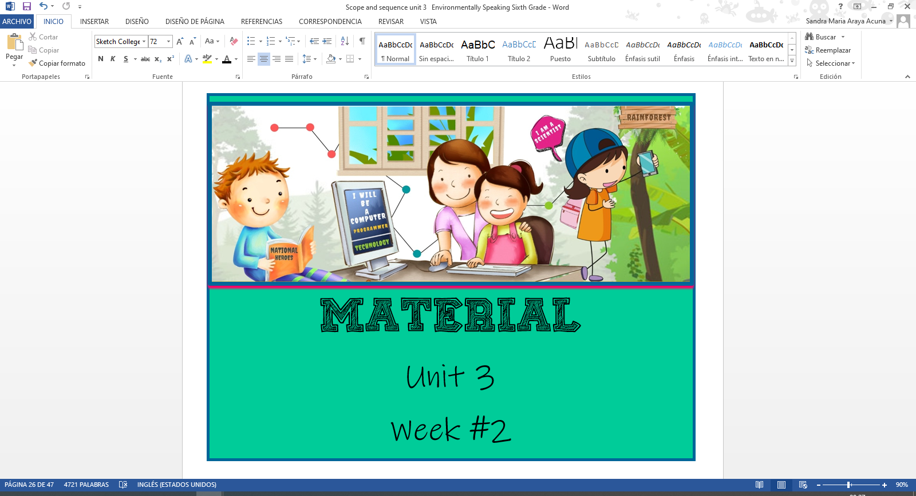



**Annex 1**





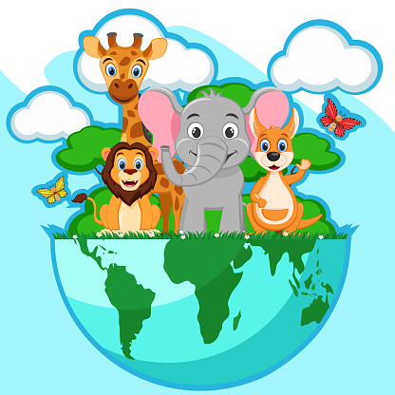

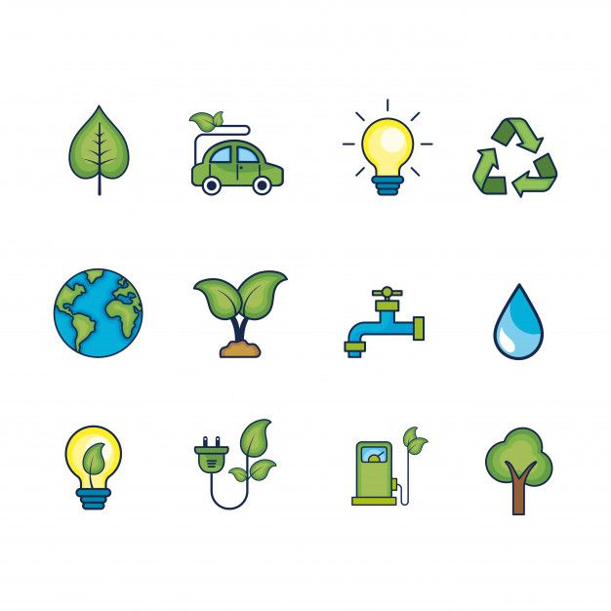

**Annex 2**

PowerPoint Presentation

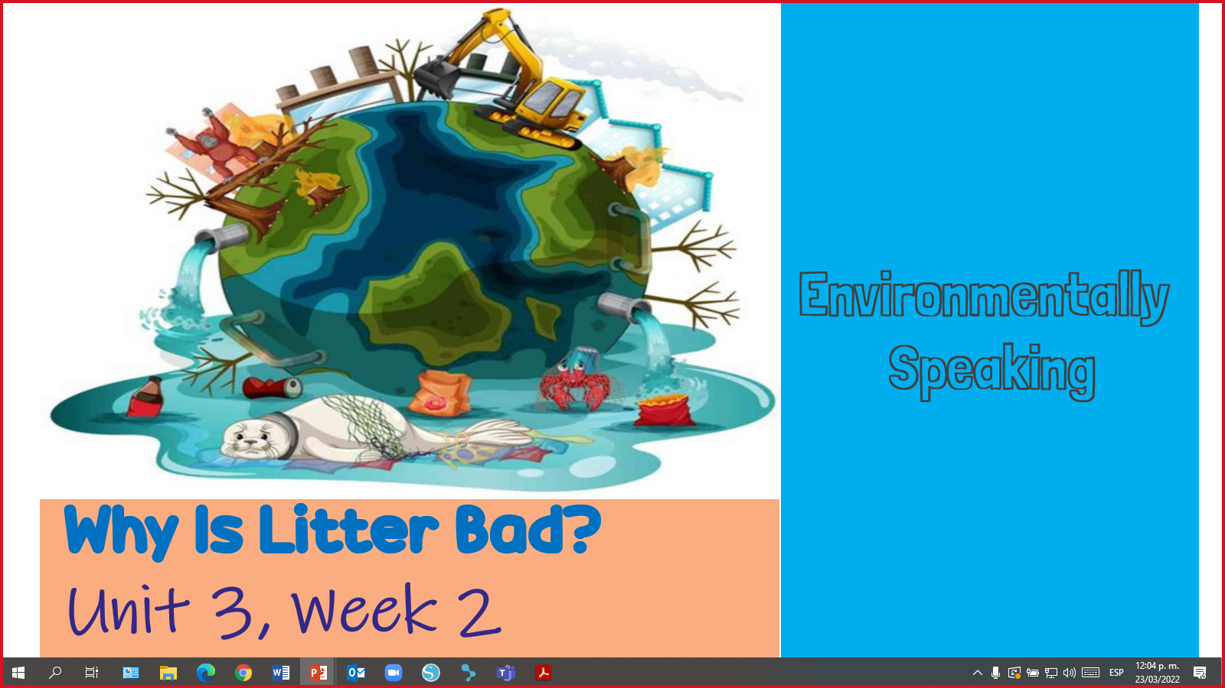

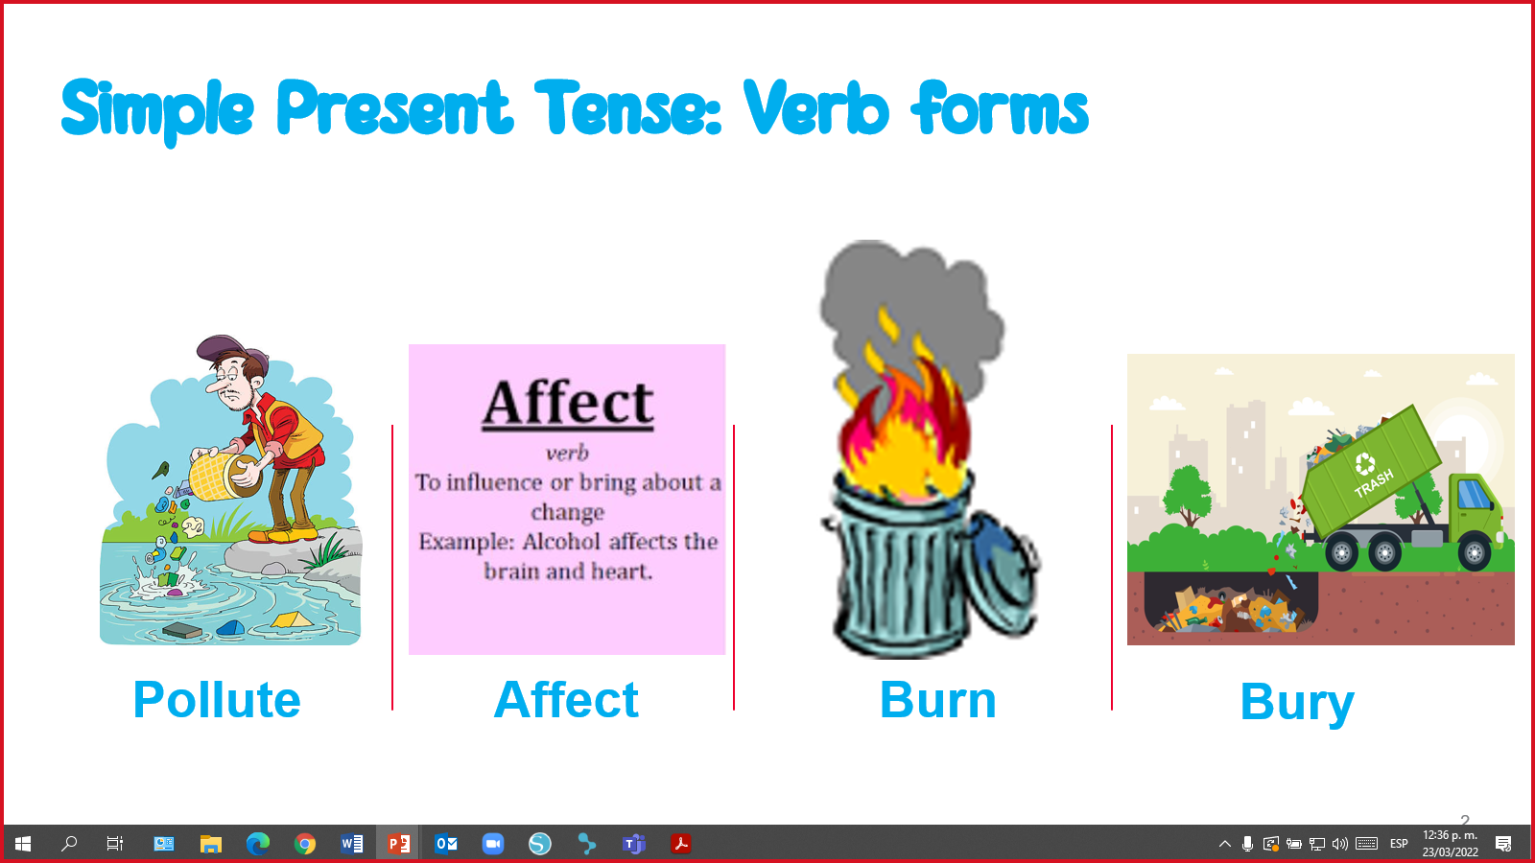

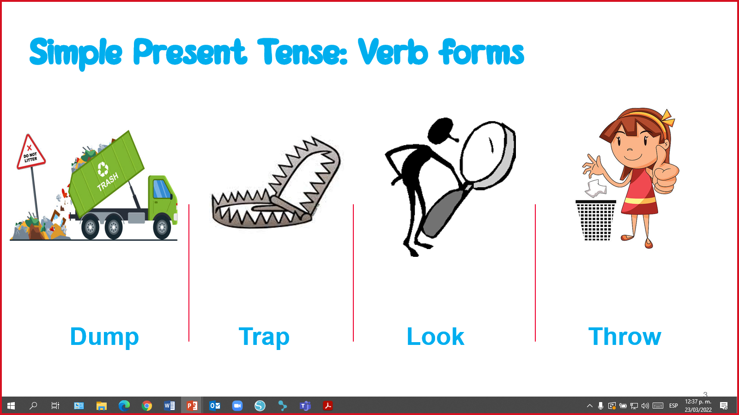

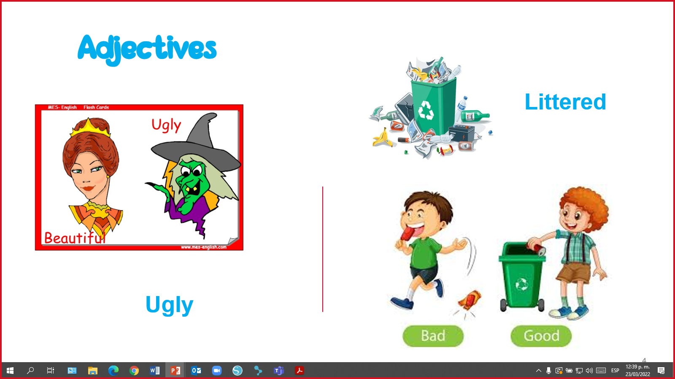

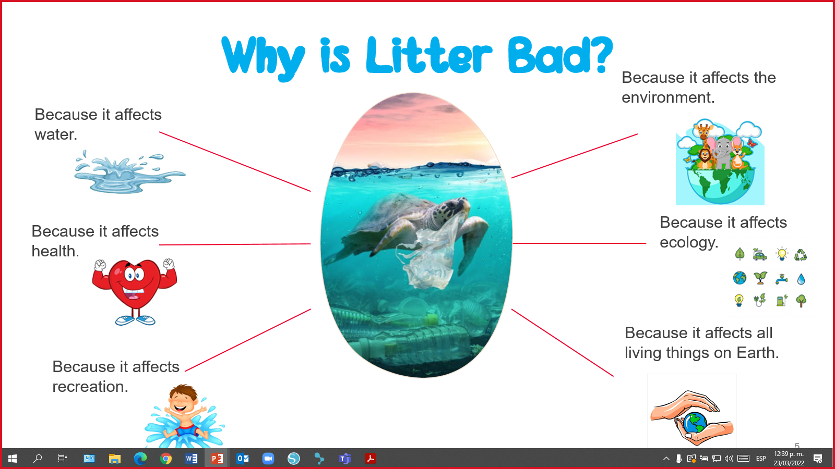

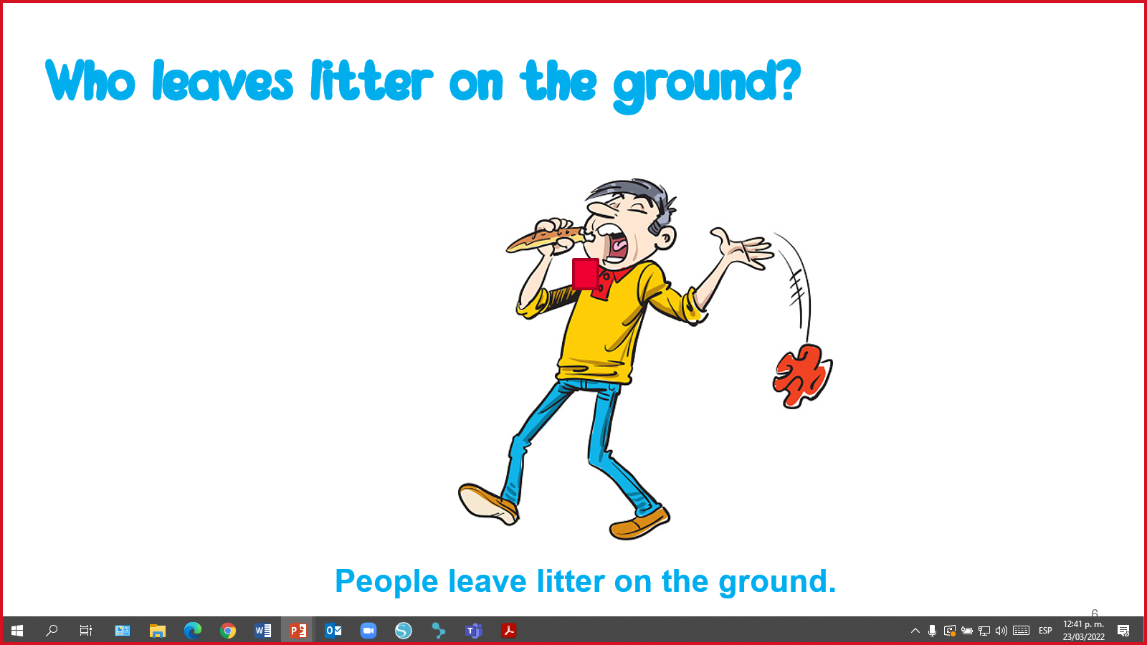

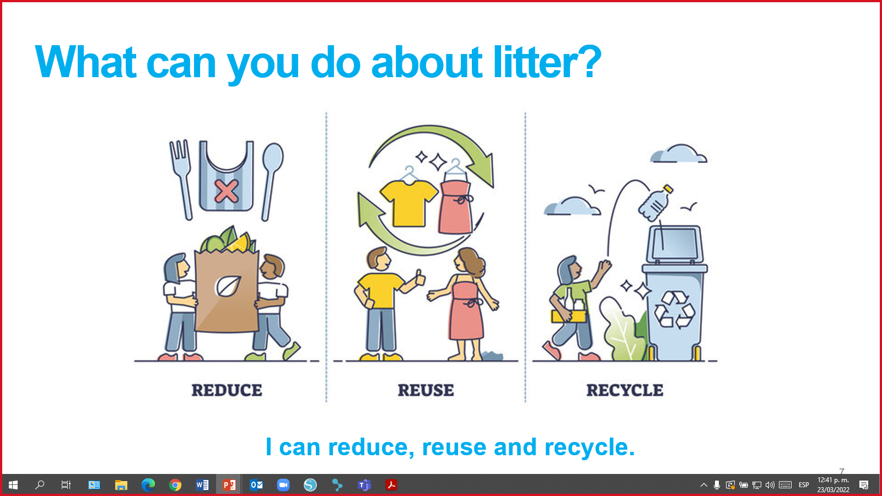

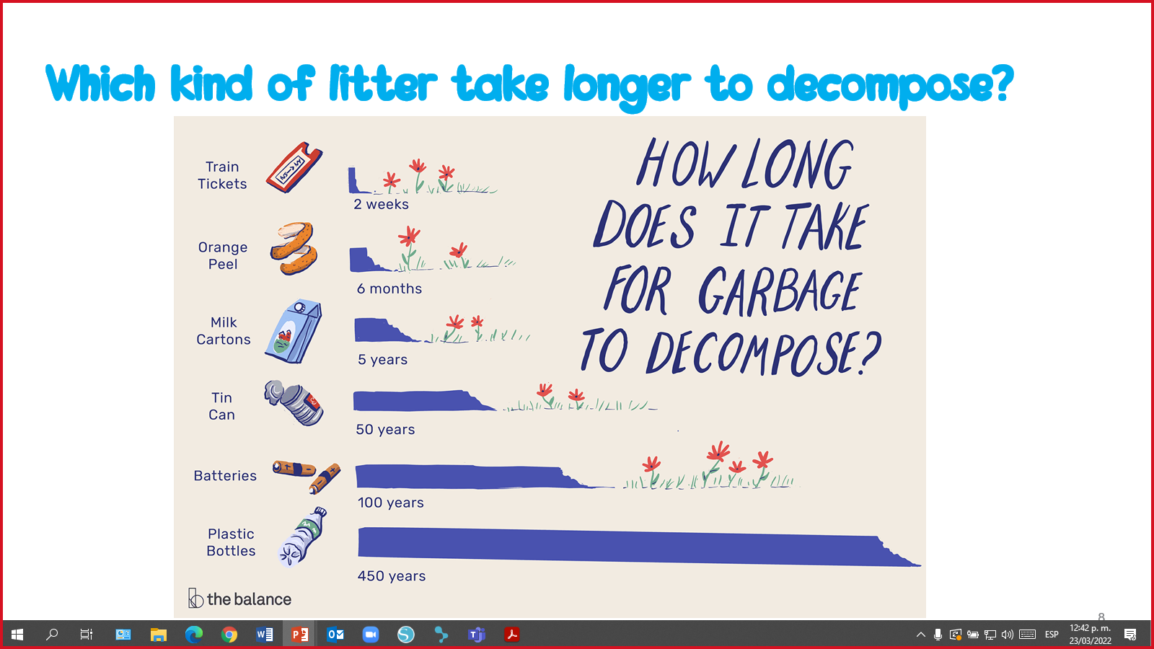

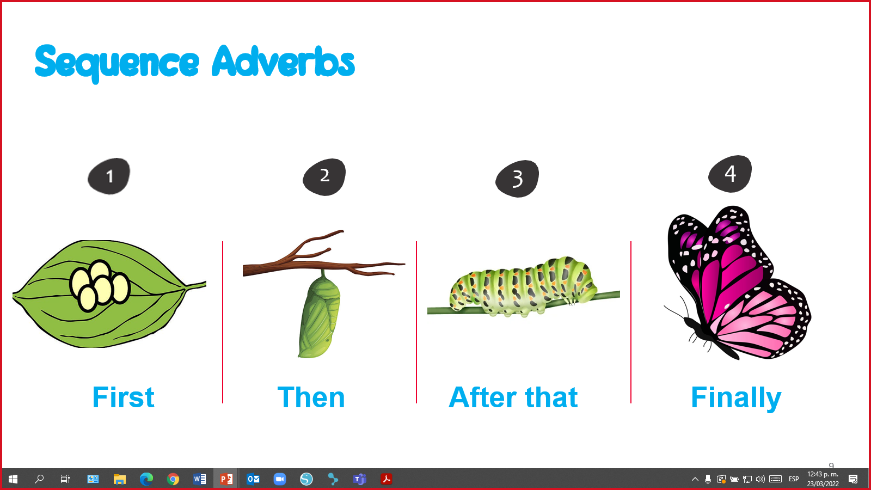

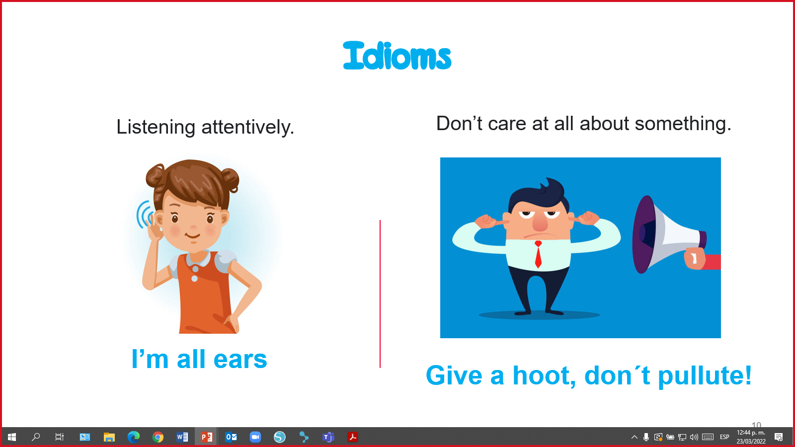

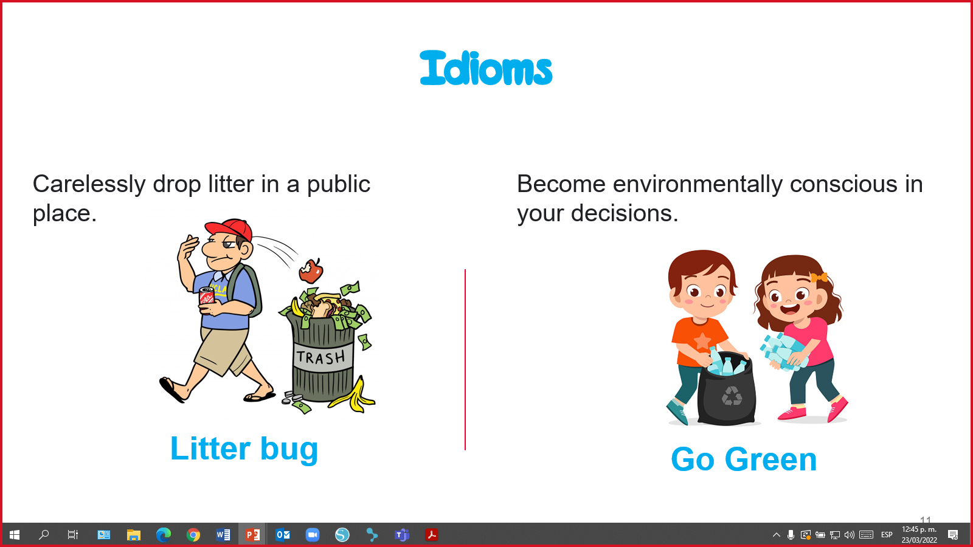

**Annex 3**

|  |  |  |
| --- | --- | --- |
| **Column A** |  | **Column B** |
| A quantity of something. | ( ) | 1. Trash |
| To put or hide under ground. | ( ) | 1. Ton |
| To finish, use, or sell all of something, so that there is none left. | ( ) | 1. Amount |
| Without inhabitants; [vacant](https://www.collinsdictionary.com/dictionary/english/vacant) or [unoccupied](https://www.collinsdictionary.com/dictionary/english/unoccupied). | ( ) | 1. Burn |
| I'm ready and eager to hear what you have to say. | ( ) | 1. Dump |
| To move into a direction quickly and suddenly. | ( ) | 1. Bury |
| Rubbish or garbage. | ( ) | 1. Run out |
| Unit of mass equal to 1,000 kilogram. | ( ) | 1. I´m all ears |
| To produce flames and heat while consuming a material. | ( ) | 1. Shoot |
| To deposit or dispose of (garbage, waste, or unwanted material), typically in a careless or hurried way. | ( ) | 1. Empty |

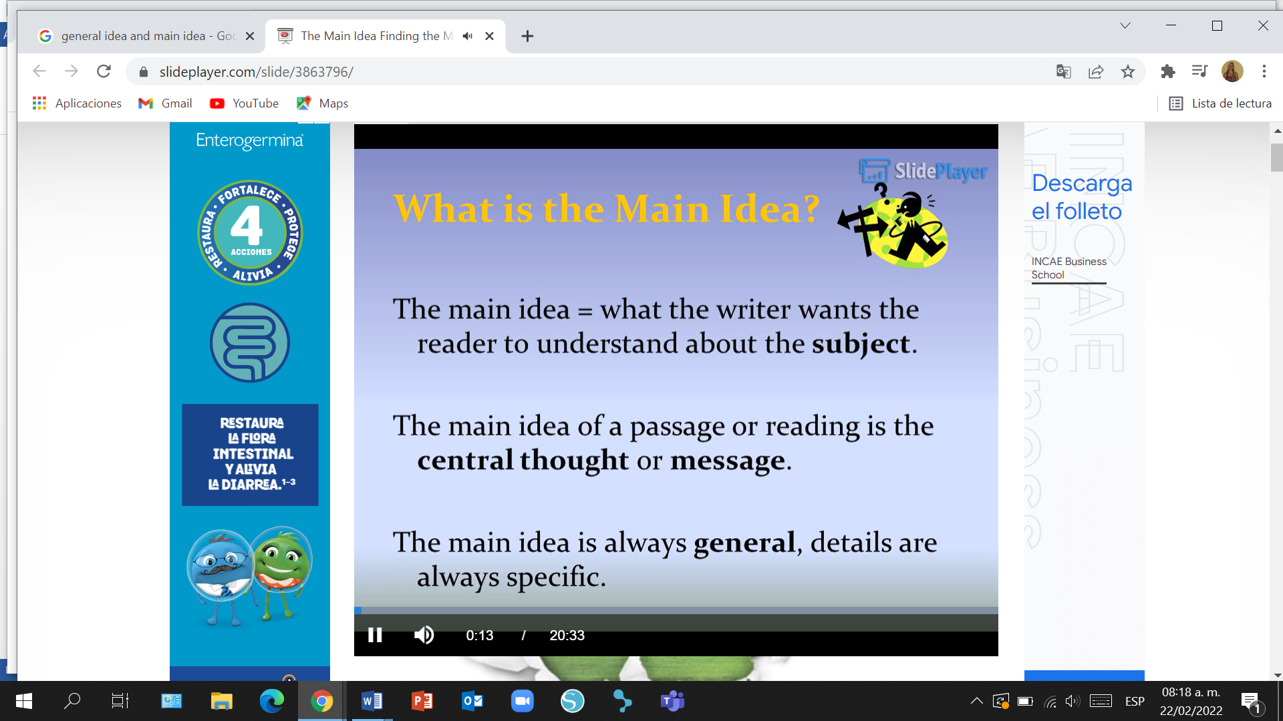

**Annex 4**

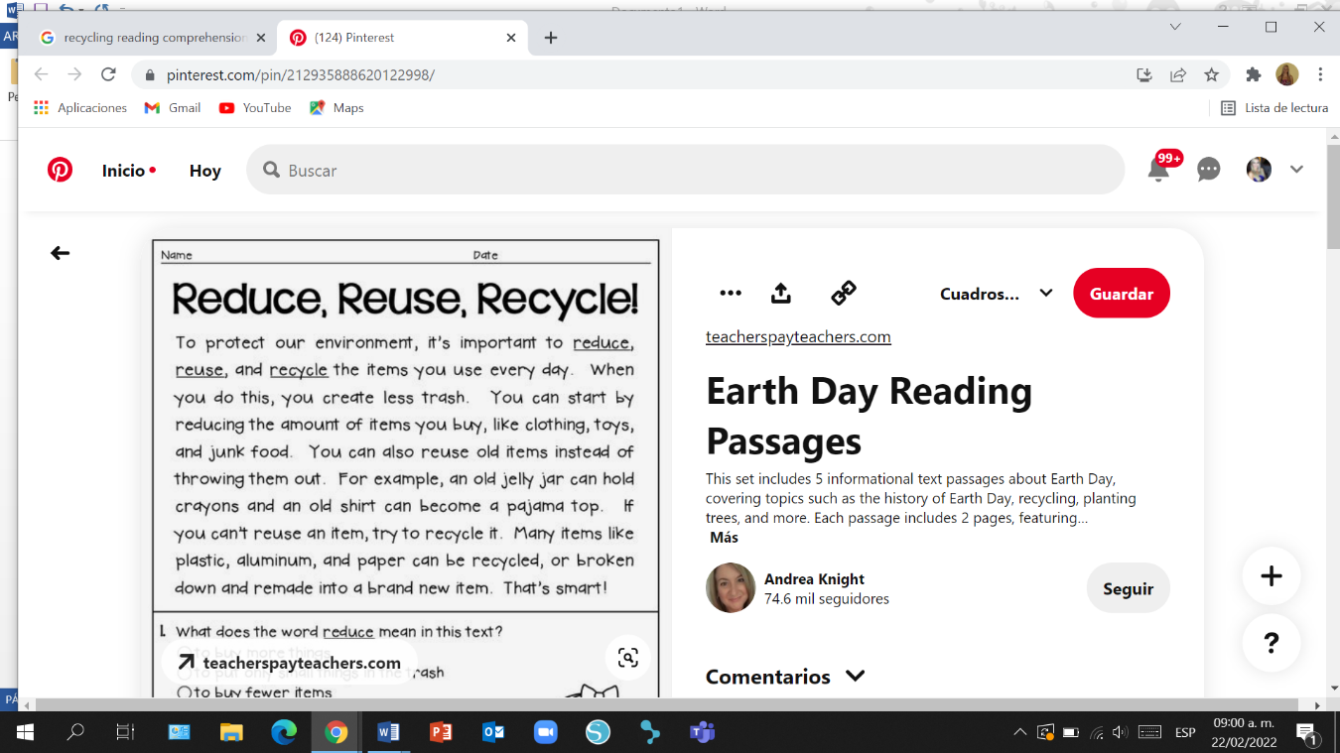

**Annex 5**

**Annex 6**

|  |  |
| --- | --- |
|  | **Talking about Trash** |
| Noah: | Oh Zoe! Look at this place. Trash is everywhere! |
| Zoe: | People have always had trash. Today trash is a big problem. More people mean more trash and more different kinds of trash. |
| Noah: | Yeah, I know! |
| Zoe: | Every year each one of us throws away almost one ton of trash. |
| Noah: | Wow! What are we going to do with this large amount of trash? |
| Zoe: | We can burn it. |
| Noah: | But burning trash can cause toxic gases and pollution. |
| Zoe: | Well… we can dump it in the ocean or rivers. |
| Noah: | But dumping can pollute water too. |
| Zoe: | We can bury it. |
| Noah: | But we are running out of empty land near cities. |
| Zoe: | I read a book at the library and it states that some scientists have even suggested shooting it off into empty space. |
| Noah: | Come on Zoe! Don´t be a litter bug. There are better solutions to go green. |
| Zoe: | Tell me, I´m all ears. |
| Noah: | I have some ideas for you. First, we can recycle. Recycling is a way to take trash and turn it into new products.  We can also reduce the amount of materials we consume. Finally, we can reuse materials or they can be used by other people.  9 |
| Zoe: | Thank you, Noah. I feel embarrassed I was a litterbug. Now, I have greener solutions to avoid littering. |
| Noah: | My pleasure. |

Pictures taken from <https://www.clipartmax.com>

**Annex 7**

|  |  |  |  |  |  |  |
| --- | --- | --- | --- | --- | --- | --- |
|  |  |  |  |  |  |  |
| Dumping trash in rivers and oceans. | Giving materials to be used by other people. | Burning trash causes toxic gases. | Burying trash in empty land. | Turning trash into new products. | Limiting the quantity of things we consume. | A person who litters public places with trash. |

|  |  |  |  |  |  |  |
| --- | --- | --- | --- | --- | --- | --- |
|  |  |  |  |  |  |  |
| Dumping trash in rivers and oceans. | Giving materials to be used by other people. | Burning trash causes toxic gases. | Burying trash in empty land. | Turning trash into new products. | Limiting the quantity of things we consume. | A person who litters public places with trash. |

|  |  |  |  |  |  |  |
| --- | --- | --- | --- | --- | --- | --- |
|  |  |  |  |  |  |  |
| Dumping trash in rivers and oceans. | Giving materials to be used by other people. | Burning trash causes toxic gases. | Burying trash in empty land. | Turning trash into new products. | Limiting the quantity of things we consume. | A person who litters public places with trash. |

|  |  |  |  |  |  |  |
| --- | --- | --- | --- | --- | --- | --- |
|  |  |  |  |  |  |  |
| Dumping trash in rivers and oceans. | Giving materials to be used by other people. | Burning trash causes toxic gases. | Burying trash in empty land. | Turning trash into new products. | Limiting the quantity of things we consume. | A person who litters public places with trash. |

|  |  |  |  |  |  |  |
| --- | --- | --- | --- | --- | --- | --- |
|  |  |  |  |  |  |  |
| Dumping trash in rivers and oceans. | Giving materials to be used by other people. | Burning trash causes toxic gases. | Burying trash in empty land. | Turning trash into new products. | Limiting the quantity of things we consume. | A person who litters public places with trash. |

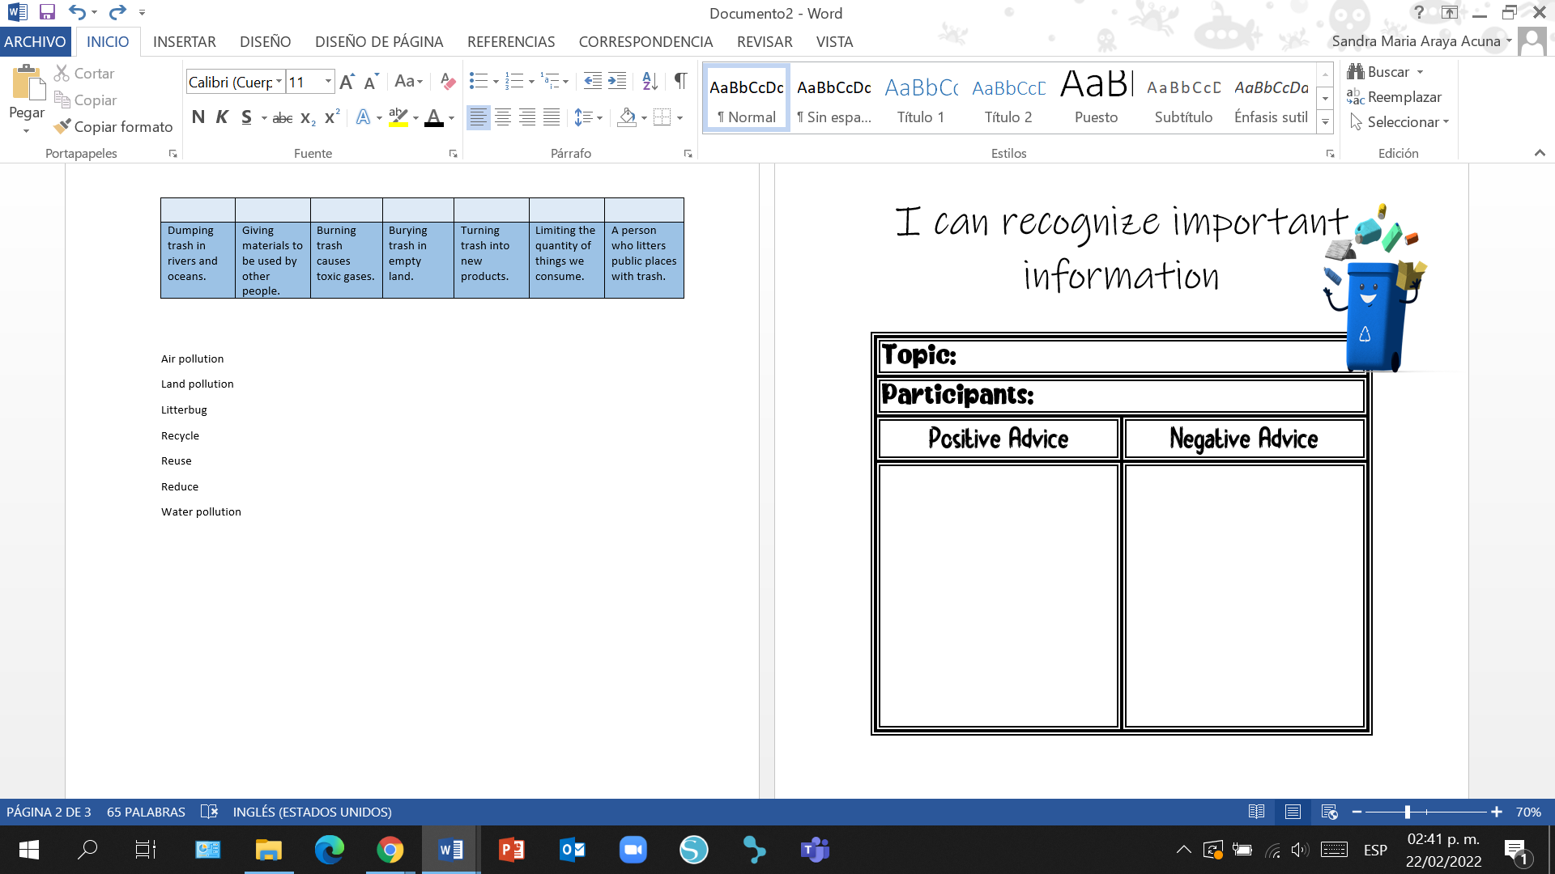

**Annex 8**



**Annex 9**

|  |  |  |
| --- | --- | --- |
| **Statements** | **True** | **False** |
| Today trash is a big problem. |  |  |
| Dumping trash in the ocean or rivers cause toxic gases. |  |  |
| Each one of us throws away almost one kilogram of trash per year. |  |  |
| One solution is to reduce the amount of materials we consume. |  |  |
| Burning trash is a great solution to deal with littering. |  |  |

|  |  |  |
| --- | --- | --- |
| **Statements** | **True** | **False** |
| Today trash is a big problem. |  |  |
| Dumping trash in the ocean or rivers cause toxic gases. |  |  |
| Each one of us throws away almost one kilogram of trash per year. |  |  |
| One solution is to reduce the amount of materials we consume. |  |  |
| Burning trash is a great solution to deal with littering. |  |  |

|  |  |  |
| --- | --- | --- |
| **Statements** | **True** | **False** |
| Today trash is a big problem. |  |  |
| Dumping trash in the ocean or rivers cause toxic gases. |  |  |
| Each one of us throws away almost one kilogram of trash per year. |  |  |
| One solution is to reduce the amount of materials we consume. |  |  |
| Burning trash is a great solution to deal with littering. |  |  |

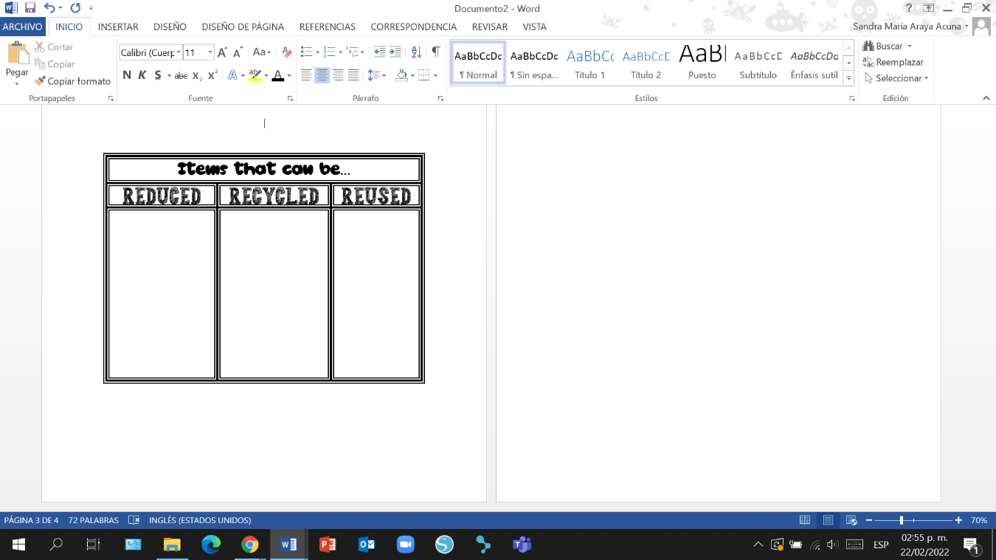

**Annex 10**



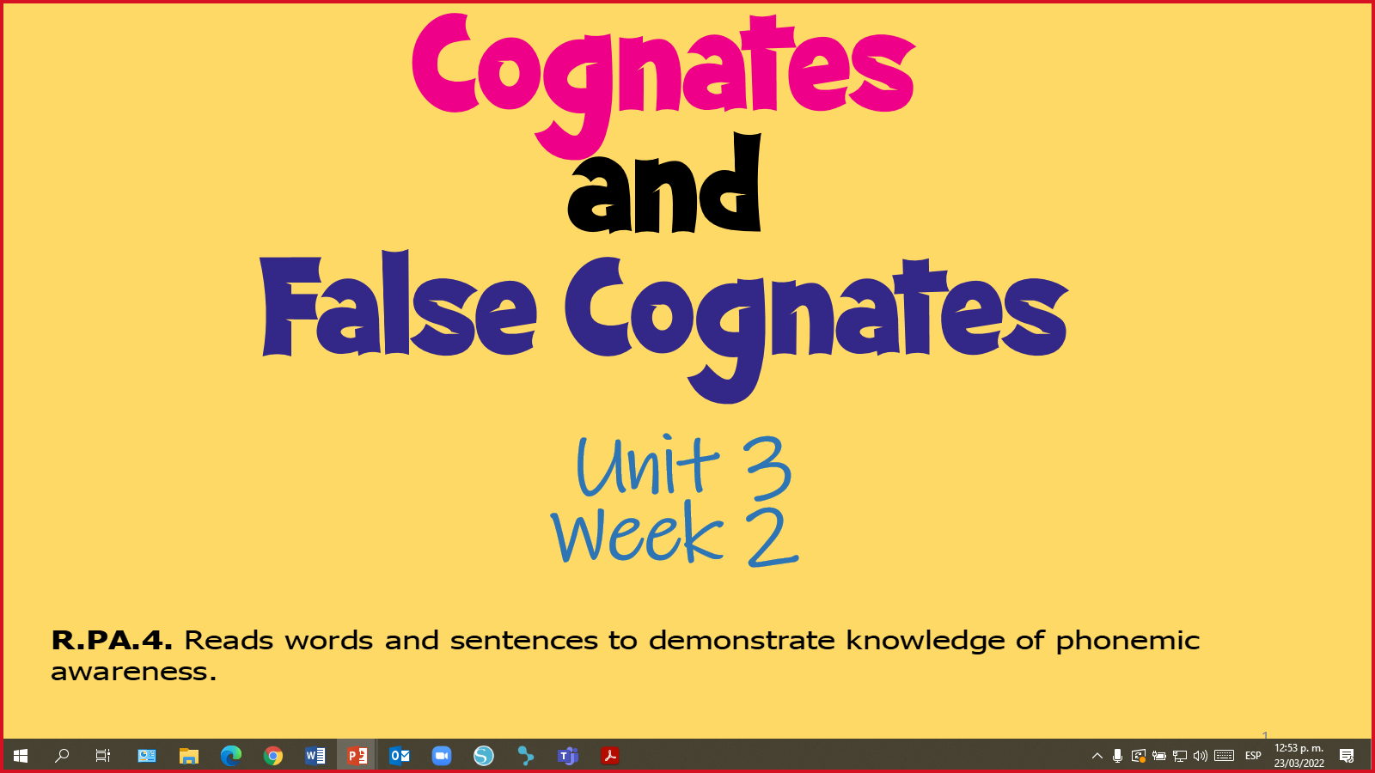

**Annex 11**

PowerPoint Presentation

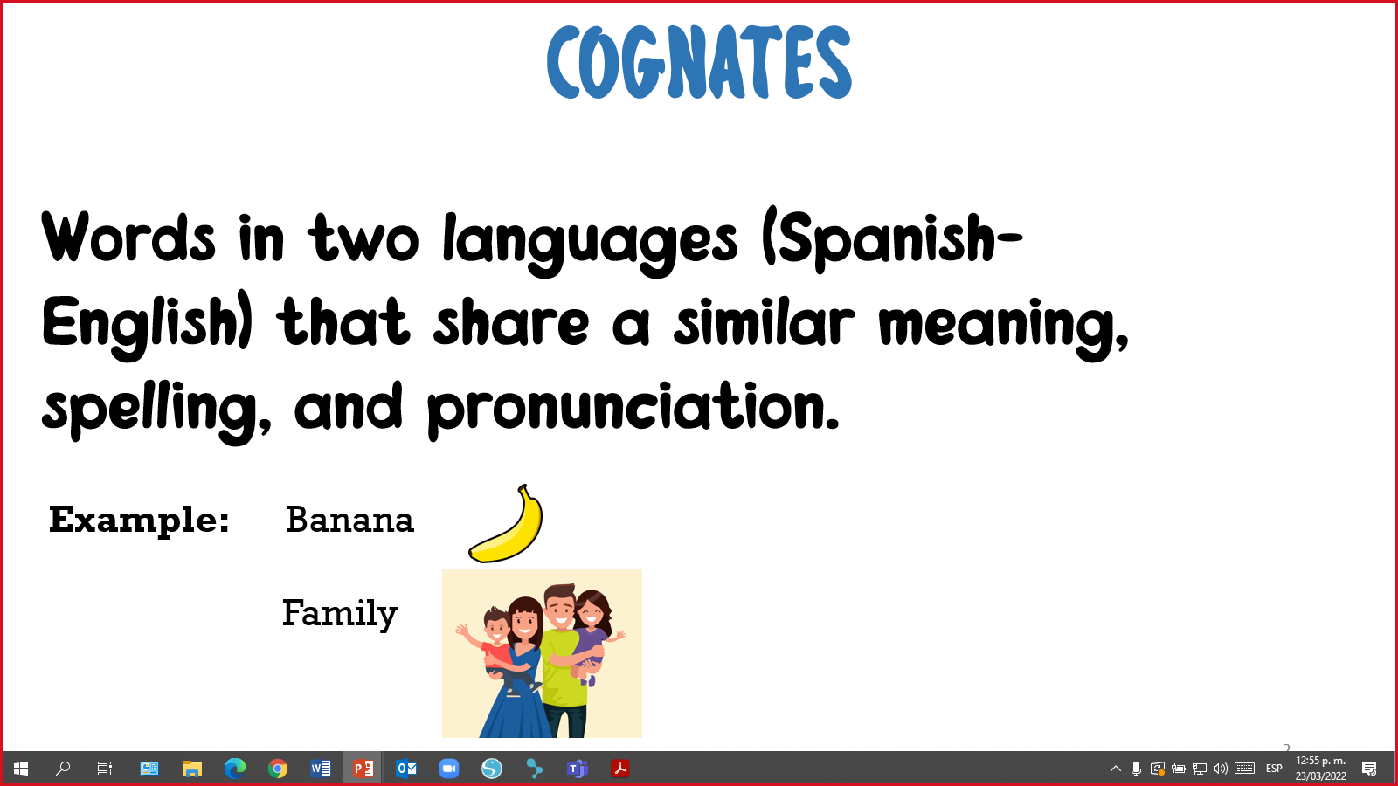

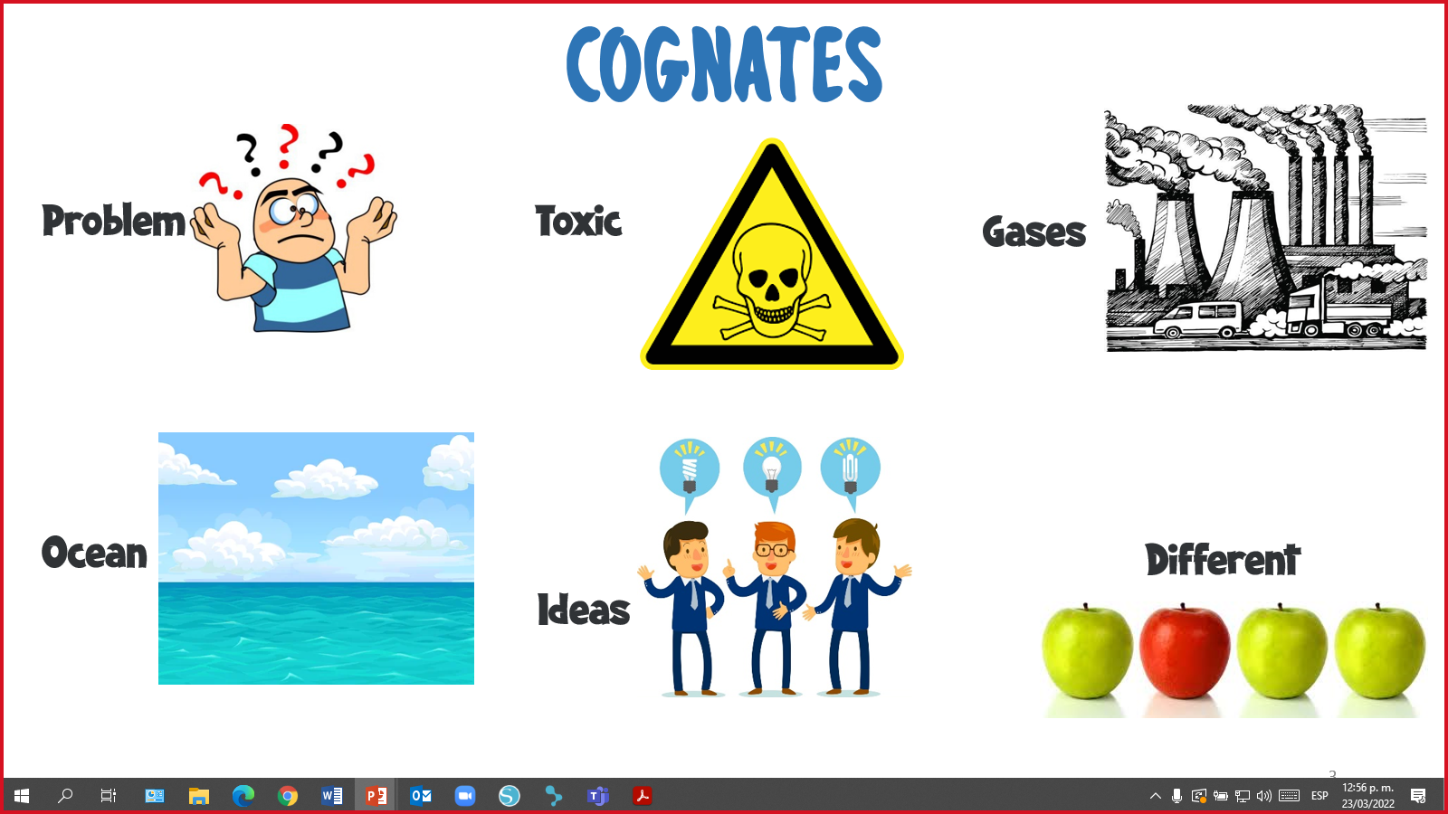

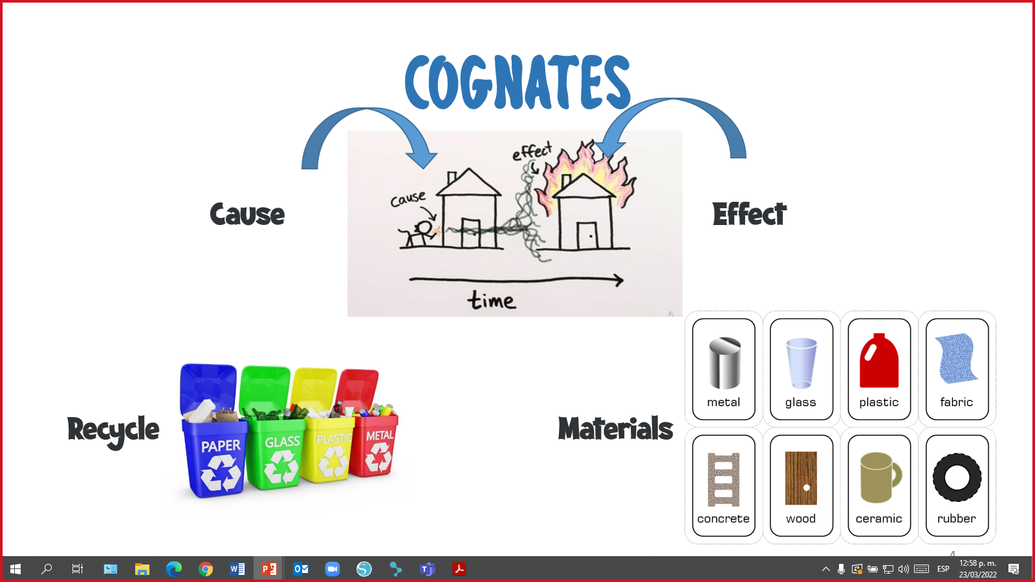

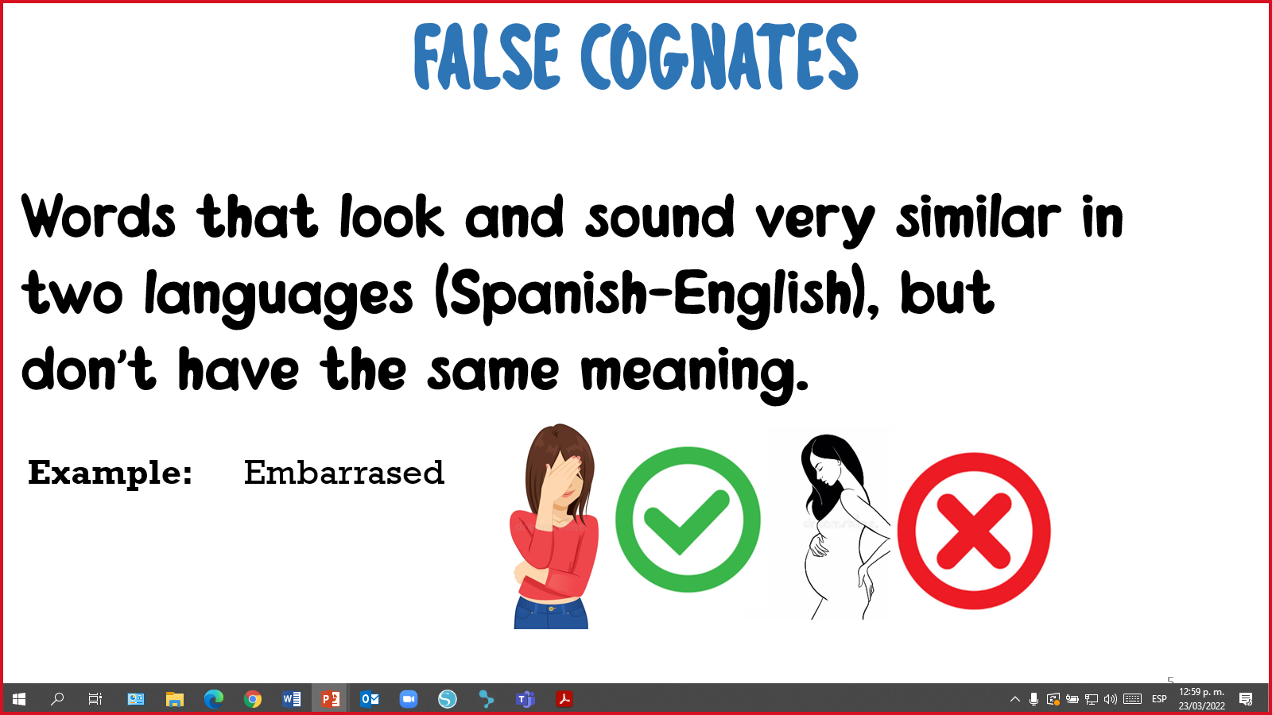

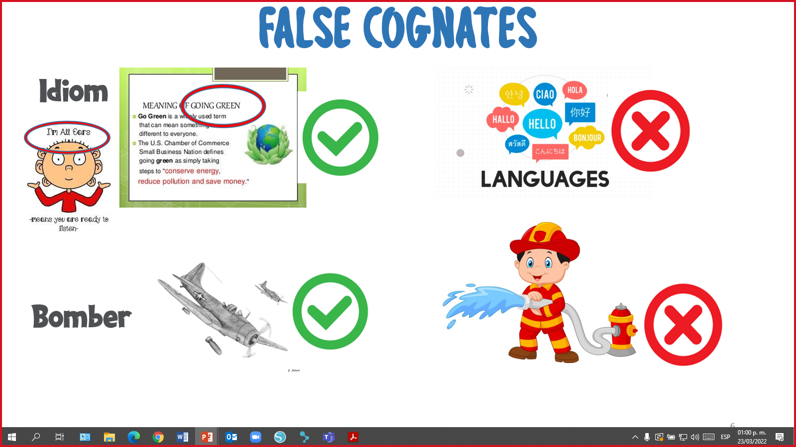

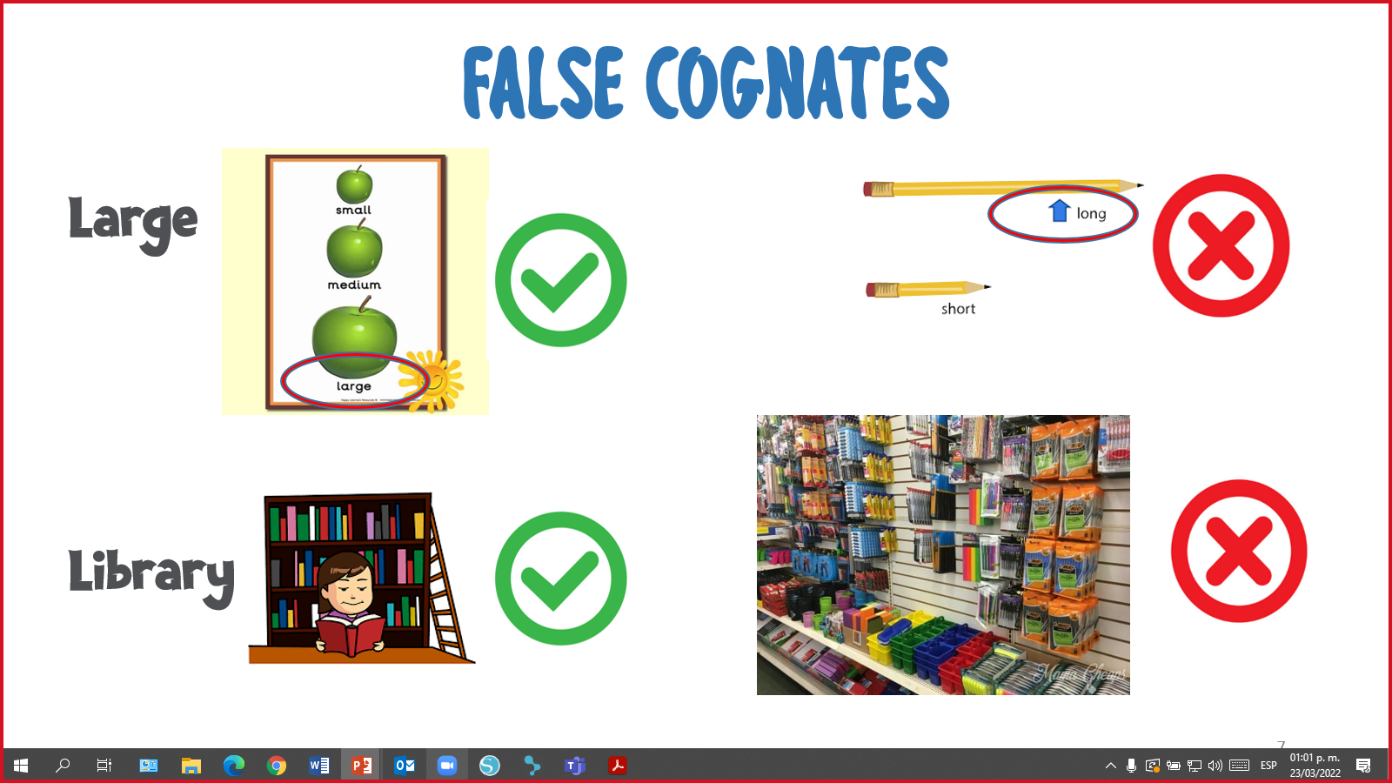

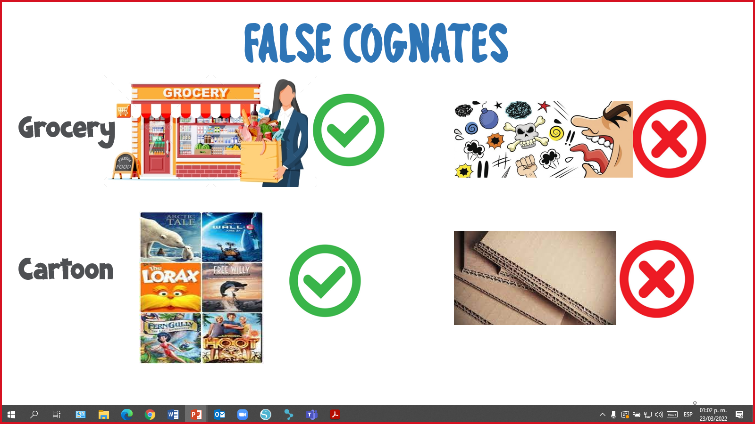

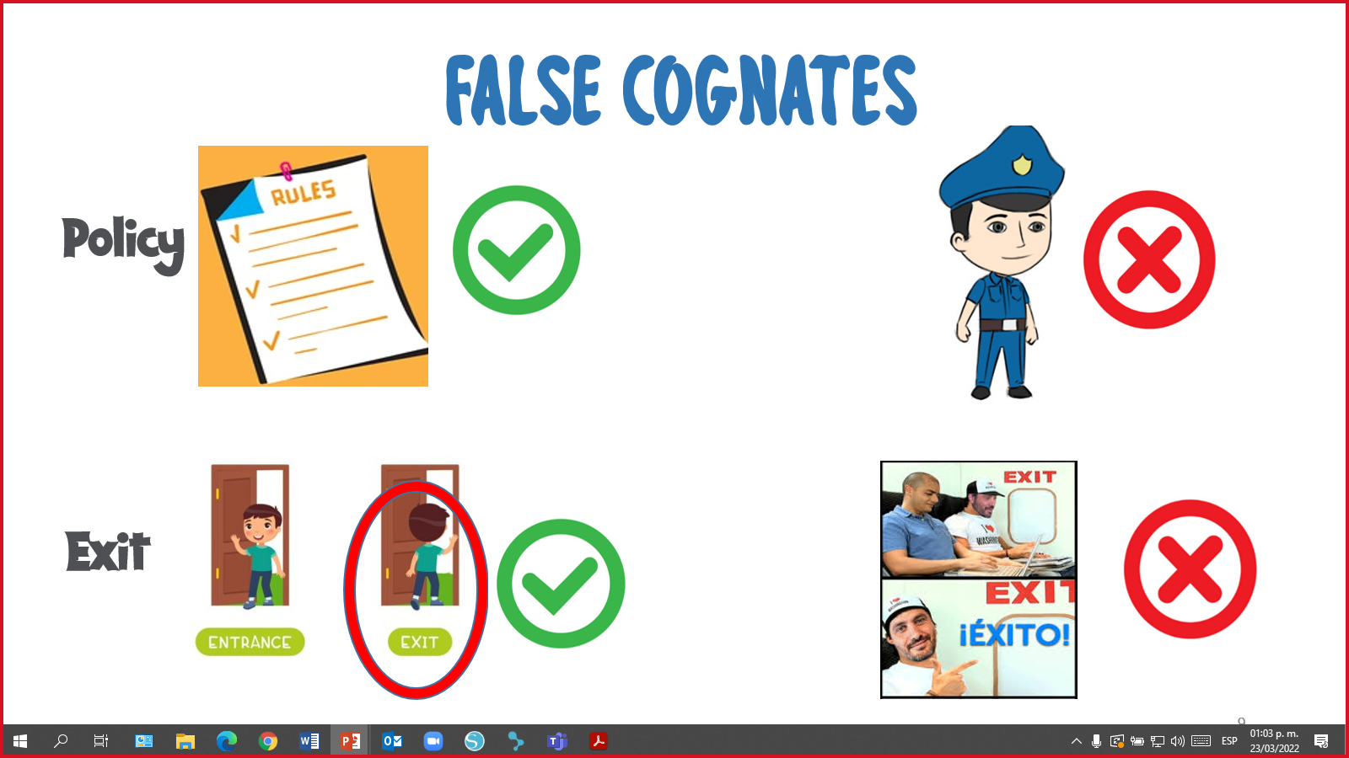

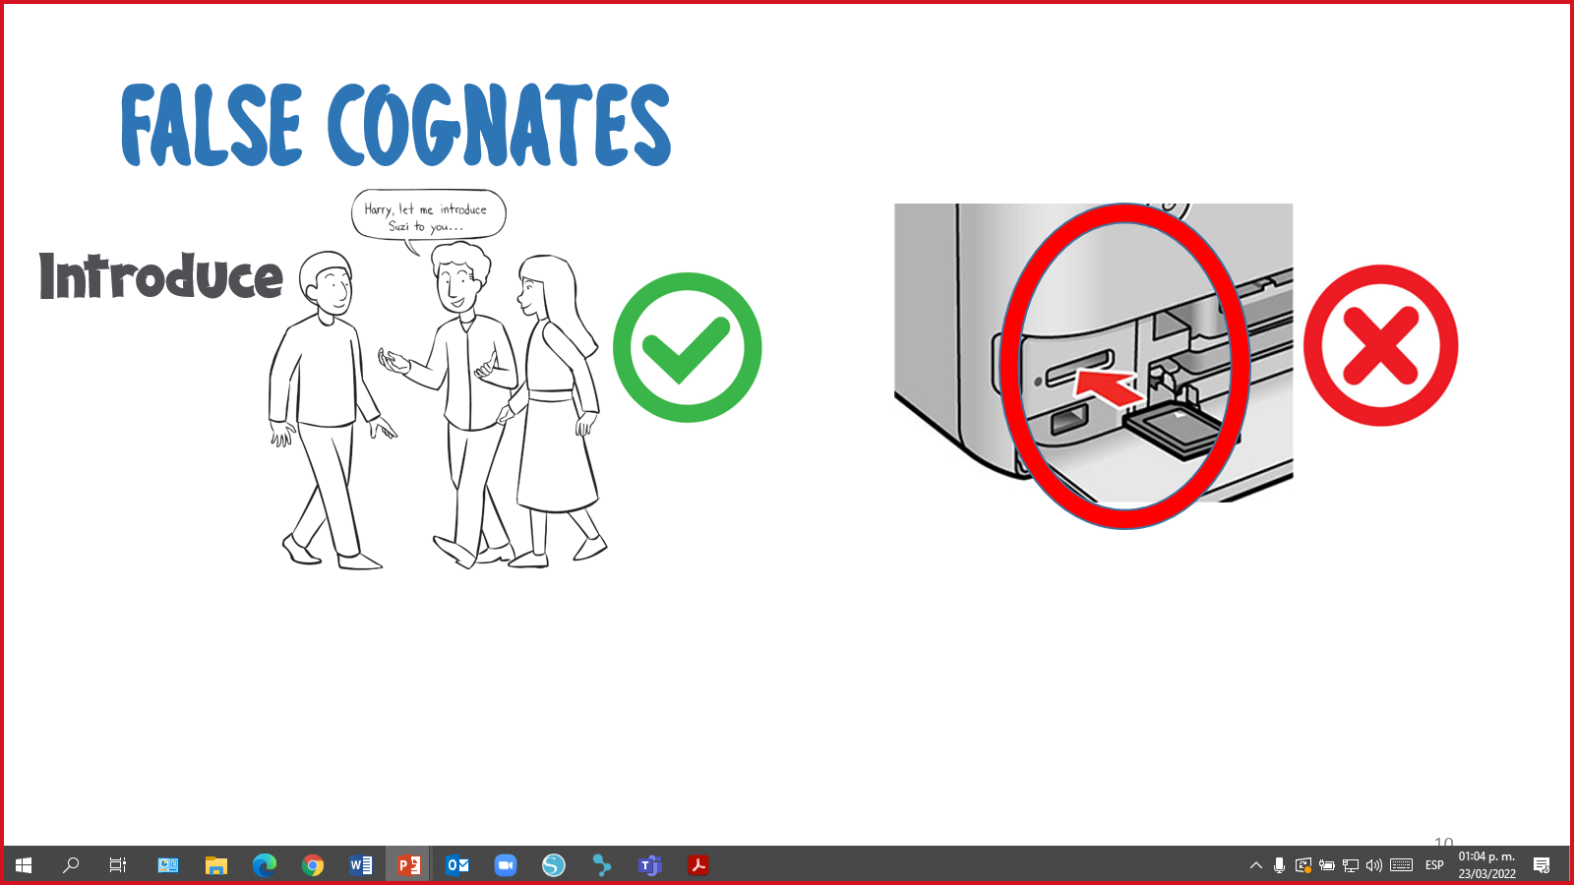

**Instructions.** Column A contains definitions of cognates and false cognates and Column B contains sentences with underlined cognates and false cognates in context. Read sentences in Column B and match their definitions in Column A.

**Annex 12**

|  |  |  |
| --- | --- | --- |
| **Column A** |  | **Column B** |
| Feel ashamed. | ( ) | 1. Littering is a serious **problem.** |
| The opposite of ***SAME.*** | ( ) | 1. A **large** amount of trash affects the environment. |
| A situation, question or thing that causes difficulty, stress or doubt. | ( ) | 1. *“Go green”* is an **idiom** that means to take care of the environment. |
| A word or phrase which means something different from its literal meaning. | ( ) | 1. I feel **embarrassed** because I don´t recycle. |
| A synonym of ***BIG***. | ( ) | 1. **Different** kinds of materials can be recycled. |

**Annex 13**

RUN AND TOUCH ACTIVITY



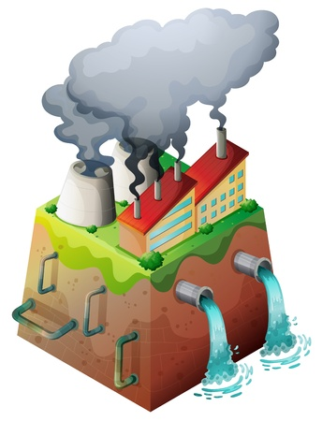



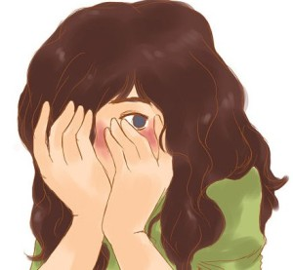

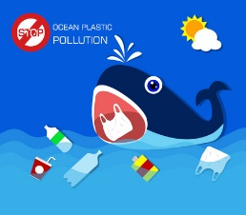

**Annex 14**

|  |  |  |  |
| --- | --- | --- | --- |
| Outline | | | |
| Introduction: |  | | |
| How you feel… | | How it affects the environment… | How she/he can help… |
| Conclusion: |  | | |

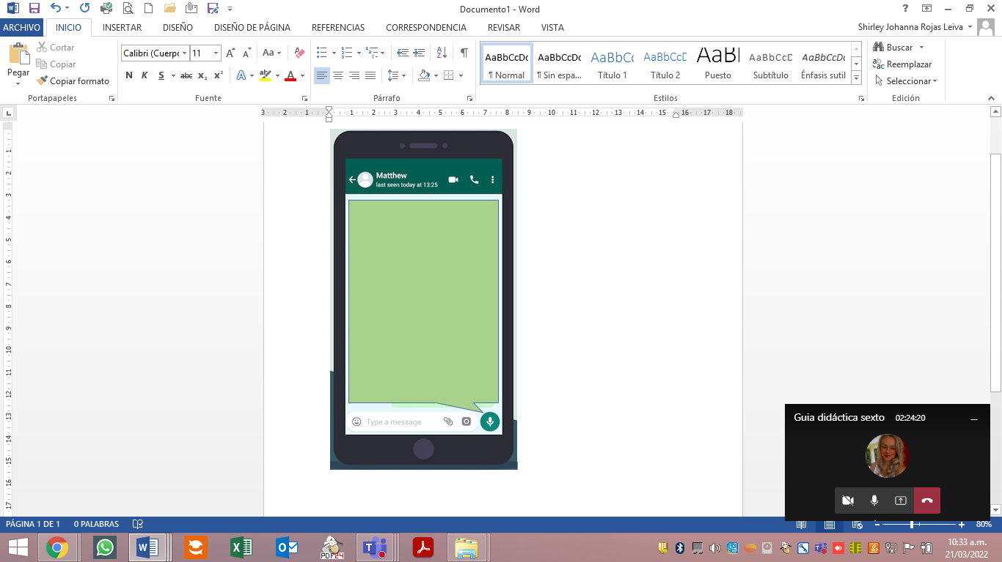

|  |  |  |  |  |  |  |  |  |  |
| --- | --- | --- | --- | --- | --- | --- | --- | --- | --- |
| **Term:** I | | **Level:** Fifth Grade | | | **Unit:** 3 | | | **Week:** 3 | |
| **Domain:** Socio-interpersonal | | | | **Scenario:** Environmentally Speaking | | **Theme:** Where Does Litter Go? | | | |
| **Enduring Understanding**: Litter harms our school, community, Costa Rica and the world. The actions we take now to help with litter will help our neighbors today and in the future. | | | | | | | | | |
| **Essential Question:** Why should we be concerned about litter? | | | | | | | | | |
| |  | | --- | | **Dimensions** | | **1.** **Ways of thinking ( X  )** | | **2. Ways of living in the world  ( X )** | | **3. Ways of relating with others  ( X )** | | **4. Tools for integrating with the world  ( )** | | | | | | | | | | |
| **Learn to Know** | | | | **Learn to Do** | | **Learn to Be and Live in Community** | | | |
| **Grammar & Sentence Frames**  **Explaining cause and effect using because and since**   * Recycle bins are important because they help us separate garbage. * Litter is dangerous because it pollutes rivers.   The park is dirty since people throw garbage on the ground.  **Phonemic Awareness**   * Creation of new words when a specific grapheme is changed, added, or removed in the initial, medial, or final position (e.g., face to place to space)   **Vocabulary**  **Where does litter go?**  **Nouns**   * Rivers * Containers * Sewers * Streets * Lot * Ocean   **Verb forms** (present and future tense)   * Damage * Destroy * Travel * Go * Throw   **Adjectives**   * Dangerous * Harmful   **Opinion:**  I think…  I believe…  In my opinion… | | | | **Function**  Describing cause and effect relationships.  **Discourse Markers**  **Linkers:** Sequential - past tense**.** First, then, after that, finally | | **Psycho-social**  Showing intrinsic/extrinsic motivations for social responsibility focused on the community.  **Socio-cultural**   * Avoiding impoliteness when expressing contempt or dislike related littering   **Idioms/ Phrases**  **Expressions**   * **Go Green:** To do things in a way that protects the natural environment.   **Give a hoot, don´t pollute!:** To care about the environment. | | | |
| **Assessment Strategies & Evidences of learning**  (Diagnostic, formative, summative) | **Goals** | | | **Pedagogical Mediation/ Didactic Sequence** | | | | | **Time** |
| Learner… | Learner can… | | | **Pre-Teaching**  **Routine:**  Greet, check attendance. Teacher reads the Essential Question that is on the wall and shares class agenda: Why should we be concerned about litter? Teacher tells students that the actions we take now to help with litter will help our neighbors today and in the future.    **Warm up**  Students are shown an aluminum can brought by the teacher. The teacher introduces the can to students (the name of the can is Al) and asks them to watch a video to know what the class will be about.  ES UNA IMAGEN DE UNA LATA LLAMADA ALIn the following link, teacher will find the video about littering. <https://www.pbslearningmedia.org/resource/ee18-sci-waterpol/kids-go-green-litter-and-our-oceans/>  Students are asked the following questions orally:   * Who was Al? * What happened to Al? * Where was Al at the beginning of the video? * Where was Al at the end?   **Activation of Prior Knowledge**  Students are divided into two groups; they are shown a PPT (annex 1) with the places where Al (the aluminum can) passed by. In the following link, teacher can find the PPT <https://recursos.mep.go.cr/sitio_primaria_ingles/sexto.html>  Each group has to note down as many words as possible seen in the PPT, in their notebooks.  Students read aloud words they wrote. The group with more words is the winner.  Once the students finish presenting, they are asked the following questions:   * Have you seen a person littering? * Have you seen a clean beach or river? * Have you seen a dirty beach or river? * Do you like clean parks? * Is your community clean?   Es una imagen que muestra la presentación  en powerpoint que se usará en la etapa de "activation of prior knowledge".  Once they finish, teacher shares the goals for the week.  **Modeling**  Students listen to the teacher´s presentation of the vocabulary, grammar and expressions. Teacher writes on the board the tittle: **Where does litter go?** Then, teacher tapes flashcards (annex 2) of the sequence of litter until it reaches the ocean. The process is explained using the sequential adverbs. The cause- effect process is also explained through examples.  Es una imagen que muestra a dónde va la basura  **Clarifying**  Students are given a summary with vocabulary and pictures (annex 2 and 3) about the presentation done by the teacher. They read along with the teacher, and glue the sheets in their notebooks. They complete the sentences with the vocabulary given. Teacher and students read the answers and check them together.  ES UN RESUMEN DE VOCABULARIO DE LA ETAPA DE CLARYFING | | | | | 5´  5´  15´  10´  5´ |
| R.1. uses knowledge of first language to aid in understanding the second language.  **Indicators of learning**  R.1.1. identifies text features such as titles, headings or illustrations that provide information to make predictions related to what the text may be about.  R.1.2. gets the gist of a text.  R.1.3. identifies specific information in the text. | **R.1.** use knowledge of first language to aid in understanding the second language. | | | **Pre-Task**  Teacher shares R.1 indicators. Students are given a worksheet (annex 5) with an example of a newspaper article; they take a look at the different features of it. Then, they have to write the title, heading and infer what the illustration is about. Teacher and students read the answers and check them together.  ES UNA IMAGEN DE UNA PRÁCTICA DEL PRE-TASK ACTIVITY  **Task-Rehearsal**  Students are given a magazine article about litterbugs (annex 6). They have to identify the text features by:   * circling the heading with color red * underlining the tittle with color green * circling the illustrations with color blue   Teacher and students read the answers and check them together. Then, they are asked the question:  ***What do you think the article will be about?***  Students brainstorm ideas.  ES UNA IMAGEN DE LA ETAPA DEL TASK-REHERSAL  **Task-Completion**  Students read the magazine article from the previous task, they read individually for the first time and answer question number one to get gist of the reading. Teacher reminds students the steps studied the last week in order to get the gist of a text.  Students along with the teacher read the article for the second time. Then, they answer specific questions about it (annex 7). Orally, answers are checked as a whole.  ES UN AIMAGEND E UNA PRSACTICA DEL TASK-COMPLETION  **Task-Assessment**  Students are given a worksheet (annex 8). They have to do the following:  First task:   1. Cut and glue parts of an article. 2. Label the text features (title, heading and illustration).   Second task:   1. Cut out the route litter takes until it reaches the ocean. 2. Write the correct information based on the picture.   ES UNA IMAGEN QUE MUESTRA LA PRÁCTICA DEL TASK-ASSESSMENT  Students are given an instrument to assess their process.  **Student Self-assessment Grid**   |  |  |  |  | | --- | --- | --- | --- | | Indicators | Level of achievement | | | | I can ... | Not achieved yet | In progress | Achieved | | identify text features such as titles, headings or illustrations that provide information to make predictions related to what the text may be about |  |  |  | | get the gist of a text |  |  |  | | get specific information in a text |  |  |  | | | | | | 5´  5´  10´  15´  5´ |
| **SP.1.** describes using simple words, their opinion of a situation or event.  **Indicators of learning**  **SP.1.1.** brainstorms words, phrases or sentences to express his/her opinion of a situation or event.  **SP.1.2.** organizes ideas in sentences to express his/her opinion of a situation or event.  **SP.1.3.** describes using simple words, his/her opinion of a situation or event. | **SP.1.** describe, using simple words, their opinion of a situation or event (e.g. too much trash, ugly litter, dumping garbage). | | | **Pre-Task**  Teacher shares SP.1 indicators. The sentence **I DON’T LIKE BACHATA MUSIC** is written on the board. Teacher starts asking some students… Do you like bachata music? Students´ answers are written on the board (no, yes, so so, etc.) Teacher tells them that we all have different opinions about the type of music we like. She/he tells them that knowing how to express opinion in English is valuable whether they are speaking or writing. Teacher states that in today’s class they will look at phrases they can use to share their point of view.  Students brainstorm words, phrases or sentences they know that are used to express opinions. Teacher takes notes on the board.  Many phrases are suitable in everyday speech and some types of writing, such as on WhatsApp messages, blogs and social media.  **Some of the phrases are:**   * I think… * I believe… * In my opinion…   Students are presented with some phrases in context to express opinion. The teacher writes the phrases on the board. Students take notes of the sentences written on the board. They read them together.  ***Expressing Opinion***   * In my opinion…the ocean will have more trash than fish in the future. * I think…animals are in danger. * In my opinion…there is too much trash. * I believe…the river is dirty and ugly. * I think… littering is a serious problem. * Teacher writes on the board the following task:   **You are an environmental activist that was invited to a school. You will make a presentation for students about the serious problem of littering.**  **Include in your presentation:**   * What is littering? * Where does litter go? * What will happen in the future? * Your opinion * Students are invited to use again the following worksheets (annex 3 and 4) and take some useful ideas from this material.   practica de la etapa de pre-task de speaking  Students use the following graphic organizer (annex 9) to include ideas and make sentences for their presentation.  es una imagen de organizador gráfico para incluir ideas  **Task-Rehearsal**  Students are given some time to rehearse individually their presentation. Then, they practice it with another classmate who is asked to give feedback to the presenter. They switch roles. Teacher walks around the class and monitors students´ work. They ask for help if necessary.    **Task-Completion**  Students present in front of the class. Teacher monitors students and provides feedback if necessary.  **Task-Assessment**  Students play hot potato, music plays while students pass an item around, when the music stops the student who has the item, has to give his or her opinion about pieces of news from Costa Rica (in a PPT) (annex 10). In the following link, teacher can find the PPT.  https://recursos.mep.go.cr/sitio_primaria_ingles/sexto.html  Es una imagen que presenta la PPT que se usaraá en el task-assessment  Students are given an instrument to assess their process.  **Student Self-assessment Grid**   |  |  |  |  | | --- | --- | --- | --- | | Indicators | Level of achievement | | | | I can ... | Not achieved yet | In progress | Achieved | | brainstorm words, phrases or sentences to express his/her opinion of a situation or event |  |  |  | | organize ideas in sentences to express his/her opinion of a situation or event |  |  |  | | describe using simple words, his/her opinion of a situation or event |  |  |  | | | | | | 15´  10´  5´  30´  10´ |
| **R.PA.4.** reads words and sentences to demonstrate knowledge of phonemic awareness.  **Indicators of learning:**  **R.PA.4.1.** identifies initial, medial or final graphemes in words.  **R.PA.4.2.** deletes initial, medial or final graphemes to create new words.  **R.PA.4.3.** substitutes initial, medial or final graphemes in words to create new words.  **R.PA.4.4.** adds initial, medial or final graphemes in words to create new words.  **R.PA.4.5.** reads new words and sentences created to demonstrate knowledge of phonemic awareness. | **R.PA. 4.** demonstrate knowledge of phonemic awareness. | | | **Pre-Task**  Teacher shares R.PA.4 indicators. The word CAT is written, taped or projected on the board (annex 9).  es una imagen de la palabra gato  Students are asked to say what is the initial (C), medial (A) and final (T) grapheme of this word.  The teacher explains the following:   * A word can change if a letter is deleted (annex 10). For example: **CAT**becomes AT, if the letter C is deleted.   imagen de la palabra gato ejemplificando word deletion   * A word can change if a letter is substituted by another letter (annex 11). For example: CATbecomes RATif letter C is substituted by the letter R.   imagen de la palabra gato ejemplificando word sustitution   * A word can change if a letter is added to it (annex 12). For example: CAT becomes CHAT, if we add an H to the word.   imagen de la palabra gato ejemplificando word addition  Students are given a sheet (annex 13) with some examples. They read the words along with the teacher.  imagen con ejemplos de palabras para la etapa de pre-task  **Task-Rehearsal**  A list of words are written on the board for students to identify the initial, medial and final word on them. Using the list, they are asked to delete, add or substitute a word to create new ones.  **List of words:**   * The * Arm * Hat * Ham   **Task-Completion**  The students are given a worksheet (annex 14). They have to read some sentences and/or words to identify initial, medial and final letters in words by circling them. In pairs, students check answers. Teacher walks around the class to monitor students’ work.  es una imagen de una práctica para identificar grafemas  A second worksheet (annex 15) is given to students. They have to delete, add or substitute letters to create new words. After they finish, the worksheet is projected or written on the board and students share their new words. Teacher takes notes on the board of all new words created and clarify their meaning and pronunciation. Students choose one word from each practice and make a sentence using the new word in context. Each student chooses one sentence to read aloud. Teacher clarifies pronunciation and/or meaning if necessary. Students along with the teacher participate in choral reading of all words written on the board.  práctica donde el estudiante debe adicionar, quitar o sustituir palabras.  práctica donde el estudiante debe adicionar, quitar o sustituir palabras.  práctica donde el estudiante debe adicionar, quitar o sustituir palabras.  **Task-Assessment**  Students play snowman with the words studied in the previous practices. Previously, teacher watches a video that explains how to play snowman *(the video is not for the students)* In the following link, teacher will find the video. <https://www.youtube.com/watch?v=8dRFwpWuRDs>  Class is split into two groups. A volunteer from each group goes to the front and tries to guess the word. Every time a word is guessed, the student has to create a new word by adding, substituting, or deleting letters, and writes it next to the snowman. Each volunteer is supported by his/her group when giving answers. To finish the game, an extra word is given to each group. Each group has to add, delete and substitute a letter to create a new one from the original word. Additional points are given to the group who finishes first and that has more words correct. Students can use extra help (use of cellphone or dictionary).  **Words and their possible answers are:**  Es una imagen para la  posible creación de palabras  When the game is over, students are given an instrument to assess their process.  **Student Self-assessment Grid**   |  |  |  |  | | --- | --- | --- | --- | | Indicators | Level of achievement | | | | I can ... | Not achieved yet | In progress | Achieved | | identify initial, medial or final graphemes in words |  |  |  | | delete initial, medial or final graphemes to create new words |  |  |  | | substitute initial, medial or final graphemes in words to create new words |  |  |  | | add initial, medial or final graphemes in words to create new words |  |  |  | | read new words and sentences created to demonstrate knowledge of phonemic awareness |  |  |  | | | | | | 5´  5´  5´  15´  15´  5´ |
| **Integrated Mini-Project** | | | | | | | | | **Time** |
| Phase: _______  See examples in week #5. | | | | | | | | |  |
| **Reflective Teaching** | | | | | | | | | |
| What worked well | | | What didn’t work well | | | | How to improve | | |
| **Enduring Understanding Reflection** | | | | | | | | | |
|  | | | | | | | | | |

List of links:

<https://www.pbslearningmedia.org/resource/ee18-sci-waterpol/kids-go-green-litter-and-our-oceans/>

[Week 3 Activation of prior knowlwdge.pptx](https://adminmepcr-my.sharepoint.com/:p:/g/personal/sandra_araya_acuna_mep_go_cr/EaveuIhWH1pHhGj5pi2ETBoBjnG4GSHqlZVdkCtfZaVINQ?e=DWT0eK)

[Week 3 Spoken production TA.pptx](https://adminmepcr-my.sharepoint.com/:p:/g/personal/sandra_araya_acuna_mep_go_cr/EcnUvYDtKY5Jir8w30tXDW8B-nuPenktqJRGBK_42oQlpw?e=lfob7P)

<https://www.youtube.com/watch?v=8dRFwpWuRDs>

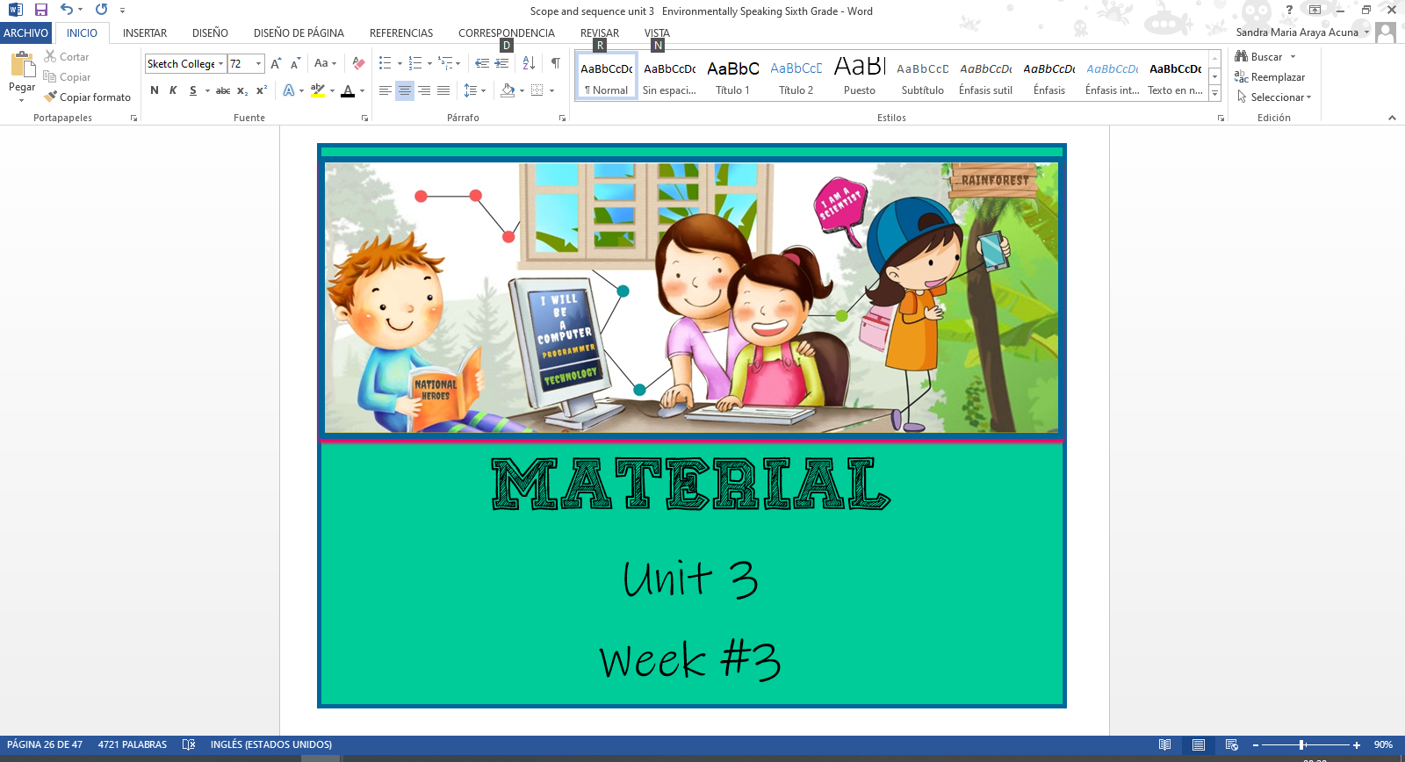

**Annex 1**

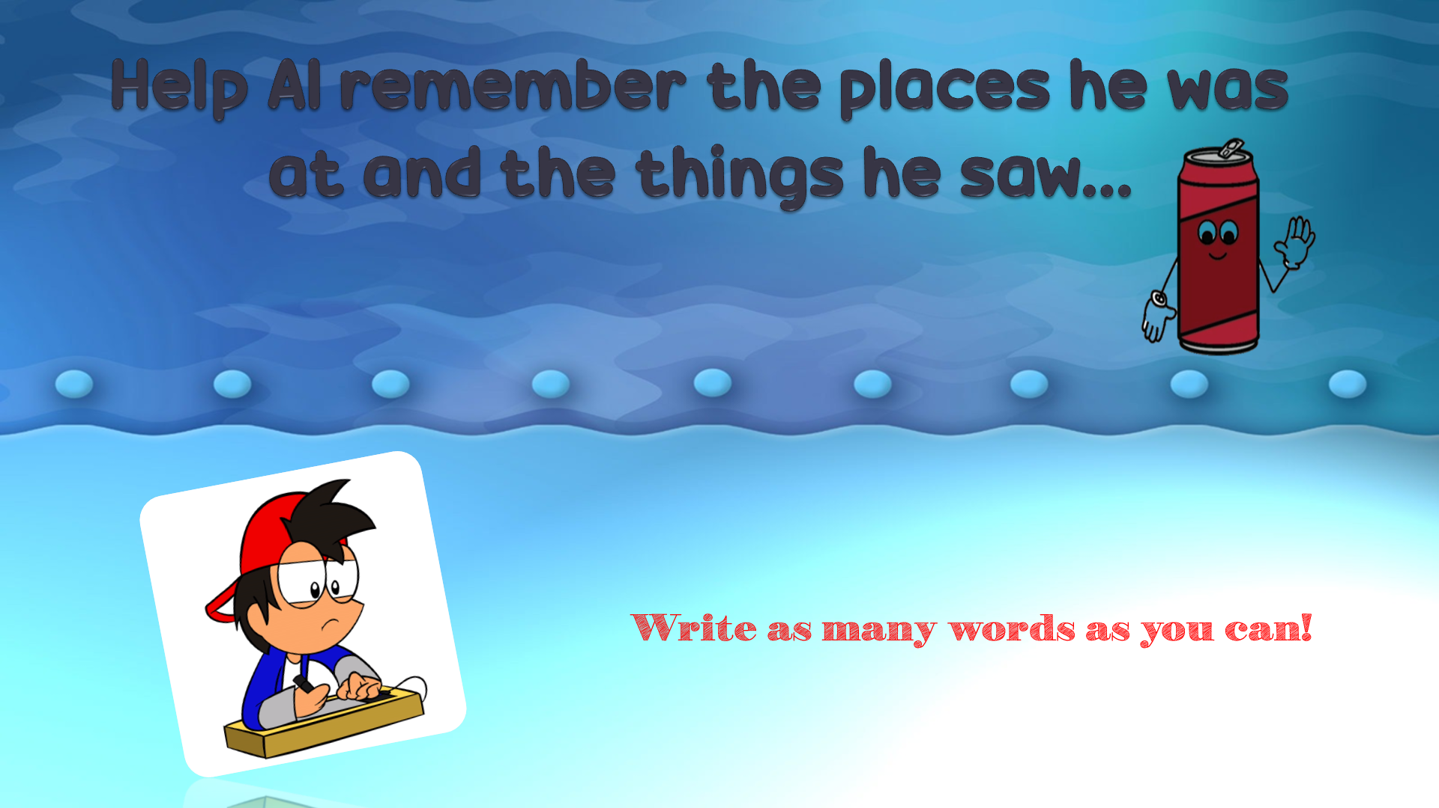

PowerPoint Presentation

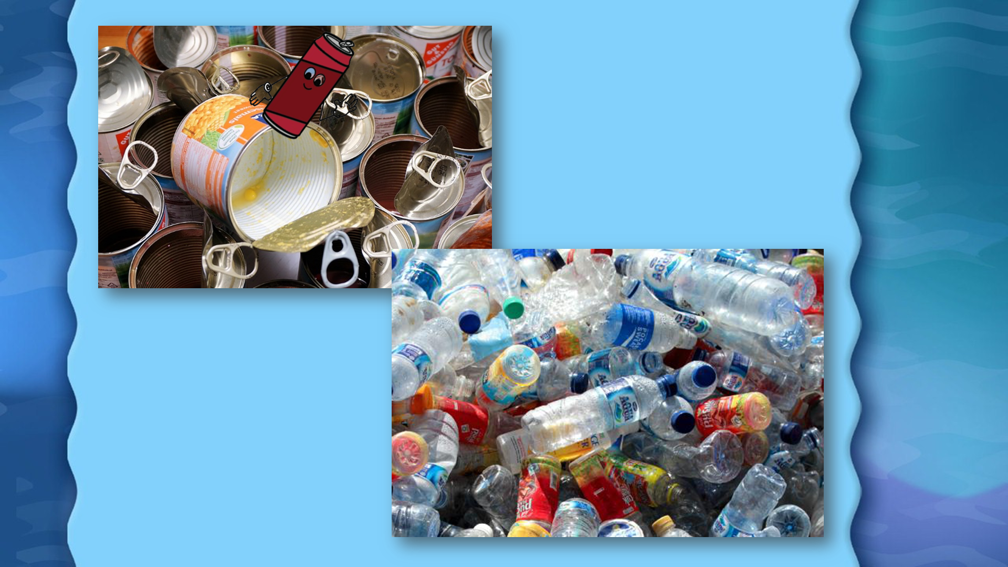

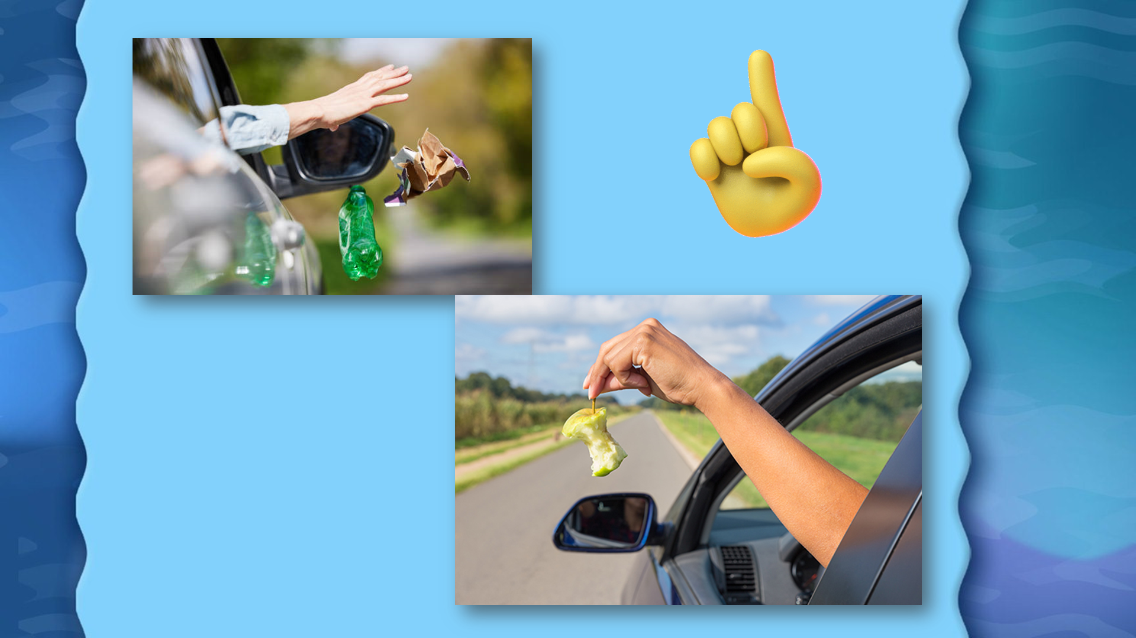

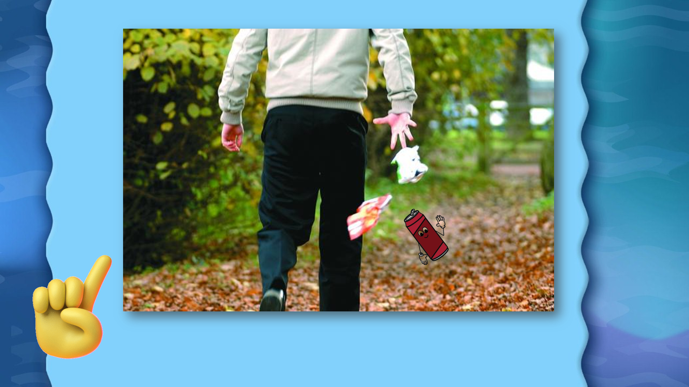

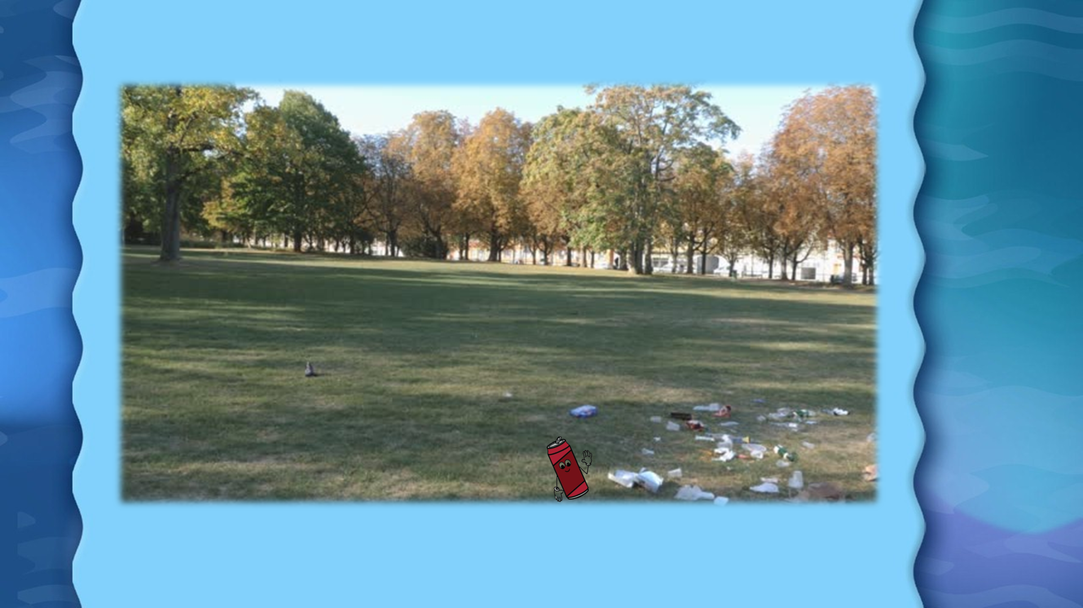

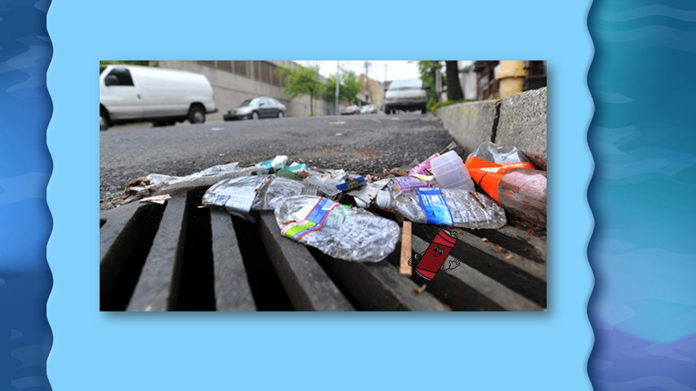

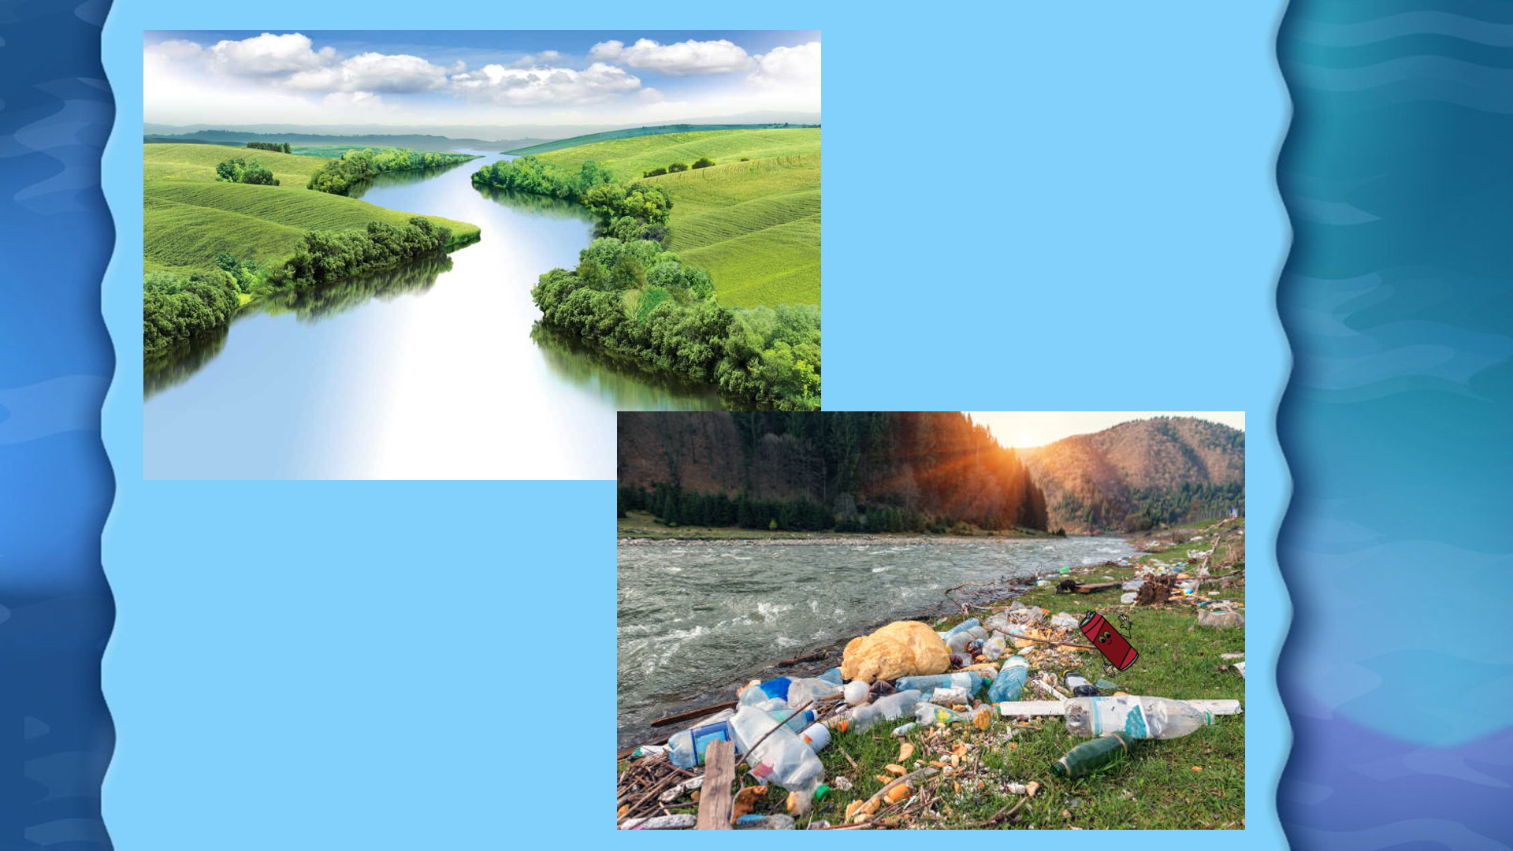

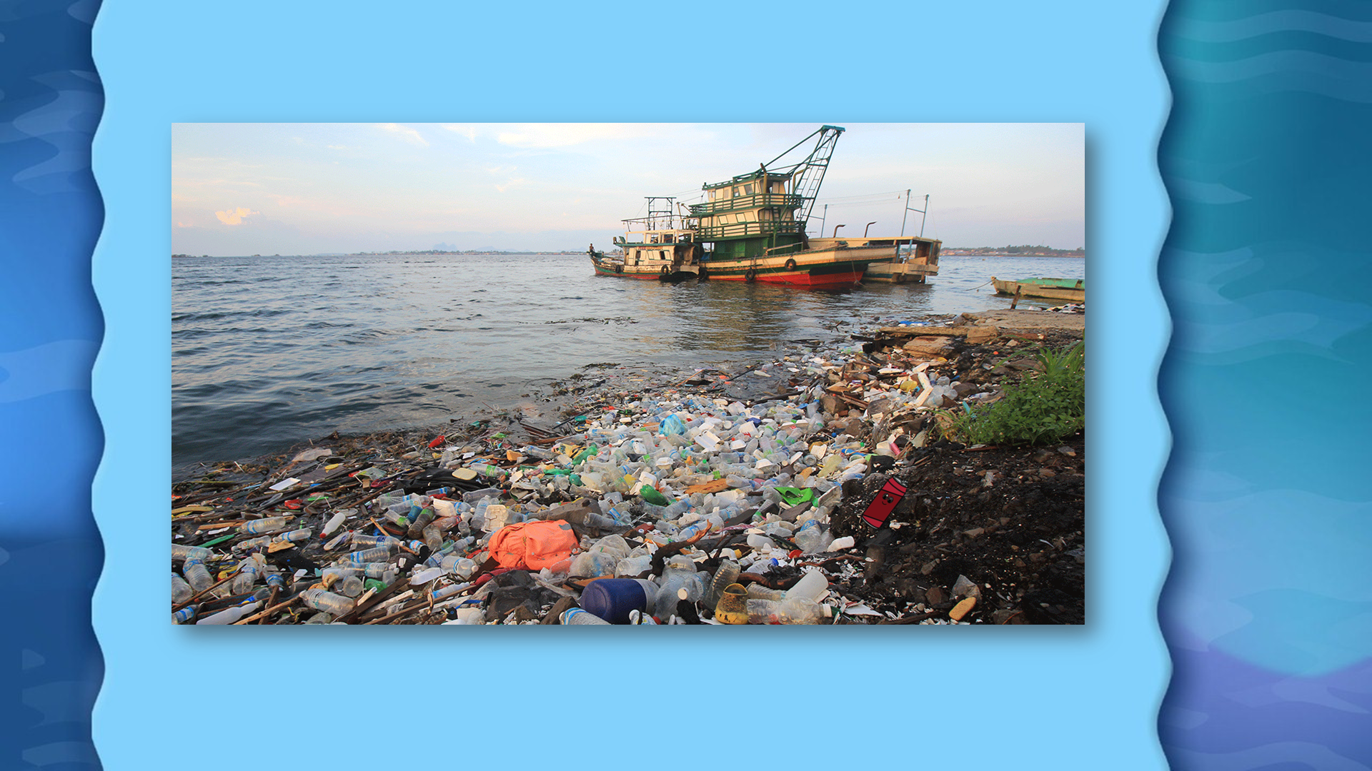

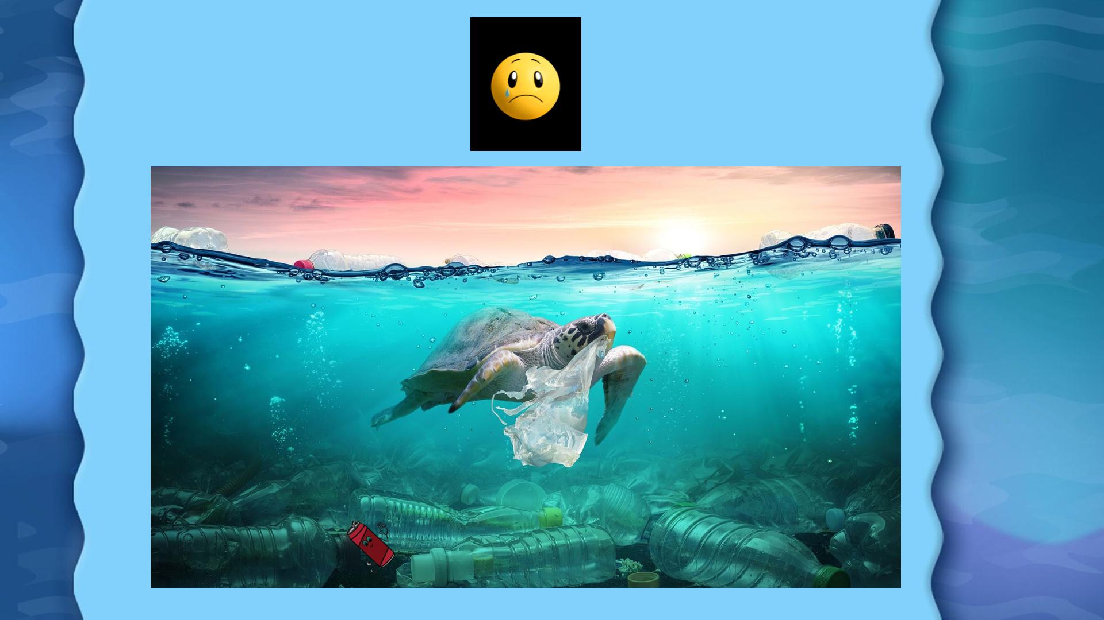

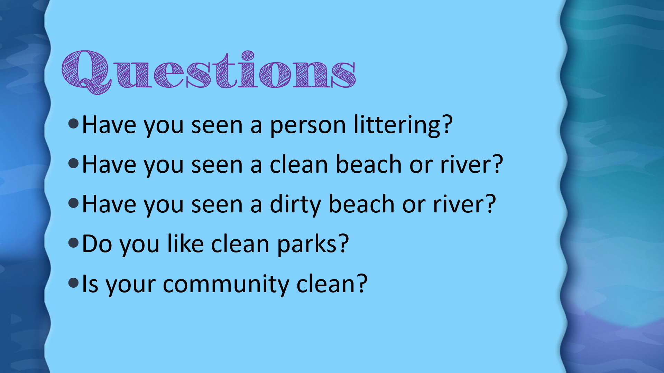

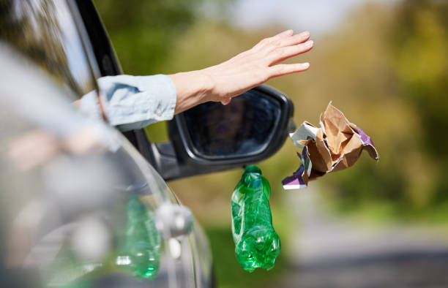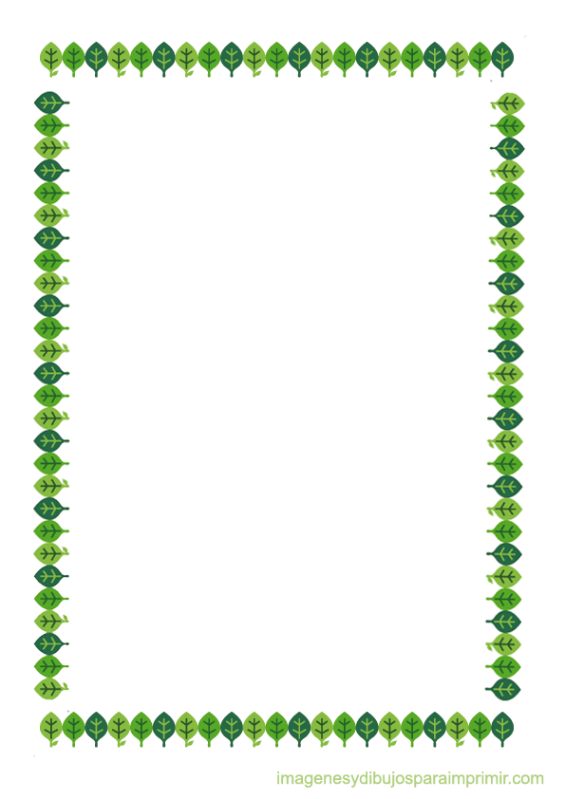

**Annex 2**

1.Litter is all the waste or trash we throw on the ground.



1. Litter is all the waste or trash we throw on the ground.

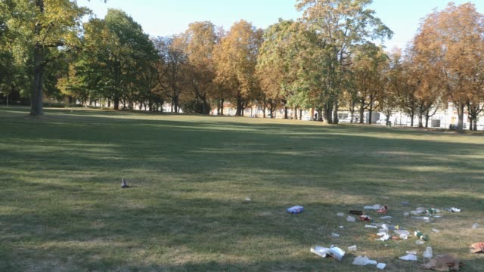

2. The park is dirty, since people throw garbage on the ground.

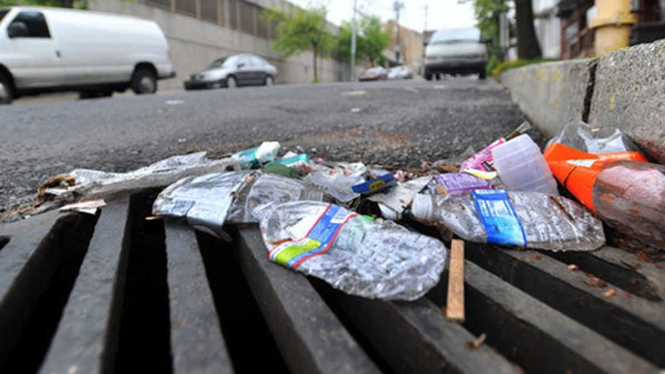

3. There are floods since litter goes into sewers and block them.



4. Litter is dangerous because it pollutes rivers.

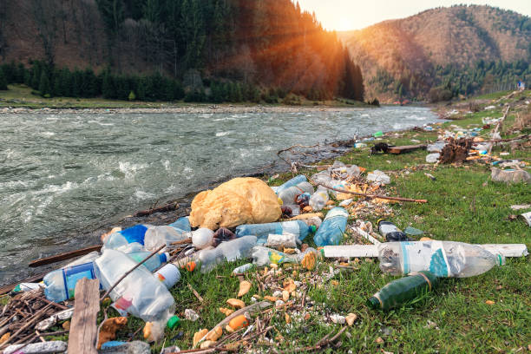



5. If litter goes into the ocean, it will destroy sea life.

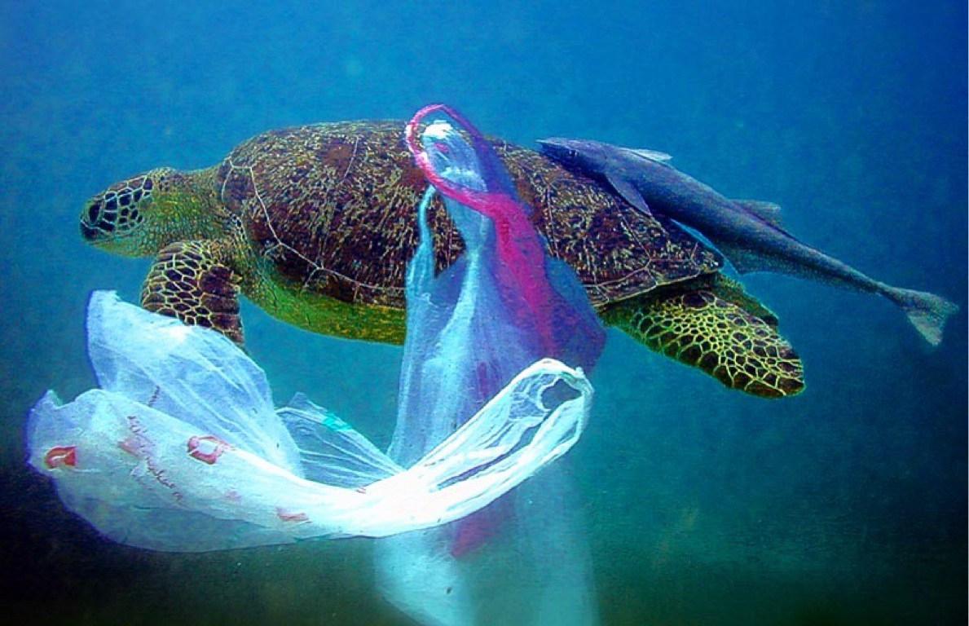

4. Litter is dangerous because it

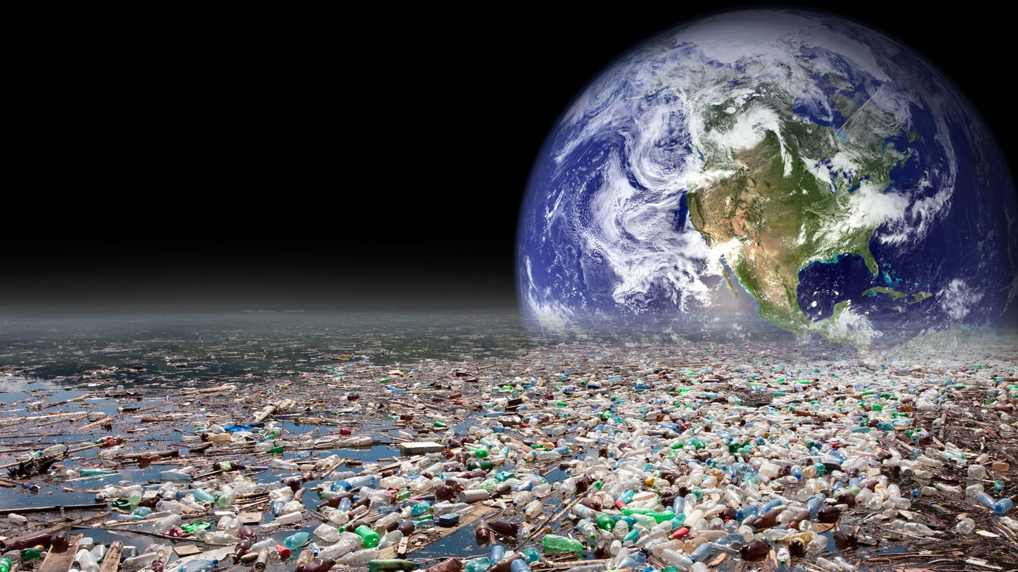

6. If you throw a lot of trash, it will be harmful for the environment.

**Annex 3**

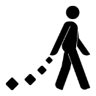**Where does litter go?**

**Cause and effect:** Complete the sentences with the words from the word bank.

Word Bank

Sewer Throw Containers Rivers

1. Recycle ________________ are important because they help us separate garbage.

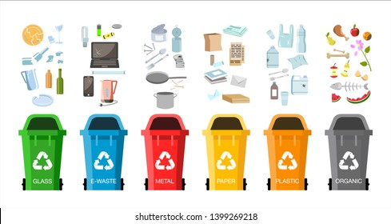

2. Litter is dangerous because it pollutes ________________.

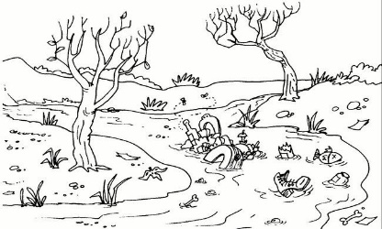

3. The park is dirty since people ________________ garbage on the ground.

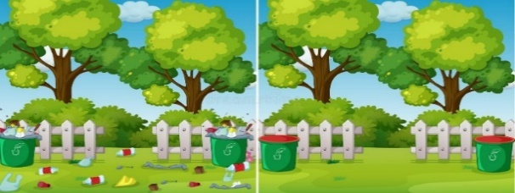

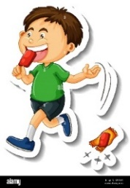

4. There are floods in my town since litter blocks the ________________.

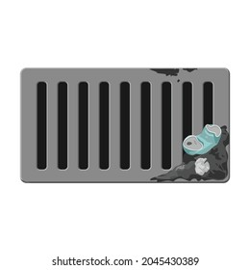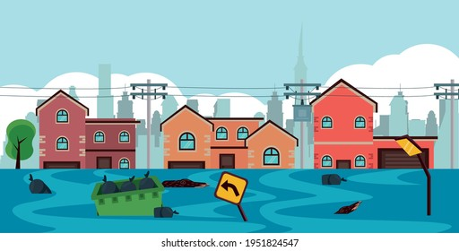

**What will happen in the future?**

**Annex 4**

**Complete the sentences with the words from the box. Some words can be used interchangebly.**

**destroy go damage harmful**

1. If litter goes into the ocean it will _____________________ sea life.

|  |  |  |
| --- | --- | --- |
| Imagen que muestra bolsas sucias con basura y comida podrida en el sueloImagen de flecha con fondo transparente que señala la imagen siguiente. | Imagen del océano | Ilustración que muestra un delfín rodeado de basura en el océano. Ilustración de signo igual que antecede a la siguiente imagenIlustración vector de Signo igual gratis | AI, SVG, EPS |

1. If litter goes into the rivers and lakes, it will _____________________ fish.

|  |  |  |
| --- | --- | --- |
| Imagen que muestra bolsas sucias con basura y comida podrida en el sueloImagen de flecha con fondo transparente que señala la imagen siguiente. | Imagen que muestra un río | Imagen que muestra un pez muerto.Ilustración de signo igual que antecede a la siguiente imagen |

1. If plastic containers travel through sewers they will____________________ to the ocean.

|  |  |  |
| --- | --- | --- |
| Imagen que muestra diferentes envases plásticos.Imagen de flecha con fondo transparente que señala la imagen siguiente. | Imagen que muestra aguas contaminadas | Ilustración que muestra el océano contaminado por basura.Ilustración de signo igual que antecede a la siguiente imagenIlustración vector de Signo igual gratis | AI, SVG, EPS |

1. If you throw a lot of trash it will be _____________________ for the environment.

|  |  |  |
| --- | --- | --- |
| Imagen que muestra a un niño comiendo helado y arrojando el envoltorio plástico al suelo. | Ilustración de señal de veneno en color rojo indicando peligroImagen de flecha con fondo transparente que señala la imagen siguiente. | Imagen del mundo rodeado de árboles y casas. Ilustración de signo igual que antecede a la siguiente imagen |

**Texts Features**

**Annex 5**

* **When we read certain features can help us understand the message better.**

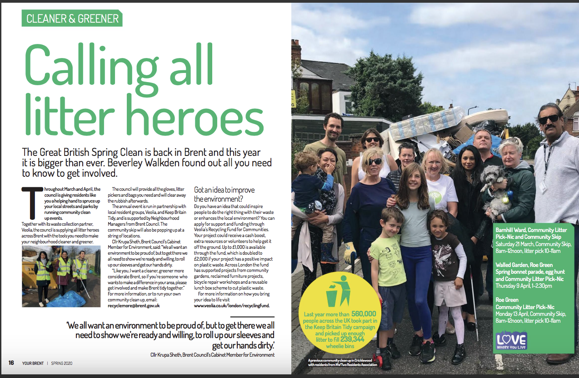

**Title**

**Heading**

**Illustrations**



**Write the correct information from the previous article.**

**Heading: _______________________________________**

**Tittle: __________________________________________**

**Illustration: ___________________________________**



**Annex 6**

Issue 15, June

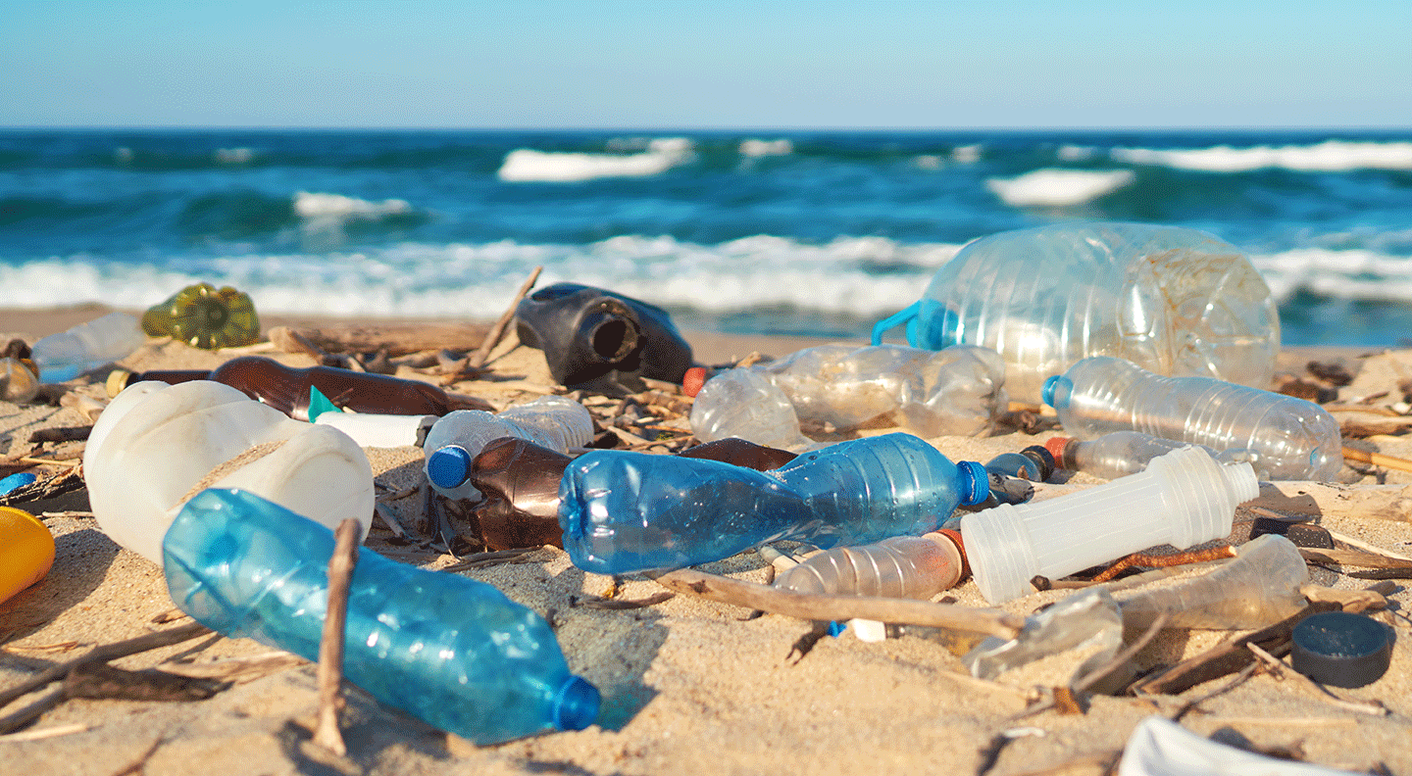LITTERBUGS

Some people don’t give a hood!

Litter is any kind of left- over that people do not put in its proper container. These people are called litterbugs because they throw garbage on the street.

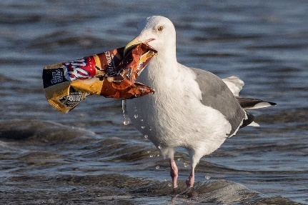

A campaign called “Green Bugs” will start next month. First, recycle containers will be around town so people can separate garbage. After that, neighbors will participate in community clean – up days. Then, people will ride bikes to go to work and school. Finally, and expert will give a speech on how to reuse, reduce and recycle.

Effects of littering

Let’s go green!

First, litter makes our neighbourhoods look dirty. Then, the sewers are blocked because water rain takes litter into them. Litter also pollutes rivers and, it is harmful for species. Finally, it gets to the ocean and damage sea life. Litter is really dangerous for the planet since it destroys ecosystems.

LITTERBUGS

**Annex 7**

1. **Read the question. Mark with an x the option that best answers the question.**

What is the article about?

( ) Littering is harmful for the environment.

( ) Litterbugs are very important in communities.

( ) Recycling is a good way to help the planet.

1. **Read the questions and answer them according to the article Litterbugs.**

What is littering?

( ) Littering is not recycling.

( ) Littering is “throwing left overs on the street”.

( ) Littering is putting trash in proper containers.

What are litterbugs?

( ) People who reduce, reuse and recycle.

( ) People who do cleanup days.

( ) People who throw garbage on the street.

1. **Read statements and answer them according to the article Litterbugs.**
2. Write 3 effects of littering.

___________________________________________________________________________________________________________________________________________________________________________________________________________________________________________________

1. Write 3 actions that neighbors will do in the camping “green bugs”, to help the environment.

___________________________________________________________________________________________________________________________________________________________________________________________________________________________________________________

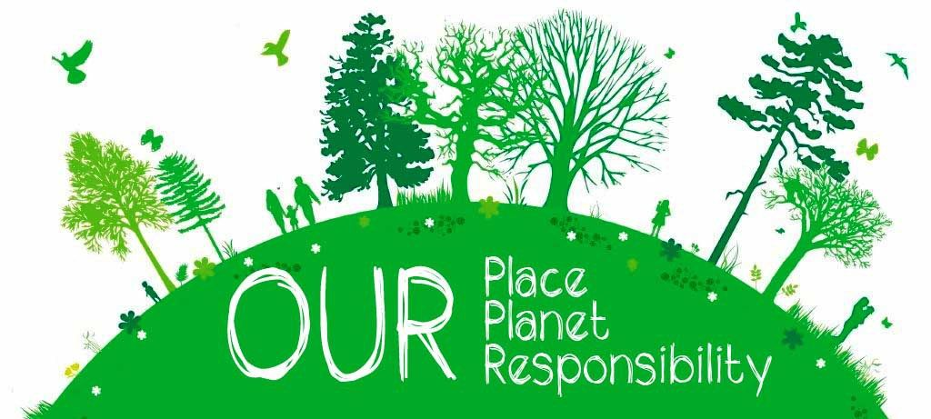

**Annex 8**

Be a designer!

* Cut out the parts of the article and organize it in your notebook.
* Write the text features: Title, illustrations and heading.

---------------------------------------------------------------------------------------------------

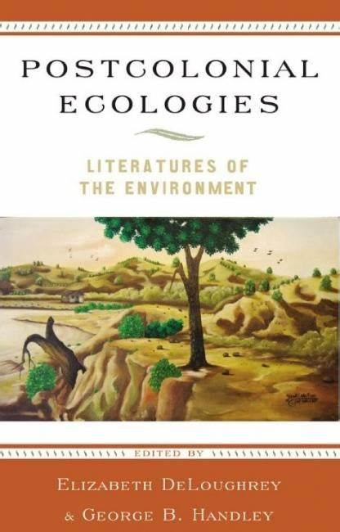







Be a reporter!

* Cut out the process of littering from the beginning until it reaches the ocean. Paste it in your notebook, in the correct order.
* Write the correct information on each picture, use: First, then and finally.

---------------------------------------------------------------------------------------------------

|  |  |  |  |
| --- | --- | --- | --- |
| Introduction for the presentation | What is littering? | Where it goes  (include opinion) | What will happened in the future  (include opinion) |
|  |  |  |  |

**Annex 9**

**Annex 10**



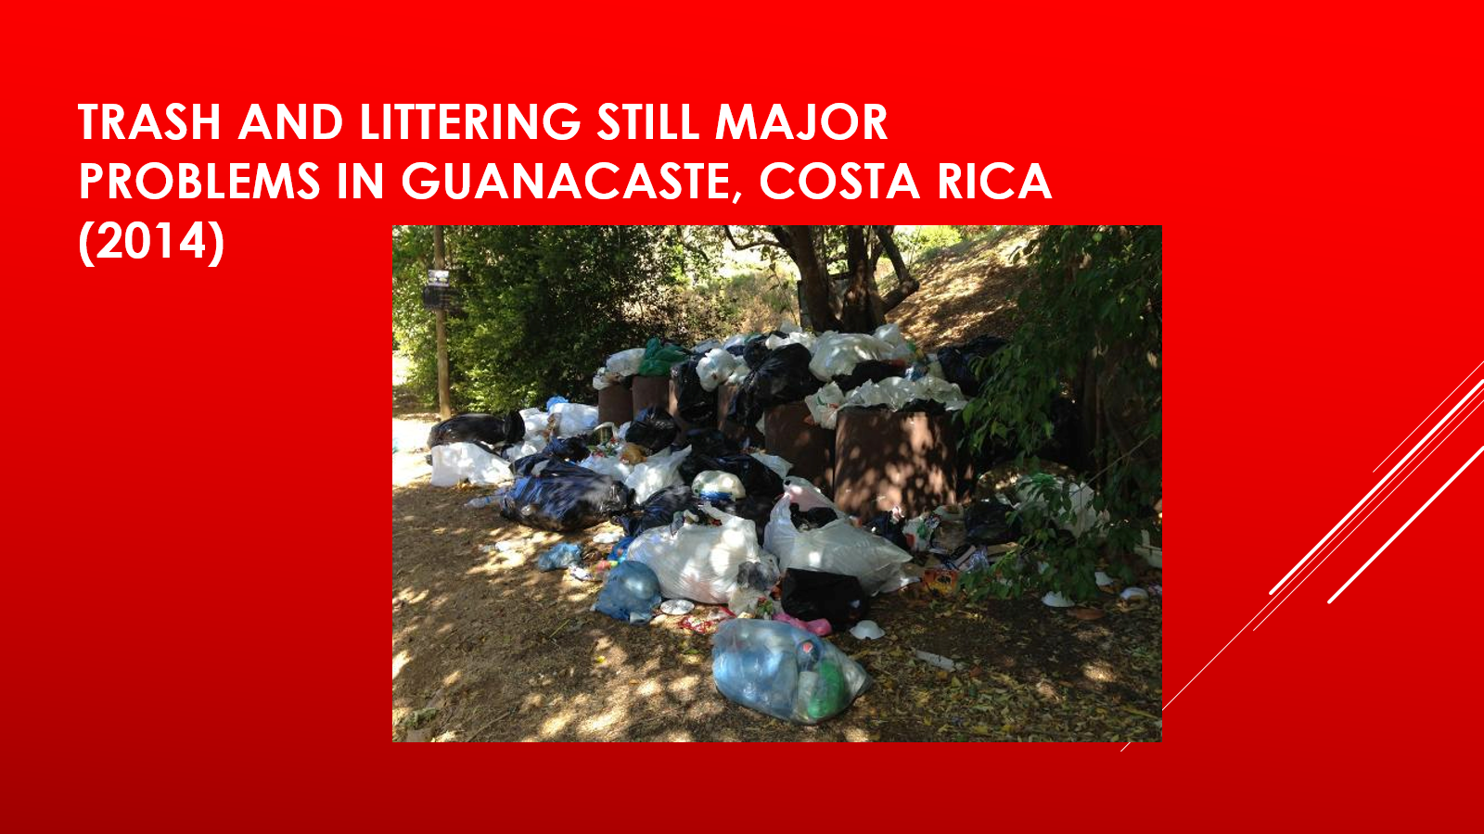

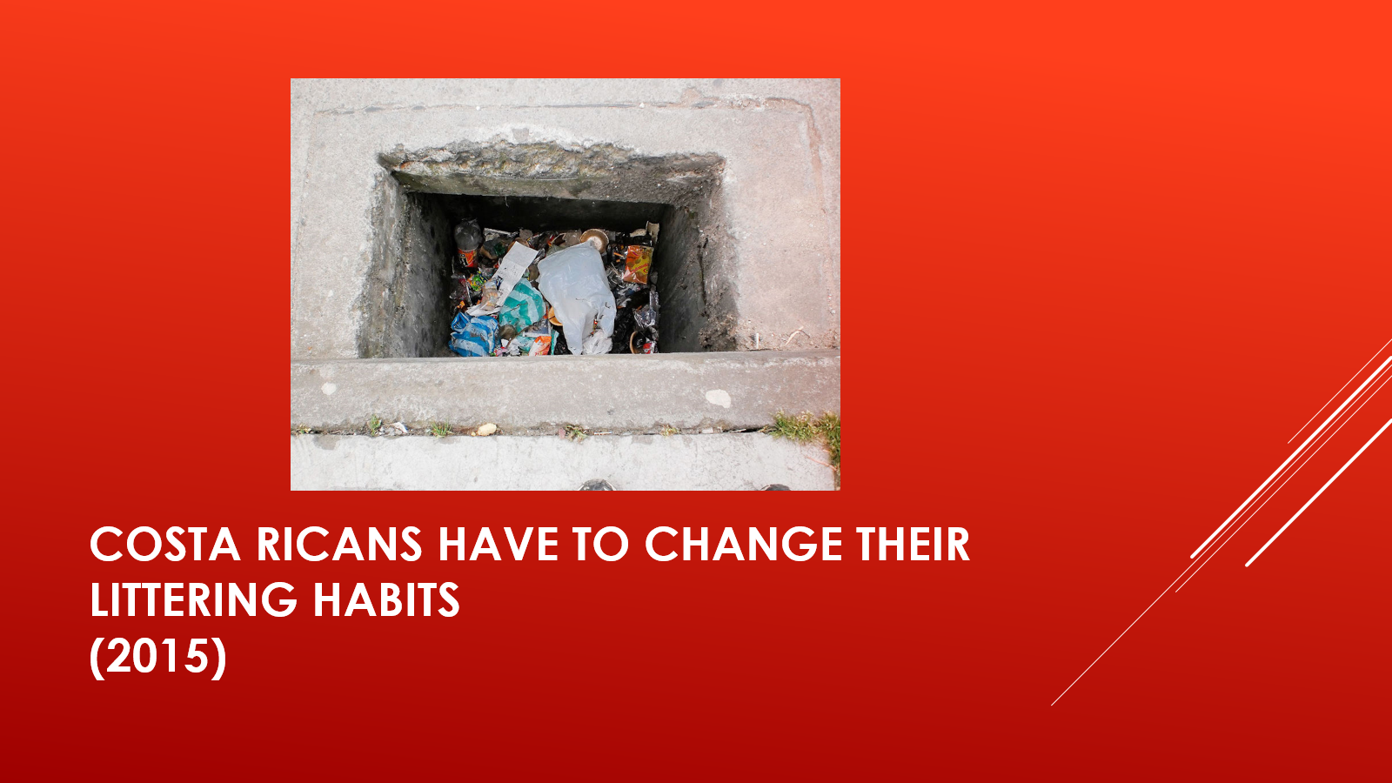

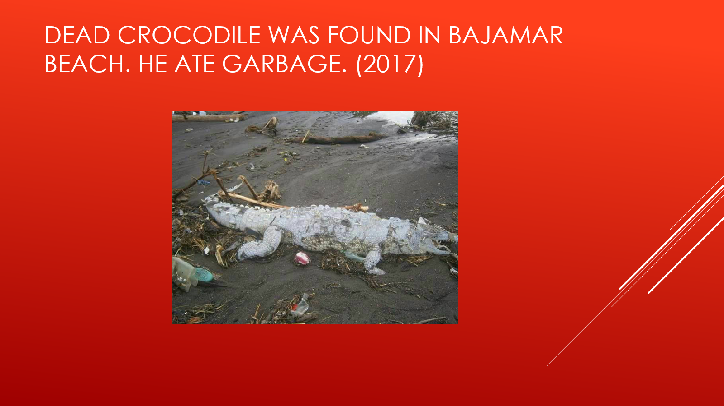

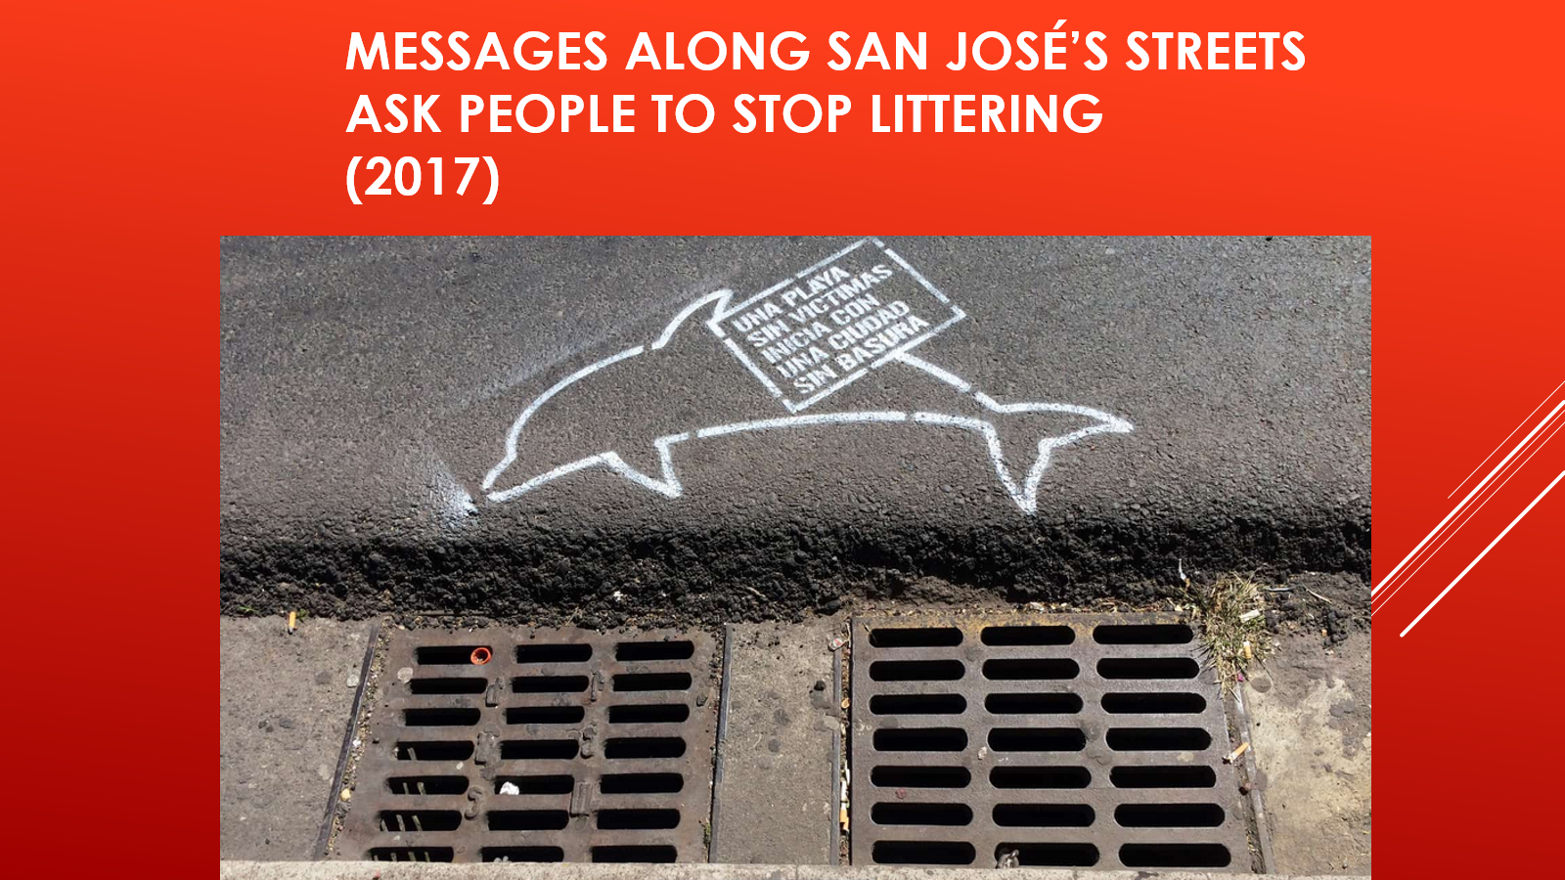

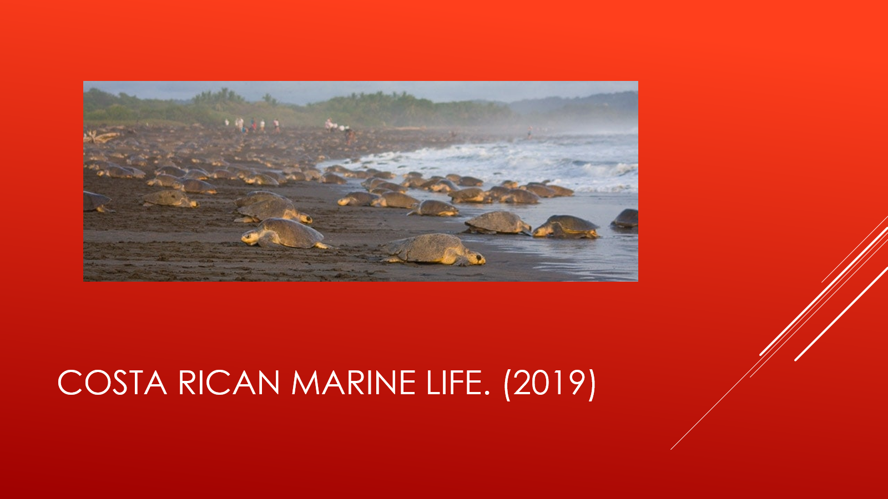

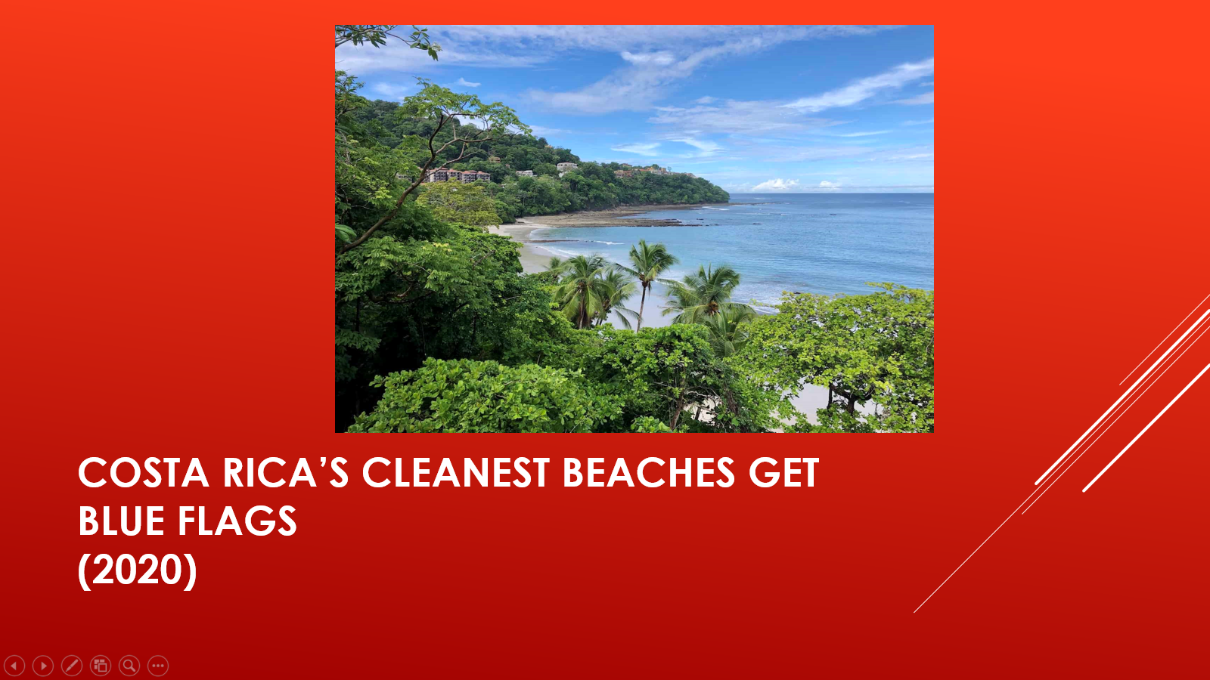

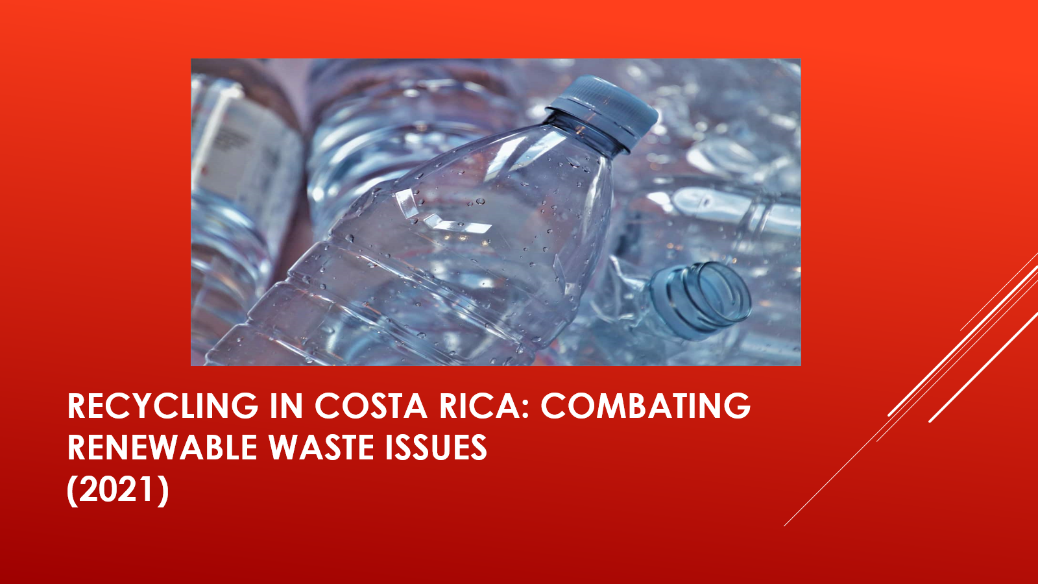

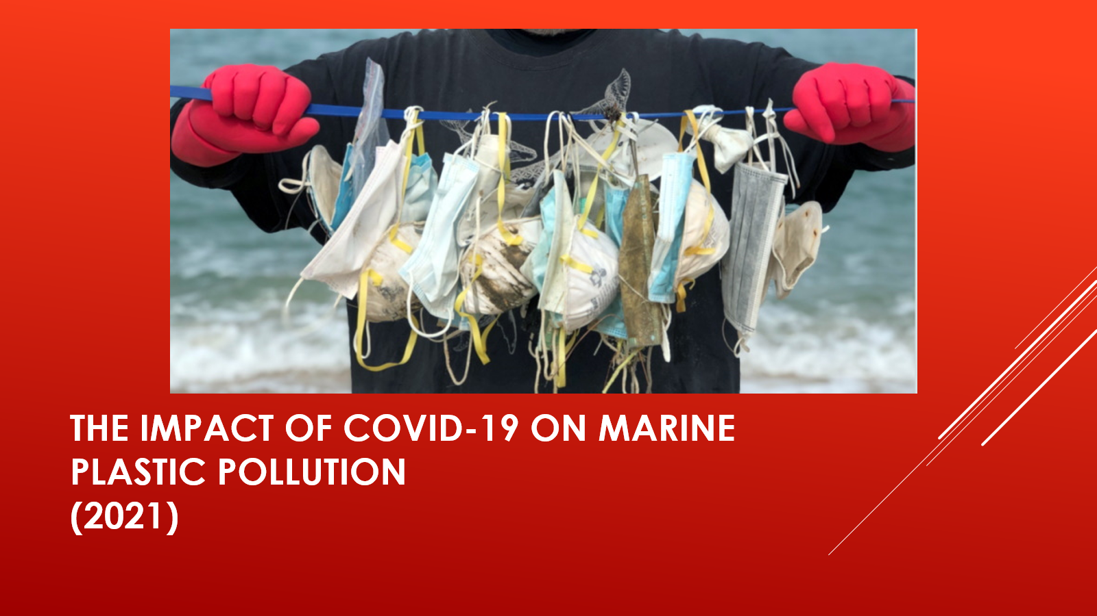



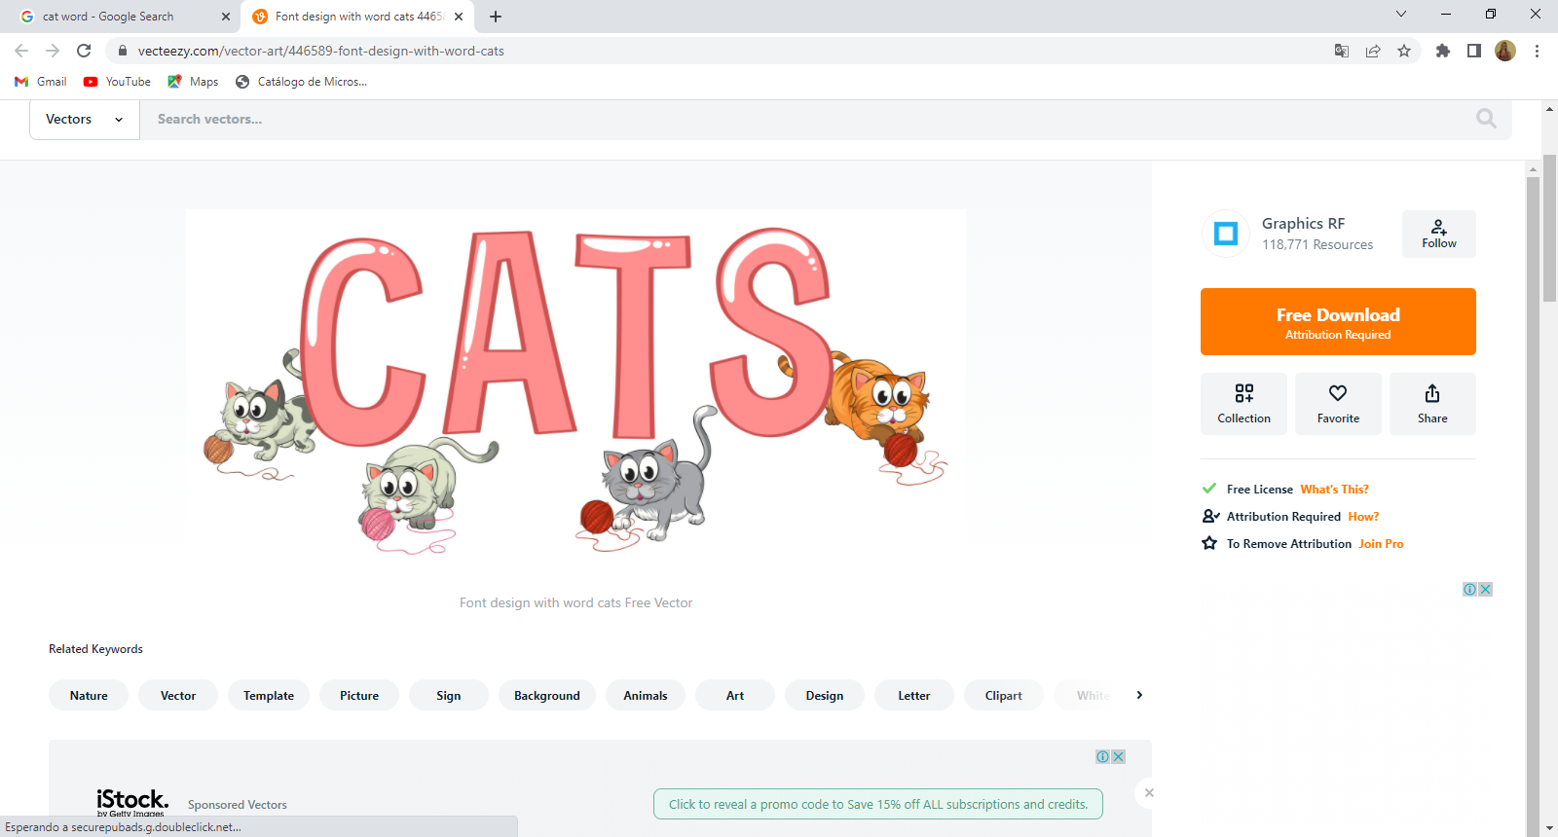

**Annex 9**

**Annex 10**

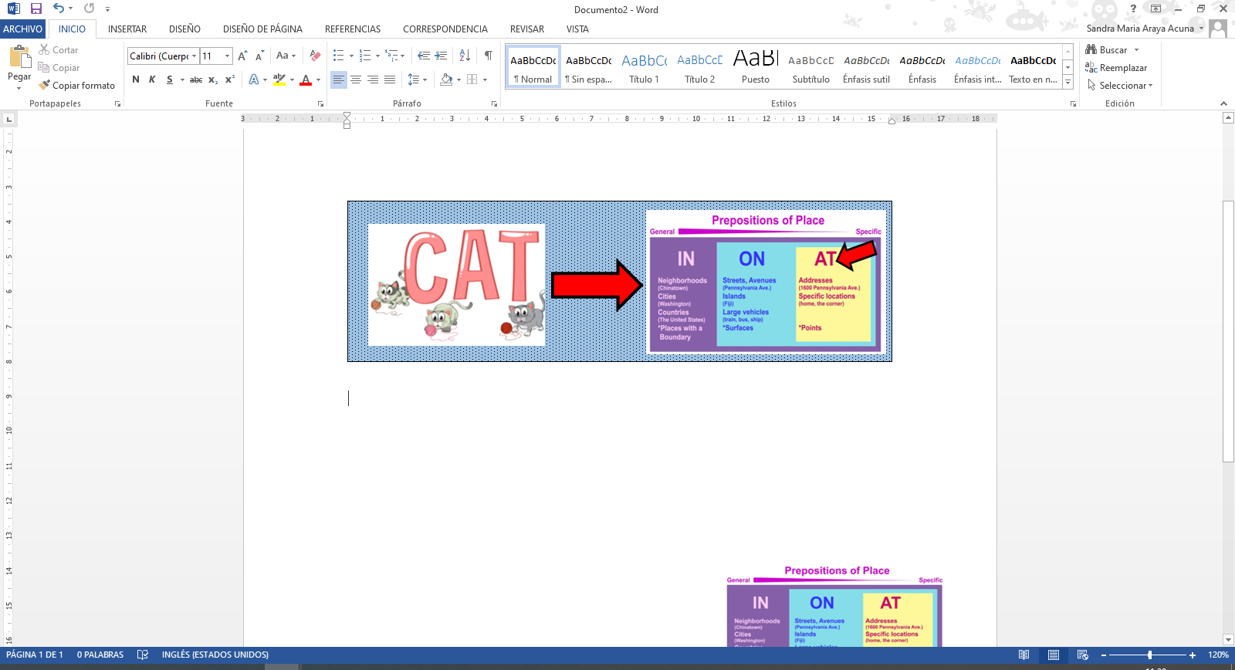

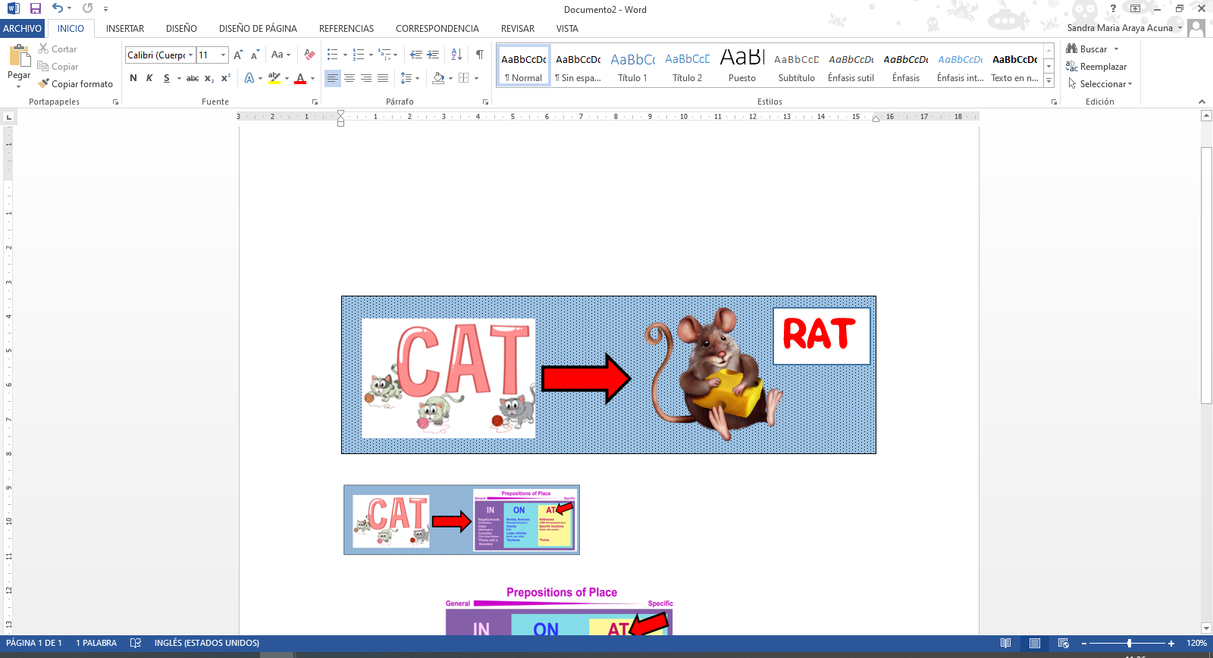

**Annex 11**

**Annex 12**

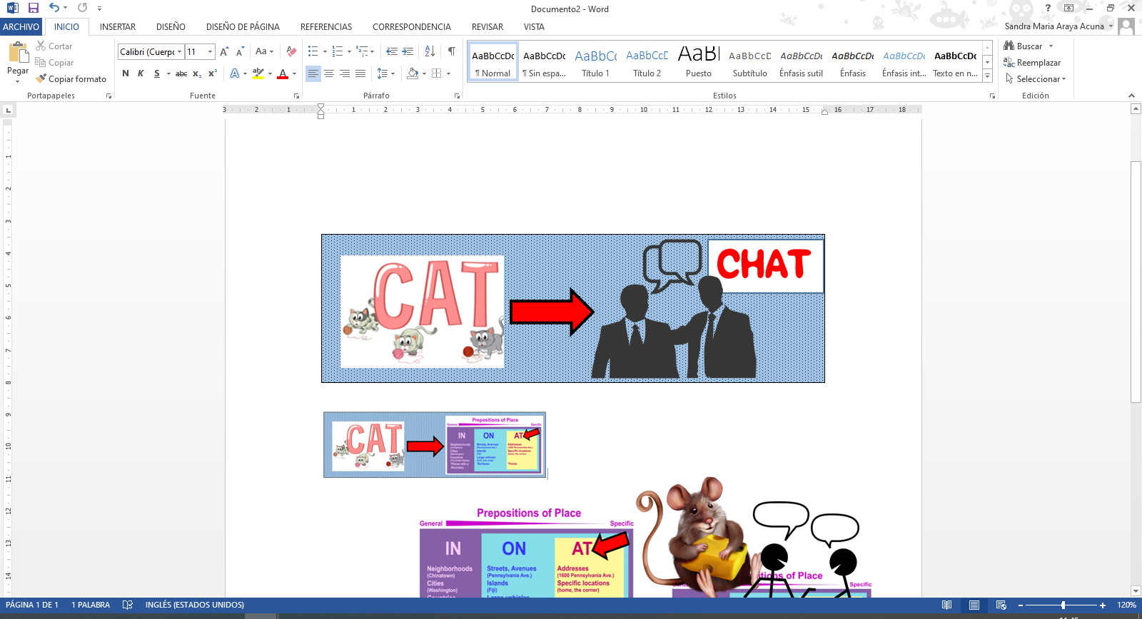

**Annex 13**

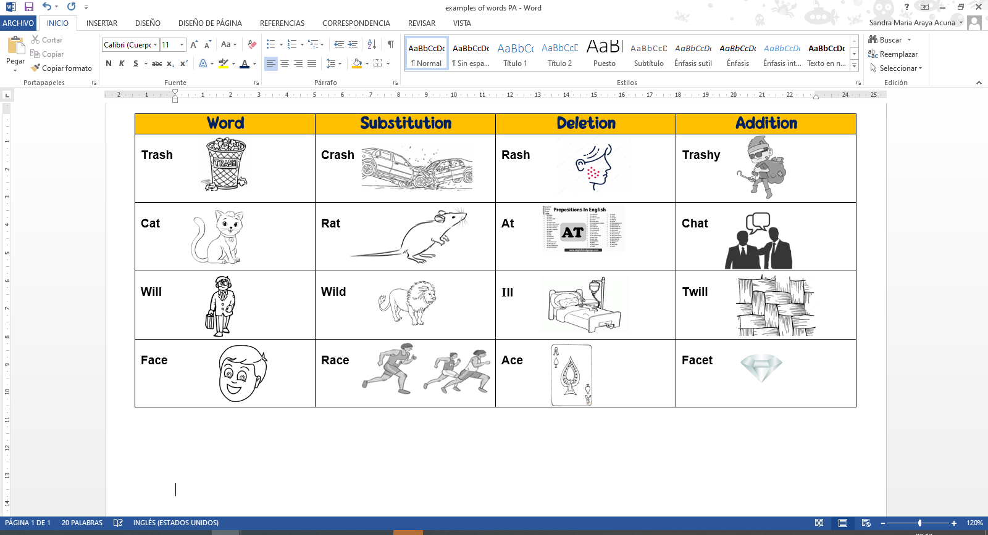

Identifying Graphemes

**Annex 14**

* Read the following sentence and circle the **initial** grapheme of each word with color green.

My uncle Will was picking up trash one day, and the next day, he had a rash on his face.

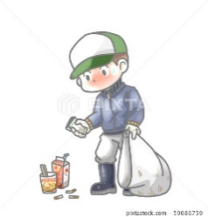

* Read the following sentences and circle the **final** grapheme of each with color blue.

Two months ago, things were really wild here. People were having car crashes, since they were driving very fast.

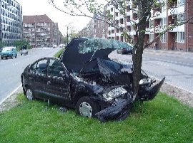

* Read the following words and circle the **medial** graphemes with color yellow.

ace can net bug

cat sun sea log

**Look at the following list of words. Add a grapheme in order to create a new word and draw each one.**

**Annex 15**

|  |  |  |
| --- | --- | --- |
| **Word** | **New Word** | **Drawing of the new word** |
| **For** | Four | Imagen del número 4 |
| **Ace** |  |  |
| **In** |  |  |
| **All** |  |  |
| **Set** |  |  |
| **To** |  |  |

**Look at the following list of words. Delete a grapheme in order to create a new word and draw each one.**

|  |  |  |
| --- | --- | --- |
| **Word** | **New Word** | **Drawing of the new word** |
| **Warm** | War | Imagen que representa a la guerra |
| **Card** |  |  |
| **Trash** |  |  |
| **Cat** |  |  |
| **Hill** |  |  |
| **Part** |  |  |

**Look at the following list of words. Substitute a grapheme in order to create a new word and draw each one.**

|  |  |  |
| --- | --- | --- |
| **Word** | **New Word** | **Drawing of the new word** |
| **Box** | Fox | Imagen que muestra a un zorro |
| **Way** |  |  |
| **Fix** |  |  |
| **Well** |  |  |
| **Ball** |  |  |
| **Hat** |  |  |

|  |  |  |  |  |  |  |  |  |  |
| --- | --- | --- | --- | --- | --- | --- | --- | --- | --- |
| **Term: 1** | | **Level: Sixth Grade** | | | **Unit: 3** | | | **Week:4** | |
| **Domain: Socio-interpersonal** | | | | **Scenario:**  **Environmentally Speaking** | | **Theme:**  What Can I do About Litter? | | | |
| **Enduring Understanding**: Litter harms our school, community, Costa Rica and the world. The actions we take now to help with litter will help our neighbors today and in the future. | | | | | | | | | |
| **Essential Question:** Why should we be concerned about litter? | | | | | | | | | |
| |  | | --- | | **Dimensions** | | **1.** **Ways of thinking ( X  )** | | **2. Ways of living in the world  ( X )** | | **3. Ways of relating with others  ( X )** | | **4. Tools for integrating with the world  ( )** | | | | | | | | | | |
| **Learn to Know** | | | | **Learn to Do** | | **Learn to Be and Live in Community** | | | |
| **Grammar & Sentence Frames**  **Sequencing adverbs**   * First, we have to make a plan. * Then, we will present the plan to our teacher. * Finally, we will make a school campaign.   **Phonemic Awareness**   * Applying knowledge of affixes to base words in context: tree --> trees protect--> protects --> protected --> protecting   Organize--> organizes -->organized-->organizing-->organization-->disorganized -->reorganize  **Vocabulary**  **What can I do about litter?**  **Nouns**   * Garbage * Goods/products * Container * Can * Bottle * Bin * Compost * Packaged food * Boxes * Electricity * S.T.E.A.M * **Present sent and future tense)** * Reuse * Recycle * Reduce * Refuse * Dispose * Clean * Use/buy   **Adjectives**   * Reusable * Recyclable * Right * Responsible | | | | **Function**   * Describing actions to clean public places from litter * Retelling events in past simple   **Discourse Markers**  Linkers: Sequential - past tense  First, then, after that, finally | | **Psycho-social**   * Describing values related to ethical and moral service   **Sociocultural**   * Expressing social responsibility in actions related to the environment   **Idioms/phrases**  Expressions   * Go Green * Give a Hoot, Don’t Pollute * Reduce, reuse, recycle | | | |
| **Assessment Strategies & Evidences of learning**  (Diagnostic, formative, summative) | **Goals** | | | **Pedagogical Mediation/ Didactic Sequence** | | | | | **Time** |
| Learner… | Learner can… | | | **Pre-Teaching**  **Routine:** Greet students**,** check attendance, read the Essential Question and the Enduring Understanding that are on the wall, class agenda, etc.  **Warm up**  Teacher walks around the classroom drinking a beverage (could be a plastic bottle of water or a can of soda) and eating chips out of a small one-serving, pre-packaged container, and throws the waste on the floor. Teacher asks students…What do you think about what I just did? Teacher elicits students’ responses.  Then, the teacher asks the students if they know actions that can help to reduce litter. Students will probably answer: dispose the garbage in the proper place, recycle, reduce, reuse among others.  **Activation of Prior Knowledge**  Teacher asks students the following question:   * Do you know what recycle is?   Teacher explains to students that there are different processes to convert one material into another product. Students are asked to watch a video and take notes of litter (plastic bag, can, food, glass and plastic bottle, metals, magazine, etc.)  In the following link, teacher will find the video.  https://www.youtube.com/watch?v=6jQ7y_qQYUA  After the video, the teacher asks the following questions:   * Can you mention some examples of litter from the video? * What type of materials can be recycled? * Can you recycle food? * Is it ok to throw food to the trash bin? * What can you do with food instead of throwing it into the trash bin?   Teacher shows students a picture of a compost bin as a way to dispose food (annex 1).  Dig and drop composting   * Do you use a compost bin in your school or at home? Teacher elicits students´ responses.   **Modeling**  Teacher uses a PowerPoint presentation (annex 2) to introduce and model the vocabulary for this week, as well as the grammar and sentence frames. In the following link, teacher finds the PPT.  <https://recursos.mep.go.cr/sitio_primaria_ingles/sexto.html>  For example: What can I do about litter?  There are some actions we can take to reduce litter:   * I can reduce, reuse, refuse and recycle. * I can dispose garbage properly. * I can use a compose bin to dispose food. * We can clean our school. * We can buy less packaged food.   ES UNA IMAGEN QUE MUESTRA LA PPT QUE SE USARAÁ EN ESTA ETAPA  While the teacher is showing every slide (until slide N° 7), the students repeat after her. Then, she/he reviews the sequence words (Slides N° 8-9) and explains how to reduce litter through recycling.  **Clarifying**  After teacher clarifies meaning and pronunciation, students are given a worksheet (annex 3) in which they have to complete sentences using given words. Then, they have to organize the sequence of the events described. Finally, they look at some pictures and glue them next to each sentence that best describes them. Students glue the worksheet into their notebook. Teacher checks the answers with them.  ES UNA IMAGEN CON LA PRACTICA DE LA ETAPA DE CLARYFING | | | | | 5´  5´  10´  10´  7´ |
| **L.2.** recognizes simple procedural explanations if given slowly and clearly.  **Indicators of learning:**  **L.2.1.** gets the topic of simple procedural explanations if given slowly and clearly.  **L.2.3**. identifies specific information in simple procedural explanations if the explanations are given slowly and clearly.  **L.2.2.** gets keywords, phrases and expressions in simple procedural explanations if given slowly and clearly. | **L.2.** understand simple procedural explanations if given slowly and clearly, and opportunity is given for clarification (e.g., how to do a project to have a cleaner school, how to live in a cleaner society). | | | **Pre-Task**  Teacher shares L.2 indicators and asks students to play a game named “*Broken Phone”.*  Students are arranged in two lines, teacher whispers the sentence “**recycling transforms garbage into a new product**” to the first in line who whispers it on to the next in line, and so on until the last student. The last student for each line writes the sentence on the board. Teacher awards the winner team.  **Task-Rehearsal**  Students listen to an audio (script annex 4) about a teacher that creates new products out of plastic waste. In the following icon, teacher can find the audio.    Students listen to the audio for the first time and are asked to get the gist of it. Teacher writes or projects on the board the following question (annex 5) and its possible answer:  **What is the general idea of the audio? How to_________________.**   1. make a Christmas tree out of plastic 2. turn plastic waste into art 3. make earrings and bracelets   MUESTRA IMAGEN DEL SCRIPT QUE SE USARÁ EN ESCUCHA  Volunteers give answers, orally.  **Task-Completion**  Students listen to the audio again and are given a worksheet (annex 5). They have to read some questions and choose the correct answer for each one.  ES UNA IMAGEN CON PRACTICA PARA LA ETAPA DEL TASK COMPLETION  When students finish the previous the task, they are asked to write in the chart (annex 10) the items that teacher Carlos created out of the plastic.   |  | | --- | | **Things to be created out of plastic** | |  |   Teacher checks answers along with the students.  **Task-Assessment**  To check understanding, students are asked to organize a sequence of steps presented in the audio by completing a matching (annex 6). Teacher gives feedback if necessary.  IMAGEN QUE MUESTRA MATCHING DE LA ETAPA DE TASK ASSESSMENT  Students participate in self-assessment of task performance.  **Student Self-assessment Grid**   |  |  |  |  | | --- | --- | --- | --- | | Indicators | Level of achievement | | | | I can ... | Not achieved yet | In progress | Achieved | | get the topic of simple procedural explanations if given slowly and clearly |  |  |  | | identify specific information in simple procedural explanations if the explanations are given slowly and clearly |  |  |  | | get keywords, phrases and expressions in simple procedural explanations if given slowly and clearly |  |  |  |   **Post-Task**  Students are asked to think about an art project they can make made out of plastic waste and share their ideas orally with the rest of the class. | | | | | 3´  5´  6´  5´  5´ |
| **R.2.** follows instructions as part of daily activities.  **Indicators of learning:**  **R.2.1**. gets the gist of simple instructions.  **R.2.2.** recognizes key words, phrases and expressions in simple instructions.  **R.2.4.** follows simple instructions.  **R.2.3.** labels pictures that contain instructions. | **R.2.** follow instructions for protecting the environment from litter (e.g., reuse, recycle, reduce litter) | | | **Pre-Task**  Teacher shares R.2 indicators and asks students to play bingo (annex 7). The bingo contains some materials or items can be reduced, reused or recycle. In advance, teacher makes copies of the bingo for the class and brings beans or something that can be used as tokens.  imagen que muestra bingo para la etapa del pre-task de reading  **Task-Rehearsal**  As soon as the bingo game is finished, the teacher hands out a reading called ***The 3R´s of the Environment*** (annex 8) and gets them to skim it. The teacher writes the following question on the board and elicits students´ responses.  **What is the general idea of the reading?**  imagen que muestra el texto que se usará  Teacher gives feedback if necessary.  **Task-Completion**  Students read the text again and complete the following chart with some statements (annex 11). Teacher can make copies or write the information on the board. Students identify if the statement is **TRUE** or **FALSE** according to the reading. As a whole, answers are checked.   |  |  |  | | --- | --- | --- | | Statement | True | False | | There are 4 Rs to deal with waste. |  |  | | Newspapers can be read online to reduce printing. |  |  | | Shoe boxes can be very useful to store things. |  |  | | Using plastic bag is better when we buy things. |  |  | | Electricity can be reduced by turning lights off when we don't need them. |  |  | | Recycling is a process that makes it possible to create new products. |  |  | | Clothes that are in good shape can be used again. |  |  |   Students take again the reading **The 3R´s of the Environment** (annex 8) and follow the instructions below:   1. Highlight the tittle. 2. Circle with red pen/pencil the items that can be recycled. 3. Circle with blue pen/pencil the items that can be reused. 4. Circle with yellow pen/pencil the items that can be reduced. 5. Extract two unknown words and look up for their meaning.   **Task-Assessment**  Students are given a worksheet (annex 9) to label the containers with the words **Reduce, Reuse and Recycle.** Then they have to cut, classify and glue the objects to be disposed in each one.  imagen que muestra práctica de las 3 erres.  Students participate in self-assessment of task performance.  **Student Self-assessment Grid**   |  |  |  |  | | --- | --- | --- | --- | | Indicators | Level of achievement | | | | I can ... | Not achieved yet | In progress | Achieved | | get the gist of simple instructions |  |  |  | | recognize key words, phrases and expressions in simple instructions |  |  |  | | follow simple instructions |  |  |  | | label pictures that contain instructions |  |  |  |   **Post-Task**  Orally, students mention one item (that is not in the reading) that can be reduced, recycled or reused. | | | | | 7´  10´  15´  10´  3´ |
| **R.PA.4.** reads words and sentences to demonstrate knowledge of phonemic awareness.  **Indicators of learning:**  **R.PA.4.1.** identifies affixes in base words in context.  **R.PA.4.2.** creates new words using derivational affixes and prefixes and inflectional suffixes.  **R.PA.4.3.** reads affixes in base words in context to demonstrate knowledge of phonemic awareness. | **R.PA. 4.** demonstrate knowledge of phonemic awareness. | | | **Pre-task**  Teacher shares R.PA.4 indicators and tapes/projects the following printed words on the board with the affixes in different color:  **Re**cycle - Tree**s** - Protect**s** – Protect**ed**  - Protect**ing**  She/he asks the students if they know why some letters are printed in a different color.  Using a PPT (annex 12), teacher tapes/projects the following pictures on the board to explain the meaning of affixes. In the following link, teacher finds the PPT.  <https://recursos.mep.go.cr/sitio_primaria_ingles/sexto.html>  imagen que muestra defición de affix  Imagen de prefijo RE Imagen de INFLEXIONAL SUFFIX S Imagen de INFLEXIONAL SUFFIX S  Imagen de INFLEXIONAL SUFFIX ED Imagen de INFLEXIONAL SUFFIX ING Imagen de SUFIJO ABLE  **Task-Rehearsal**  Through choral reading students along with the teacher pronounce the words presented. Teacher models and monitors pronunciation.  **Task-Completion**  Teacher uses the previous reading titled **“The three R’s of the environment”** (annex 8) and asks the students to identify affixes by underlining:   * prefixes using color GREEN * suffixes using color ORANGE   imagen que muestra el texto que se usará  Teacher gives the students a worksheet with the affixes reviewed (annex 13) as well as the root words to create new ones.  imagen de la práctica de task completion de phonemic awareness  Teacher uses again the reading titled **“The three R’s of the environment”** (annex 8) and asks the students to work in pairs and read it aloud in order to demonstrate knowledge of phonemic awareness. During the activity the teacher walks around the class, provides feedback and monitors pronunciation of words.  imagen que muestra el texto que se usará  **Task-Assessment**  Orally, students provide more examples of suffixes and prefixes and teacher takes notes on the board of given words.  Students participate in self-assessment of task performance.  **Student Self-assessment Grid**   |  |  |  |  | | --- | --- | --- | --- | | Indicators | Level of achievement | | | | I can ... | Not achieved yet | In progress | Achieved | | identify affixes in base words in context |  |  |  | | create new words using derivational affixes and prefixes and inflectional suffixes |  |  |  | | read affixes in base words in context to demonstrate knowledge of phonemic awareness |  |  |  |   **Post-Task**  Students are asked to participate in a competition. Teacher writes on the board the word **ORGANIZE** and asks students to write as many suffixes and prefixes as they can. The winner is the student that creates more words. | | | | | 10´  5´  10´  5´  5´  3´  3´ |
| **SP.2.** produces a summary of a short story expressed in a simple sequence of events.  **Indicators of learning:**  **SP.2.1.**brainstorms the most important aspects of a short story such as who, where and what.  **SP.2.2.** organizes ideas in sentences according to what happened in the story.  **SP.2.3.** summarizes the short story in a simple sequence of events. | **SP.2.** produce a summary of a short story expressed in a simple sequence of events. | | | **Pre-Task**  **Note for the teacher:** Positive teaching influence can boost your students´ confidence when making career choices. In daily life, teachers will find many opportunities to help their students prepare for a great future because they can make a significant impact by helping to take care of the world.  Teacher shares SP.2 indicators and asks students to watch a video that shows some information about S.T.E.A.M. Teacher writes the acronym S.T.E.A.M. on the board and asks students to take notes of its meaning. In the following link, teacher finds the video. <https://www.youtube.com/watch?v=ysNGVmzlZvo>  When they finish watching the video, teacher elicits students´ responses and talks about how some careers can impact and help people and the environment.  The following question will be written on the board:  **What would you like to be when you grow up?**  Teacher elicits students´ responses, takes notes on the board and explains the following task:  You have the power to create a SUPER GIRL that will help to save the environment by cleaning public places from litter. The SUPER GIRL will be presented to the rest of the class. To create this SUPER GIRL you need to take into account the following:   * Choose one paper doll given by your teacher. * Choose a career and clothes for her. * Describe your SUPER GIRL by giving her some special characteristics (physical and/or personality features, special powers, etc.) * Create a short story about your SUPER GIRL. Include in your story these aspects: * Introduce your SUPER GIRL. Tell your classmates who she is. * Tell your classmates where the story took place. * Tell your classmates what the story is about and how this SUPER GIRL helped to save the environment by cleaning public places from litter. Use sequential words (first, then, etc.) * Tell your classmates how the story ended. * When presenting your story try to summarize it by giving only important details.   Teacher makes sure students understand the task and gives them a graphic organizer (annex 15) for them to brainstorm important ideas/ aspects to be included in the short story.  IMAGEN QUE MUESTRA EL GRAPHIC ORGANIZER A USAR EN SPEAKING  Teacher gives students a worksheet with some paper dolls (annex 14) and asks them to choose one. They cut out the doll and choose clothes according to the career they like the most. Teacher also takes a paper doll and presents her story in front of the class and models students the expected outcomes.  paper doll to be used paper doll to be used paper doll to be used  Once students finish, they are asked to make sentences to organize and create the short story using the information provided before.  **Task-Rehearsal**  Once students have finished the short story, they are asked to practice it in pairs. They work on pronunciation, intonation and tone of voice. Teacher walks around the class and monitors students´ work. They ask for help if necessary.  **Task-Completion**  Students present in front of the class. Teacher monitors students and provides feedback if necessary.  **Task-Assessment**  Once students listen all short stories, volunteers are asked to choose their favorite and tell why.  Students participate in self-assessment of task performance.  **Student Self-assessment Grid**   |  |  |  |  | | --- | --- | --- | --- | | Indicators | Level of achievement | | | | I can ... | Not achieved yet | In progress | Achieved | | brainstorm the most important aspects of a short story such as who, where and what |  |  |  | | organize ideas in sentences according to what happened in the story |  |  |  | | summarize the short story in a simple sequence of events |  |  |  |   **Post –Task**  All stories are taped on the wall for the rest of the class to read them. | | | | | 15´  10´  5´  20´  3´  5´ |
| **Integrated Mini-Project** | | | | | | | | | **Time** |
| Phase: _______  See examples in week #5. | | | | | | | | |  |
| **Reflective Teaching** | | | | | | | | | |
| What worked well | | | What didn’t work well | | | | How to improve | | |
| **Enduring Understanding Reflection** | | | | | | | | | |
|  | | | | | | | | | |

List of links:

https://www.youtube.com/watch?v=6jQ7y_qQYUA

[PPT AFFIX WEEK 4.pptx](https://adminmepcr-my.sharepoint.com/:p:/g/personal/sandra_araya_acuna_mep_go_cr/EWWjxn974jNMgF1SbAgNhosBP3fd6i8y4DwLd7oa9Jwa8g?e=1EHOia)

<https://adminmepcr-my.sharepoint.com/:p:/g/personal/sandra_araya_acuna_mep_go_cr/EfysGpRmNKdOlTfsQif5NwcBeb9e7SGi2I2EzBtWwtf8qQ?e=jshSzG>

<https://www.youtube.com/watch?v=ysNGVmzlZvo>

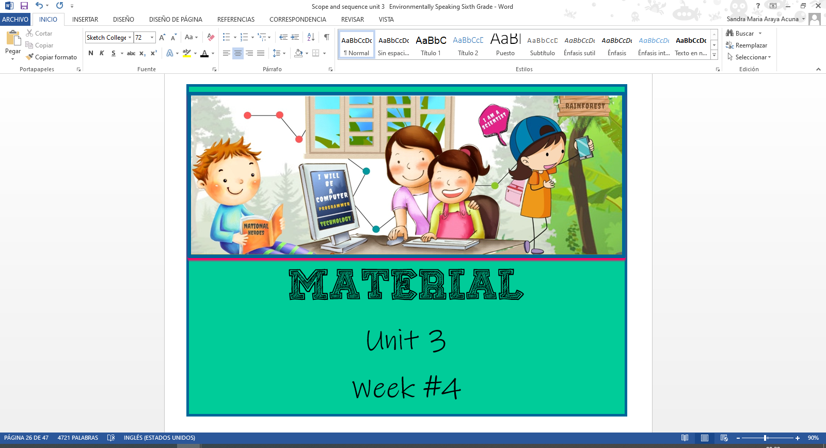

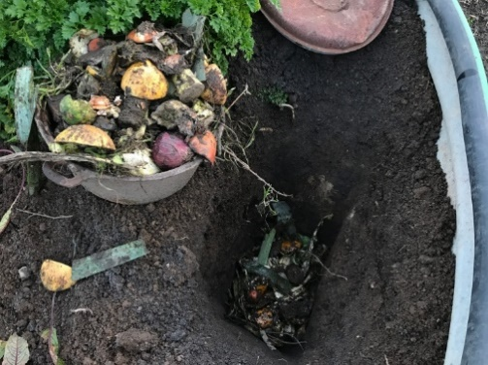

**Annex 1**

**Annex 2**

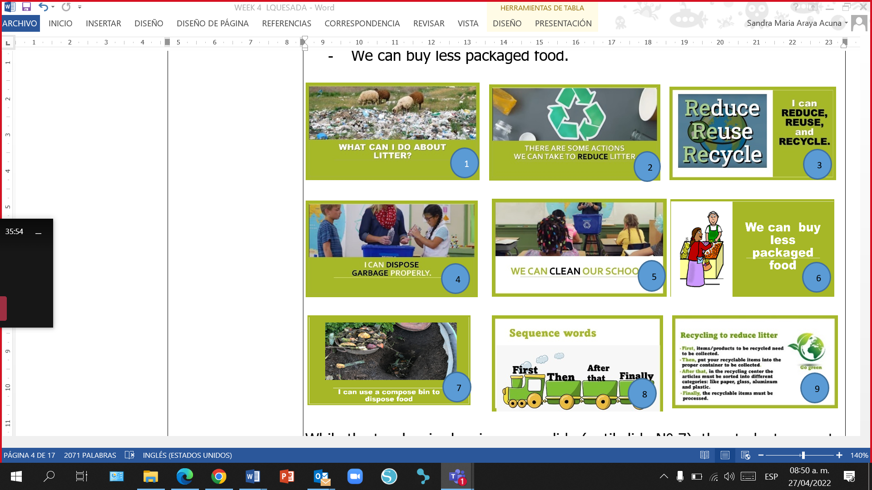

**Annex 3**

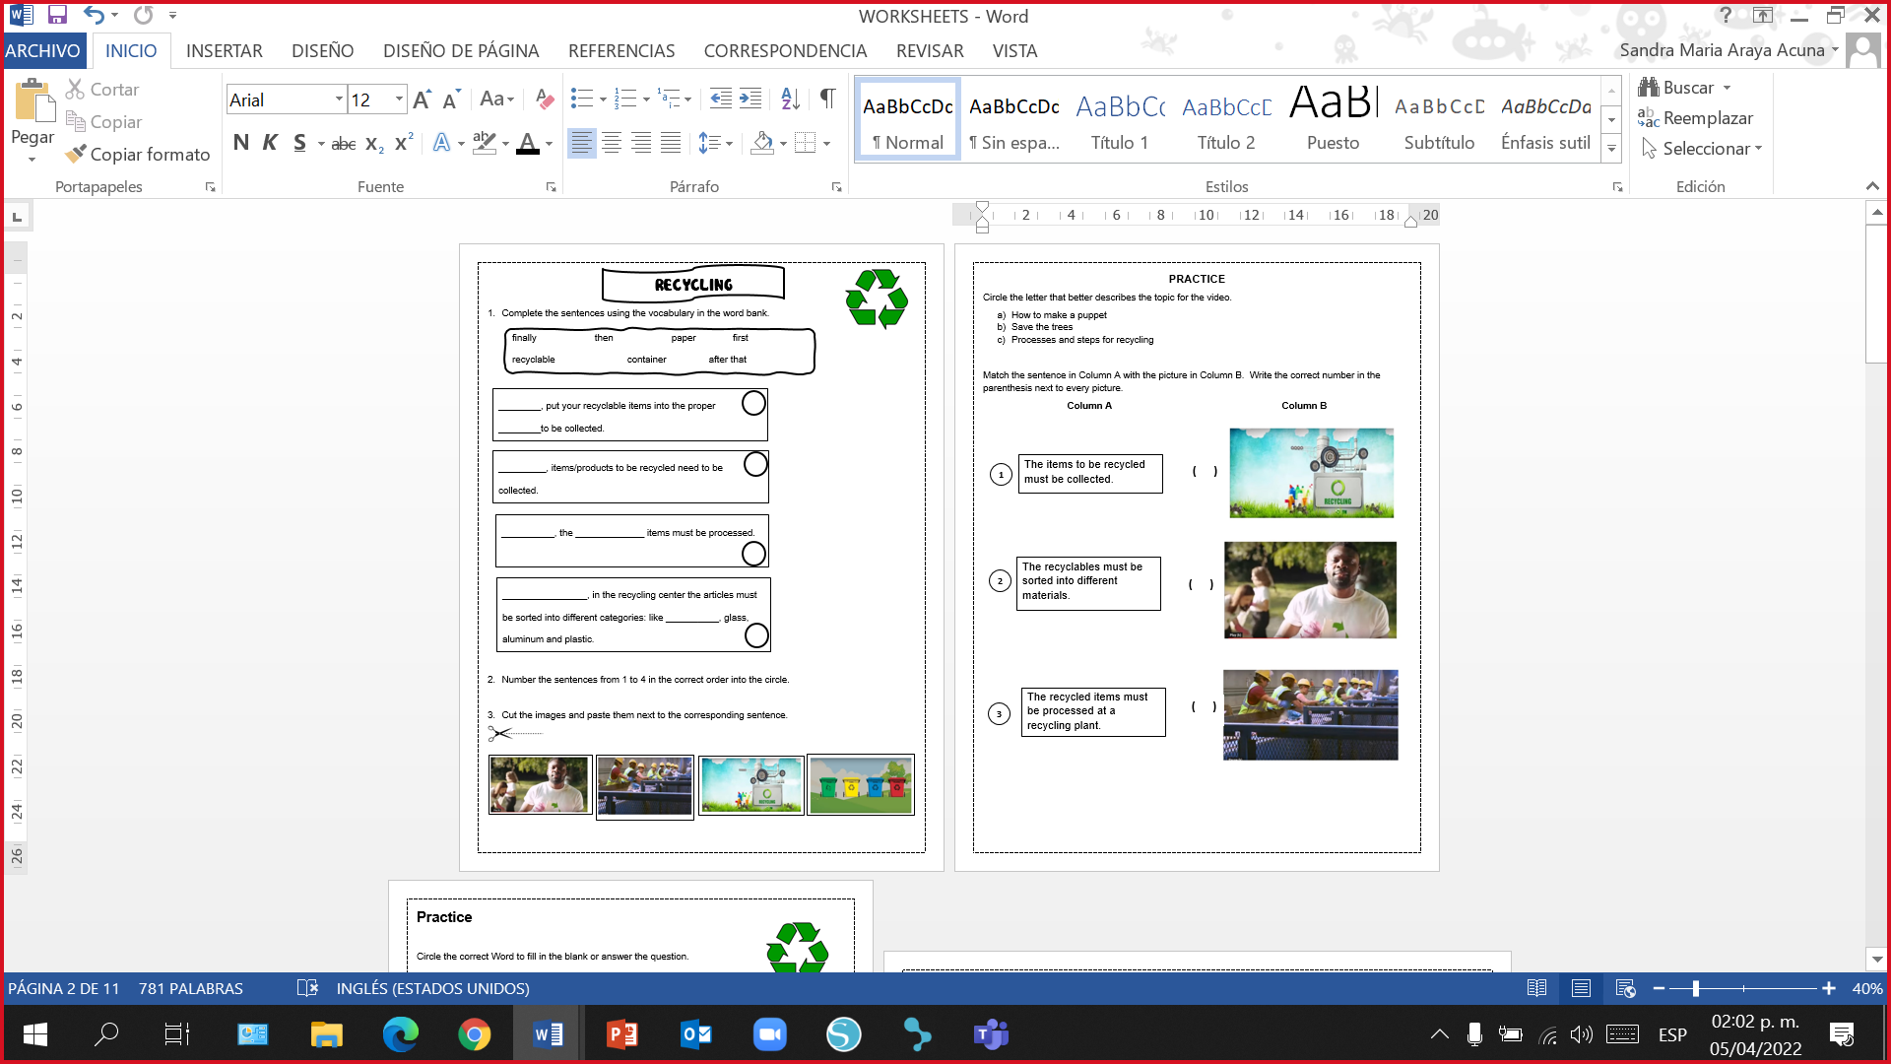

**Annex 4**

**Script for Listening**

My name is Carlos and I'm an English teacher from Costa Rica. Today, I am going to talk about an art project that I’m working on as a hobby.

The project is about how to use plastic to make things like wall murals, dresses, accessories and art. I pick up plastic that you all have disposed on the ground. And I keep it and use it to make new things. Now, I'm going to show you how we can use plastic to make beautiful things.

First, I collect plastic from the street in our communities for recycling, reducing and reusing. The caps are not useless – I use them for projects like a wall mural.

Then, I mix the cement and put it on the wall. Finally, I take the bottle caps and put them on the cement on the wall, to make a beautiful flower mosaic.

I have also made some pairs of earrings and bracelets. And I’m making necklaces right now.

So I’m making this project out of plastic waste. Plastic that you have disposed like cups, bottles and so much more. This project is 95 percent waste. I get plastic and cut it out into different shapes and patterns.

Last Christmas, my students and I made a Christmas tree out of plastic bottles. We also made plastic dresses to protest against the use of single-use plastics. I always look for different ways to protect the environment. I give a hoot, I don’t pollute.

Adapted from <https://learnenglishteens.britishcouncil.org/study-break/video-zone/turning-plastic-waste-art>

**Annex 5**

What is the general idea of the audio? How to_________________.

1. make a Christmas tree out of plastic
2. turn plastic waste into art
3. make earrings and bracelets

***Read the following questions and find the correct answers.***

**What is Carlos’ project about?**

1. Principio del formulario
2. Design and make things out of waste plastic.
3. Try not to use any plastic.
4. Sell jewelry made of plastic.

**Where does Carlos get the plastic from? From______________.**

1. Principio del formulario
2. a recycling center
3. the streets where he lives
4. the beach

**What kinds of accessories does Carlos make?**

1. Principio del formulario
2. Earrings, bracelets and necklaces.
3. Hats and earrings.
4. Bags and bracelets.

**How much of the material used for his jewelry is waste plastic?**

1. Principio del formulario
2. 50 percent
3. 75 percent
4. 95 percent

**What decoration did Carlos make for Christmas? A _______________.**

1. Principio del formulario
2. Christmas tree
3. snowman
4. Santa

**Why does Carlos make plastic dresses?**

1. Principio del formulario
2. Because they are fashionable.
3. Because they are cheaper than normal dresses.
4. To show he doesn´t agree with single-use plastic.

Final del formulario

Final del formulario

**Annex 6**

Final del formulario

Final del formulario

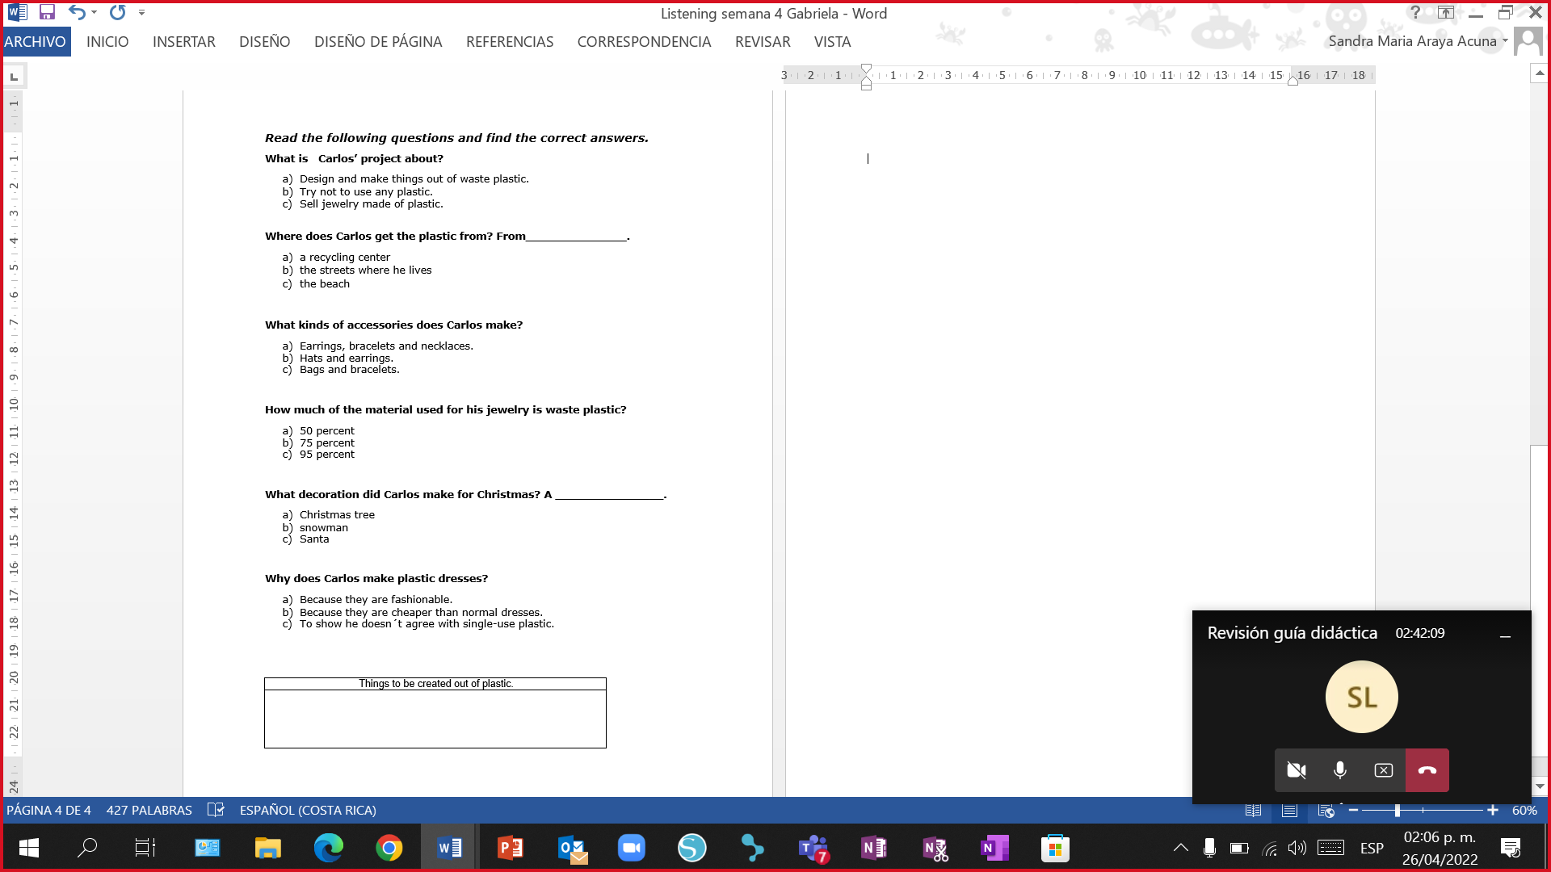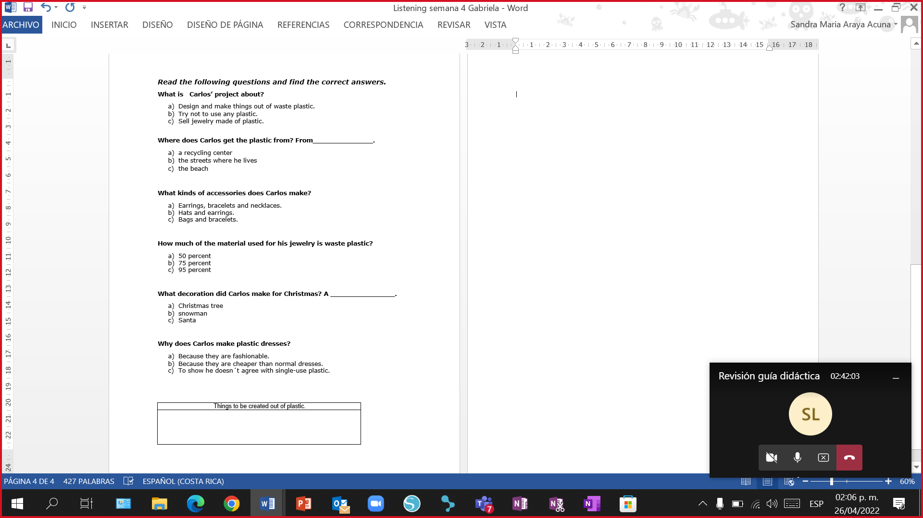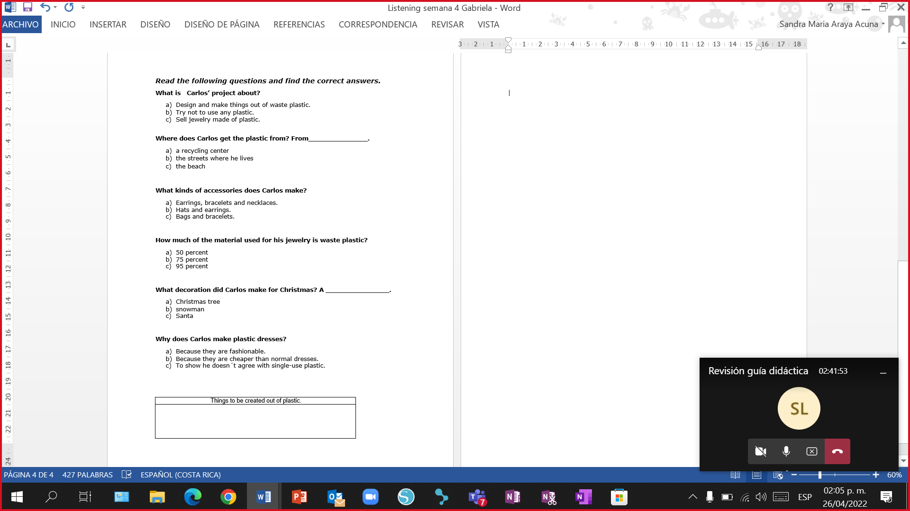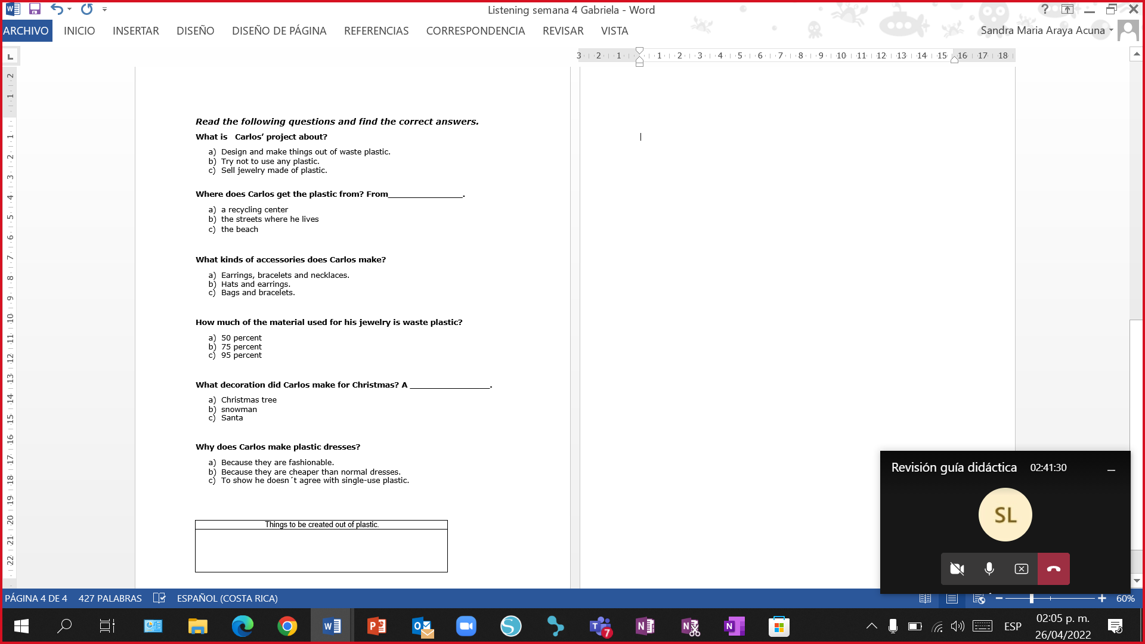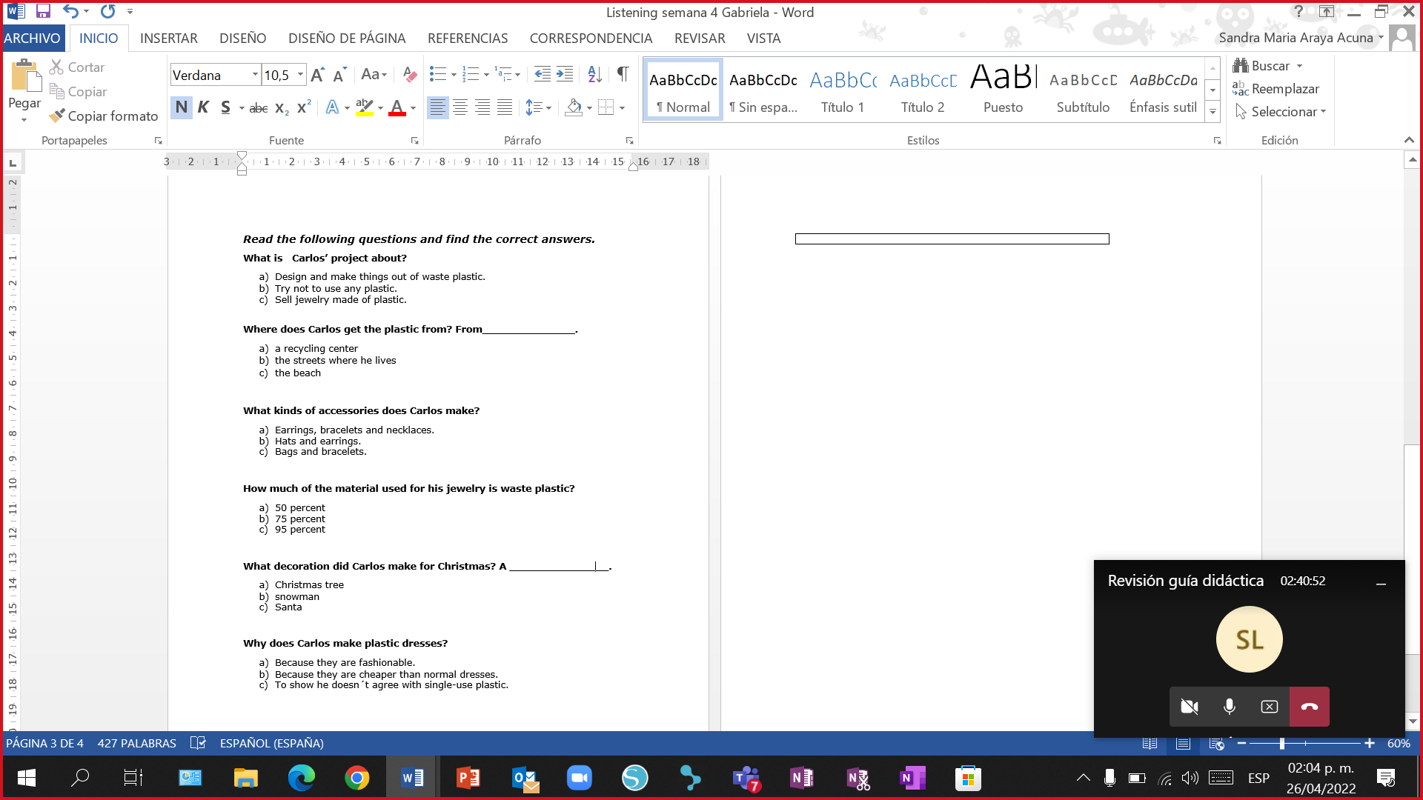Final del formulario

Final del formulario

**Matching**

Instruction: **Column A** has sequential words and **column B** has the steps to make an art project out of plastic waste. Trace a line to match column A with column B by connecting the dots.

**Column A Column B**

|  |  |
| --- | --- |
| **First.** | **.** I take the bottle caps and put them on the cement on the wall. |
| **Then.** | **.** I mix the cement and put it on the wall. |
| **Finally.** | **.** I collect plastic from the street in our communities for recycling, reducing and reusing. |

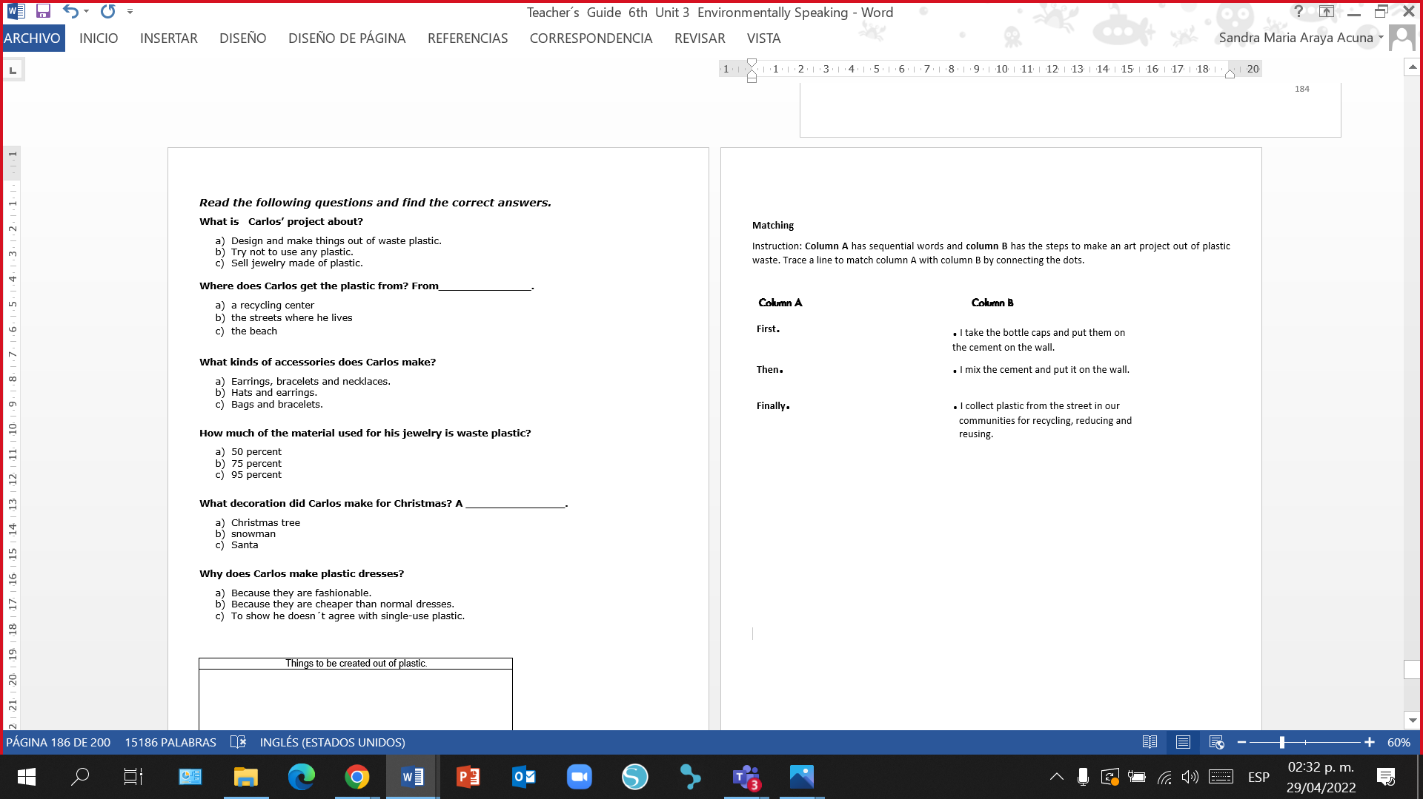

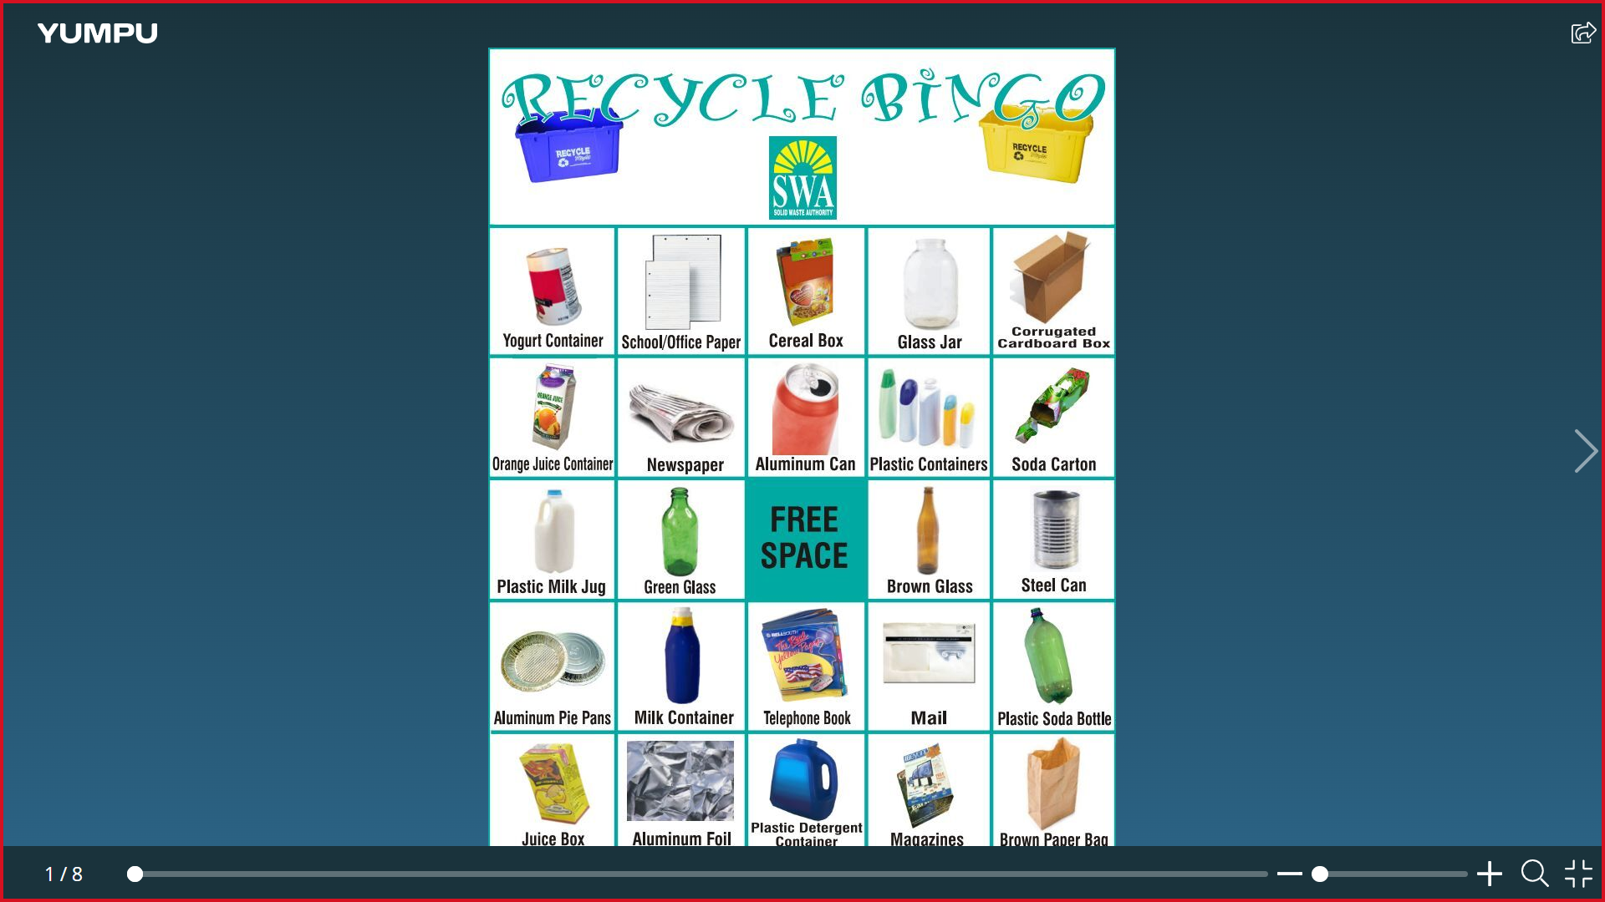

**Annex 7**



**Annex 8**

**The three Rs of the environment**

People everywhere in the world produce a lot of garbage but there is not enough space to dispose it. If we want to save our planet, then the three Rs are essential for learning how to deal with the waste we produce. The three Rs are reduce, reuse, and recycle. Here are a number of tips on what you can do to save the environment.

**Reduce**

A good place to start is by buying things that don’t have a lot of packaging. Then there are items you may not use very often, so you might as well borrow them from someone instead of buying them. Nowadays, newspapers can be read online so buying the paper edition is not necessary. The same goes for emails and hence it is usually not necessary to print them out. Generally, the use of electricity can be greatly reduced by, for example, turning off lights that are not used.

**Reuse**

When you go shopping, bring a used bag with you. If you’re not buying a lot, a bag is not necessary. Reusable bags should be heavier and more durable. If you prepare your lunch at home, put it in a plastic lunch box. I always keep shoe boxes as they are great to store stuff. Many cities have collection points for used clothes. If you have clothes that are still in good shape, you can bring them to the collection points rather than throwing them away.

**Recycle**

Recycling is a process that makes it possible to create new products out of old ones. Paper, aluminum, glass and plastic can often be recycled. Glass has been used for thousands of years and is relatively easy to recycle. Aluminum can be repeatedly recycled quickly and easily. Paper is recyclable but it cannot be recycled forever.

The small fibers in paper eventually become very weak so that they can’t be recycled into good paper anymore. Also, not every type of paper is recyclable as some high-quality paper is too expensive to recycle.

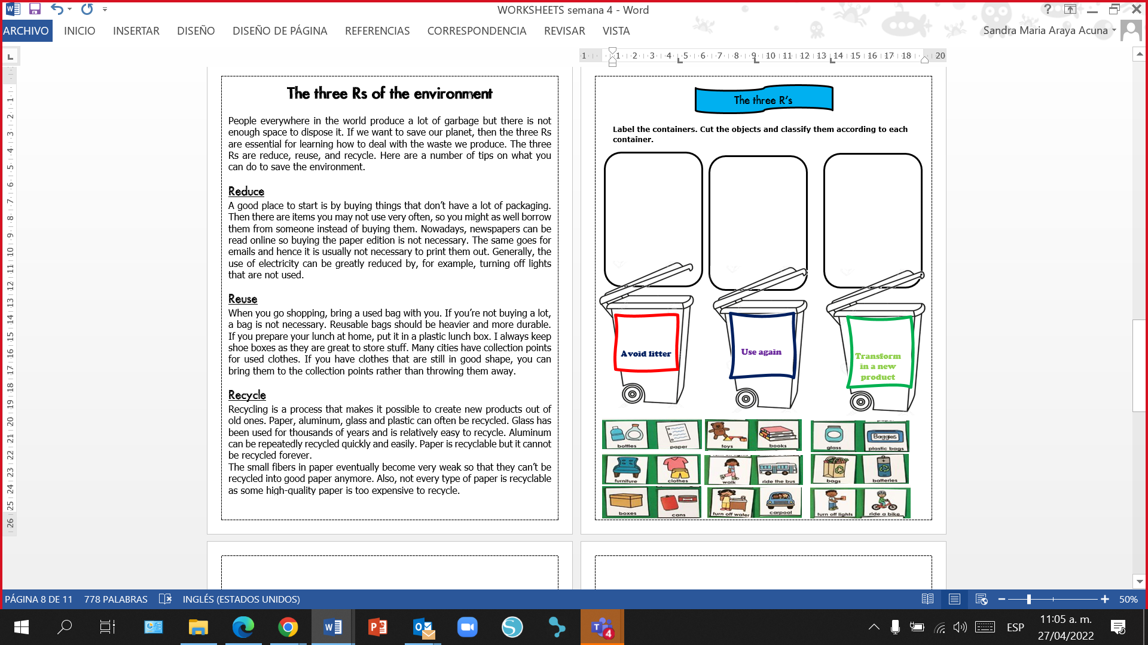

**Annex 9**

**Annex 10**

|  |
| --- |
| **Things to be created out of plastic** |
|  |

|  |
| --- |
| **Things to be created out of plastic** |
|  |

|  |
| --- |
| **Things to be created out of plastic** |
|  |

**Annex 11**

|  |  |  |
| --- | --- | --- |
| Statement | True | False |
| There are 4 Rs to deal with waste. |  |  |
| Newspapers can be read online to reduce printing. |  |  |
| Shoe boxes can be very useful to store things. |  |  |
| Using plastic bag is better when we buy things. |  |  |
| Electricity can be reduced by turning lights off when we don't need them. |  |  |
| Recycling is a process that makes it possible to create new products. |  |  |
| Clothes that are in good shape can be used again. |  |  |

|  |  |  |
| --- | --- | --- |
| Statement | True | False |
| There are 4 Rs to deal with waste. |  |  |
| Newspapers can be read online to reduce printing. |  |  |
| Shoe boxes can be very useful to store things. |  |  |
| Using plastic bag is better when we buy things. |  |  |
| Electricity can be reduced by turning lights off when we don't need them. |  |  |
| Recycling is a process that makes it possible to create new products. |  |  |
| Clothes that are in good shape can be used again. |  |  |

|  |  |  |
| --- | --- | --- |
| Statement | True | False |
| There are 4 Rs to deal with waste. |  |  |
| Newspapers can be read online to reduce printing. |  |  |
| Shoe boxes can be very useful to store things. |  |  |
| Using plastic bag is better when we buy things. |  |  |
| Electricity can be reduced by turning lights off when we don't need them. |  |  |
| Recycling is a process that makes it possible to create new products. |  |  |
| Clothes that are in good shape can be used again. |  |  |

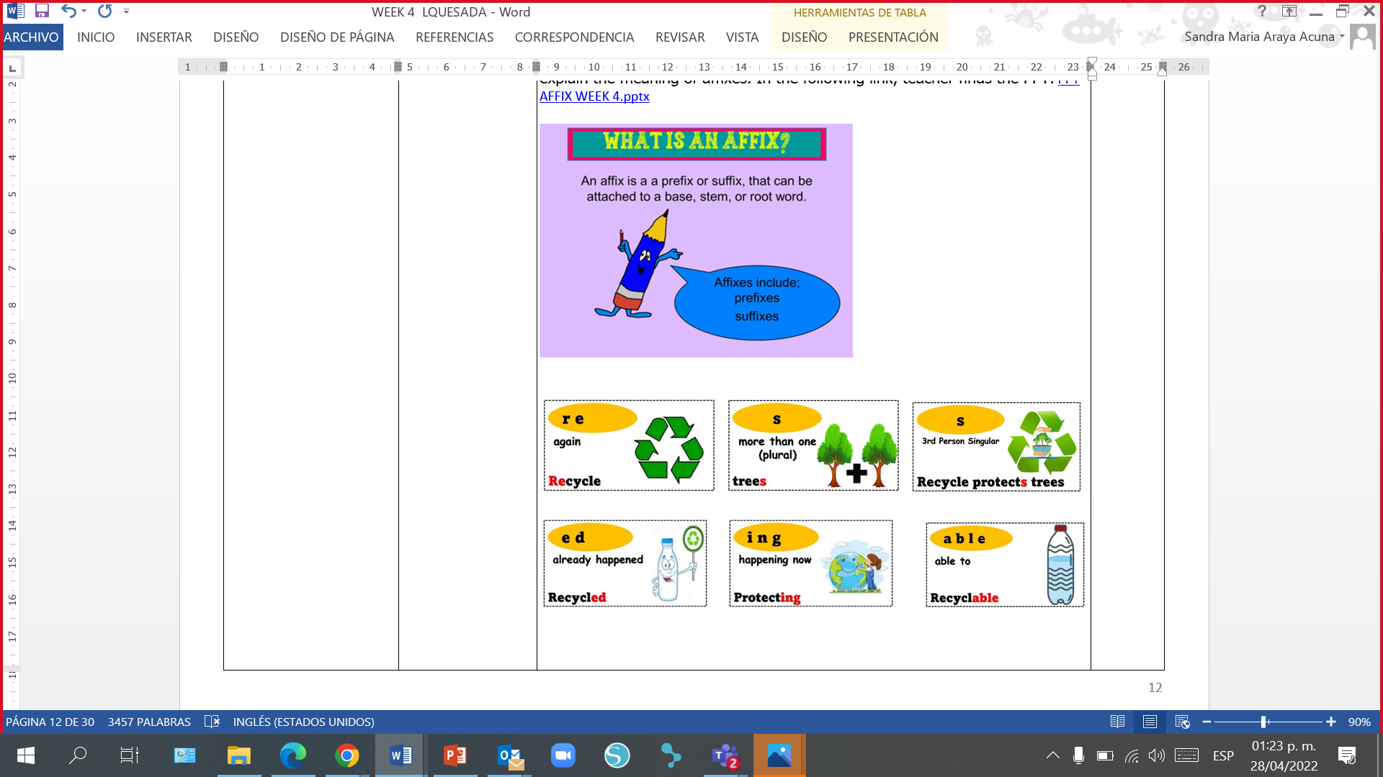

**Annex 12**

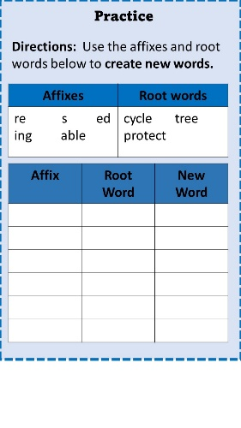

**Annex 13**

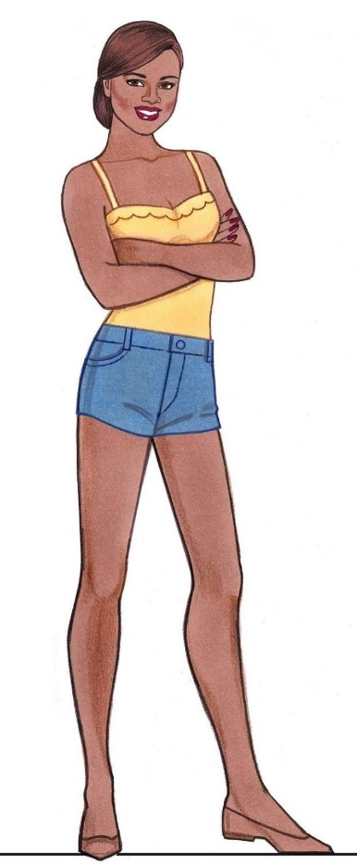PAPER DOLL 1

**Annex 14**

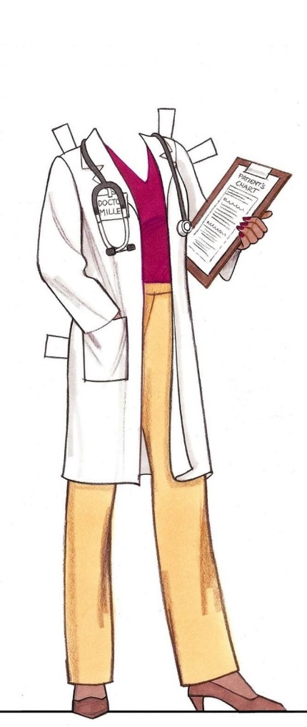

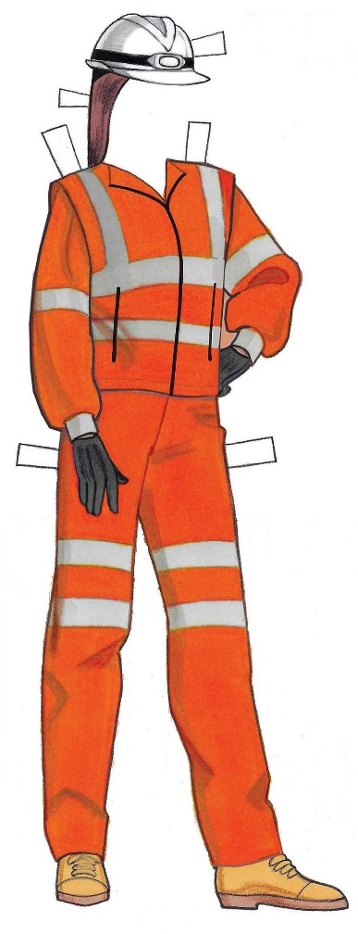

PAPER DOLL 2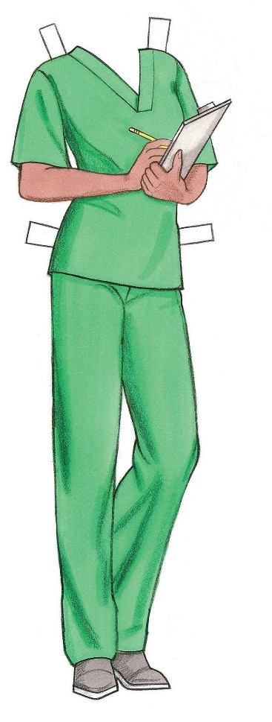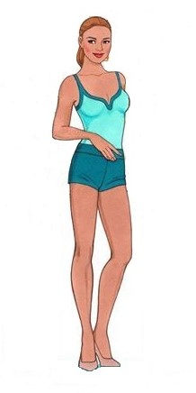

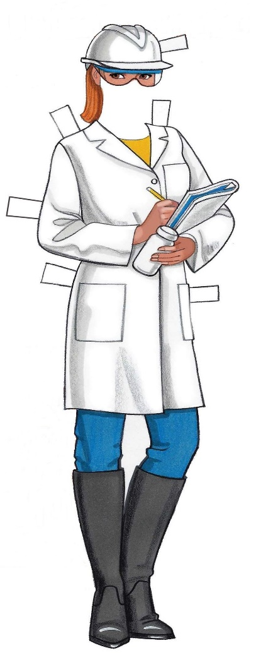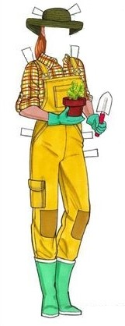

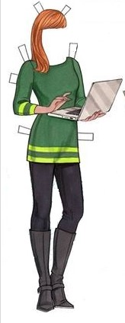

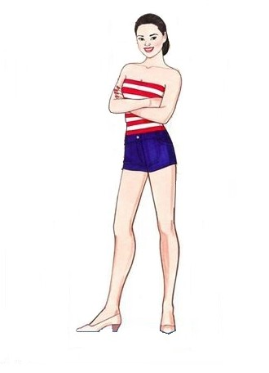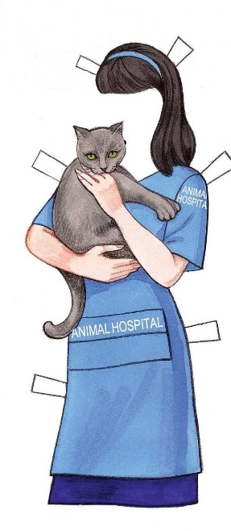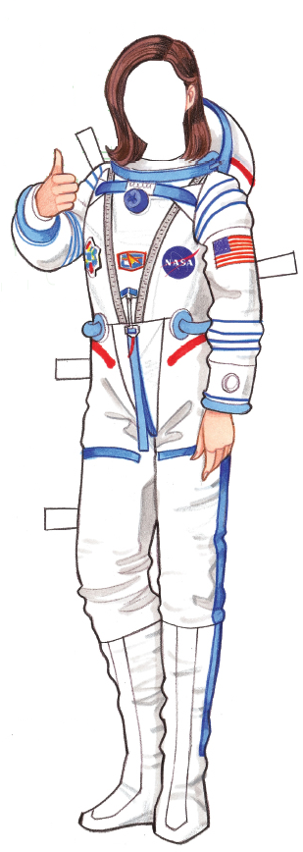

PAPER DOLL 3

Pictures taken from <https://www.doverpublications.com/zb/samples/820246/sample7c.html>

|  |  |  |  |
| --- | --- | --- | --- |
| SHORT STORY | | | |
| Title of the story |  | | |
| What the story is about |  | | |
| Characteristics of the SUPER GIRL |  | | |
| Who is she? |  | | |
| Where the story took place |  | | |
| What she did to help the environment | First | Then | Finally |
| End of the story: |  | | |

**Annex 15**

|  |  |  |  |  |  |  |  |  |
| --- | --- | --- | --- | --- | --- | --- | --- | --- |
| **Review and Integrated Mini-Project (MP)**  **Week # 5** | | | | | | | | |
| **Level: 6th** | | | | | **Unit: 3** | | | |
| **Enduring Understanding:** Litter harms our school, community, Costa Rica and the world. The actions we take now to help with litter will help our neighbors today and in the future.  **Essential Question:** Why should we be concerned about litter? | | | | | | | | |
| **New Citizenship:**   |  | | --- | | **Dimensions** | | **1.** **Ways of thinking (**x**)** | | **2. Ways of living in the world (**x**)** | | **3. Ways of relating with others (**x**)** | | **4. Tools for integrating with the world (**x**)** | | | | | | | | | |
| **Learn to Know** | | | **Learn to Do** | | | **Learn to Be and Live in Community** | | |
| **Grammar & Sentence Frame**   * Did Ls use all sentence frames?   **Vocabulary**   * Did Ls say aloud, write and understand all vocabulary? | | | **Function**   * Did Ls use all functions?   **Discourse Markers**   * Did Ls practice the discourse markers in spoken interactions? | | | **Psychosocial**  Did Ls show evidence of …   * Working on their own strengths and limitations. * Being flexible and open to changes to reach success in many areas of life.   **Sociocultural**  Did Ls show evidence of …   * Supporting classmates to reach goals together. * Promoting healthy habits for improving my family and classmates lives. * Did Ls practice idioms and quotes? | | |
| **Assessment Strategies & indicators of learning**  (Diagnostic, formative, summative) | **Learner can** | **Didactic Sequence Mediation** | | | | | **Time** Total:  200 min (5 lessons) | |
| * Did Ls achieve all indicators of learning? | * Can Ls do all tasks? | Teacher uses this column to plan the tasks that need to be strengthen and reviewed according to the assessment strategies and their indicators of learning. | | | | | 80´ | |
| **Options** | | | | **Integrated Mini-Project** | | | **Time** |
| **Suggested Integrated Mini-Project**  **-“Go green fair” (groups of 3/4)**  **Task:** You and your friends are presenters at a School Fair. You have to raise awareness and show your classmates what they can do to help the environment. Each stand should have a different topic (What can you do about litter? Why is litter bad? Where does litter go? Why should we be concerned about litter?) Choose your topic, organize your ideas, make a creative stand and present the information to your classmates.  **-“Helping the environment” (LAPBOOK and oral presentation)** **(groups of 3)**  **Task:** You and your friends will present information about different ways to help the environment. You will create a lapbook to include the information and pictures related to it. Take into account the following aspects:   * Base your lapbook on your real-life experiences. * Focus on things you and other children can do to help the environment and keep the world around us clean. * Add pictures and written ideas.(Teacher checks the written ideas previously) * Finally, share ideas orally with the rest of the class.   **-“No more litterbugs” (groups of 4/5)**  **Task:** You and your classmates will be in charge of organizing an eco-campaign at school. You have to create posters with information on how to avoid being a litterbug and the importance of keeping the environment clean. The posters will be taped around the school.  Take into account the following aspects:   * assign roles of participants * make lists of resources * present in advance the information that will be included in the poster for the teacher to check it. * Create your posters. * Tape your posters around the school * With teacher´s help, organize a tour to see and read the posters. Introduce the information of each one. | | | | **Phase 1: Planning**  Teacher explains and writes on the board ALL options of Mini-Projects learners have. Teacher can also give a sheet with the information in order to save time. Learners are asked to think about each Mini-Project and choose their favorite.  Learners make groups and choose the Mini-Project they will develop. Teacher writes the name of the members (group) and the Mini- Project they chose.  **Phase: 2 Creating Collaboratively**  Learners start planning, negotiating and finding information collaboratively about the language content and strategies, resources and organizing the work to distribute assignments among the group members. Learners make sure that the materials will be ready for next class and that all members know their responsibility.  They assign roles of participants, make lists of resources they need, check schedule,learners do some online research about the selected topic, start working on their MP to finally complete the product.  **Phase 3: Rehearsing**  Students practice the Mini-Project presentation or finish final details before presenting their Mini- Project.  Teacher monitors learners’ work and progress. | | | 120´ | |
| **Integrated Mini-Project**  **Week # 6** | | | | | | | | |
| **Options** | | **Integrated Mini-Project** | | | | | **Time**  200 min (5 lessons) | |
| **Integrated Mini-Projects:**  **-“Go green fair”**  **-“Helping the environment”**  **-“No more litterbugs”** | | **Phase 4: Participating**  Students present their MP to an audience   * creatively deliver the Mini-Project * answer questions from the audience.   Leaners participate in individual and peer assessment of Mini-Projects.  Teachers monitor ….   * Did Ls use English during all aspects of Integrated Mini-Project? * How didproject presentations reflect understanding and/or mastery of Can Do statements? * Did Ls put into practice the focus of Learn to Be and Live in Community? * Did the Integrated Mini-Project provide answers to the Essential Question?   Teacher uses a check list to check MP every week to track learners’ progress. | | | | | 200´ | |

|  |  |  |  |
| --- | --- | --- | --- |
| **Mini-Project**  **Checklist** | | | |
| **Student…..** | **Yes** | **No** | **Partially** |
| chooses a suggested MP (Week 5) |  |  |  |
| gets in a group (Week 5) |  |  |  |
| distributes assignments (Week 5) |  |  |  |
| makes a list of resources they will need (Week 5) |  |  |  |
| does online research about the selected MP (Week 5) |  |  |  |
| looks for subject experts (Week 5) |  |  |  |
| prepares a plan (Week 5) |  |  |  |
| makes and distributes a schedule among teammates (Week 5) |  |  |  |
| works equally in the group (Week 5) |  |  |  |
| makes presentation eye catching (Week 5) |  |  |  |
| makes information neat and organized (Week 5) |  |  |  |
| shows responsibility in assigned tasks (Week 5) |  |  |  |
| uses English during all aspect of MP (Week 5 and 6) |  |  |  |
| reflects understanding and/or mastery of can-do statements in their Mini-Project presentation (Week 6) |  |  |  |
| puts into practice the focus of learn to BE and Live-in community (Week 6) |  |  |  |
| provides answers to the Essential Question in MP (Week 6) |  |  |  |
| pronounces correctly (Week 5 and 6) |  |  |  |
| uses grammar structures correctly (Week 5 and 6) |  |  |  |
| uses a variety of vocabulary and expressions (Week 5 and 6) |  |  |  |
| speaks smoothly with little hesitation according to his/her level (Week 6) |  |  |  |

**Comisión redactora**

**Unidad 3**

**Sandra Araya Acuña**

Asesora Regional de Inglés, Dirección Regional de Educación de Guápiles

**Shirley Rojas Leiva**

Asesora Regional de Inglés, Dirección Regional de Educación Zona Norte-Norte

**Docentes de Inglés, DRE Guápiles**

Swad Dalen Ulate González, Escuela Cascadas

**Docentes de Inglés, DRE Zona Norte Norte**

Ligia María Quesada Gómez, Escuela El Higuerón

Libia Retana Araya, Escuela Teodoro Picado Michalski

**Noelia González Cascante**

Dirección de Regional de Educación Guápiles, Diseño de portada